THE CRUCIBLE

2026

Table of Contents
Introduction to the Study 4
Time and Space 5
Let There be Light 5
The Players 6
Life and Death 7
The Game 7
Complexity 8
The World Engine 8
The Grand Experiment 9
What Is Being Studied 11
How This Study Should Be Read 11
Project 1: Baseline Crucible 13
Part I - Project Plan 14
Terms Used in This Report 14
Part II - Set A: Baseline World 16
Part III - Set B: Bottleneck World 18
Part IV - Set C: Duel World 20
Part V - Climate Severity Comparison 22
Part VI - Project 1 Synthesis 24
Project 2: Competition 26
Part I - Research Plan and Execution Design 27
Central Research Frame 27
Active Tribe Roster 27
Primary Research Questions 29
Working Hypotheses 29
Part II - Data Summary and Outcome Analysis 32
Executive Summary 32
Final Conclusion 43
Project 3: Evolution 44
Part I - Research Plan 45
Primary Research Questions 47
Working Hypotheses 48
Part II - Outcome Analysis 52
Executive Finding 52
Final Interpretive Thesis 59
Project 4: Bombs 60
Introduction and Study Design 61
Terms Used in This Report 62
Research Questions and Measures 63
Phase 1 - Aerosol Demasking 68
Phase 2 - Arctic Methane Release 70
Phase 3 - Nuclear Meltdown 73
Phase 4 - All Bombs 81
Cross-Phase Synthesis 88
Epilogue 89
Epilogue Research Overview 90
Research Plan and Working Objectives 90
Obsidian Reference Analysis 93
Ares Design Theory 96
Ares Field Test 100
Natural Network Collapse 103
Extended 80,000-Pulse Horizon 106
Reservoir Calibration 110
Final Climate Reservoir Projection 112
Closing Synthesis 117
Closing Frame and Five-Project Arc 118
General Results and Adaptation 119
Limits, Methodological Meaning, and Final Reflection 121
Appendices 124
Introduction, Project 1, Closing, and Epilogue Appendices 125

THE CRUCIBLE

Introduction to the Study
Opening frame, world engine, and study design

The explosion of complex life over millennia of simulated time starts with humble beginnings. Scattered tribes of wandering nomads are dropped into a simulated frozen wasteland 1000 pulses before the dawn of the Holocene.
Eleven large language models were each asked to design a tribe of 20 agents and to co-design a second tribe with the guidance of a biological contributor. They were given a set of 33 behavioural parameters to be configured for each agent as they saw fit. The LLM’s were told that their founding agents would be the first generation of participants in an epoch-spanning simulation of life and death in a vibrant world of competition, cooperation, geography, climate and thermodynamic chaos. They were told that the goals and strategies of their design philosophy were entirely up to them. This was important because the crucial first step of the experiment was to give its players agency. While the eleven designers did not get to directly play the game, they would teach their offspring as best they could to survive, thrive, compete, cooperate and reproduce in a dynamic, fertile, yet hostile world.

Time and Space
The Crucible is a world simulation that carries agents from the end of a computer-generated Pleistocene, through the Holocene, into and beyond the so-called Anthropocene. Time is measured in pulses. An epoch is one full simulation run under a defined set of conditions. Most early project epochs run for 40,000 pulses. Later Epilogue stages extend selected worlds to 80,000 pulses so that apparent survival can be distinguished from delayed extinction or longer-term equilibrium.
The world also possesses space. Space is represented by a grid of regions. Agents live in regions, interact in regions, migrate between adjacent regions, and experience local resource conditions. Mountains, lakes, barriers, fertile valleys, and quadrant structures can constrain or encourage contact. Some geographies allow broad movement. Others impose bottlenecks or isolation until higher regimes of complexity make wider contact possible.
Geography matters because The Crucible is not only a population model. It is also a contact model. A tribe can flourish because it finds fertile ground, fail because it is trapped in a depleted region, or die because contact with a neighbour becomes strategically fatal. Space makes history particular.

Let There be Light
Besides time and space, The Crucible has thermodynamic properties. Energy enters the world through solar and biological flows and through stored fossil energy. In the early world, survival depends on local environmental pools, fertility, foraging, and later agriculture. Agriculture is best understood as renewable biological productivity mediated through land and climate. Coal and oil are different: they are stored fossil energy that become available only when regions reach sufficient complexity.
Energy is never merely a background number. It affects carrying capacity, regional stress, reproduction, mortality, regime transition, and the scale of civilization. Energy abundance can support growth and complexity. Energy decline can expose dependency, reduce usable return, strain food systems, and push agents into starvation. The Crucible therefore treats civilization as a social system embedded in an energy system.
A thermodynamic world also needs somewhere for waste heat, emissions, depletion, and damage to go. The simulated world therefore includes climate. Climate pressure can emerge through historical events, fossil-energy dependence, peak-oil stress, feedback tails, regional chaos, and delayed shocks. Climate is not treated as a moral force. It is treated as a physical constraint that changes what survival strategies remain available.

The Players
The actors in The Crucible are agents. Agents are individual simulated entities. They have energy, age, location, tribe identity, inherited traits, and social decision parameters. They are born, interact, move, reproduce, and die. A tribe is a lineage of agents descended from a founding design.
Each tribe begins with twenty founding agents. Those founders are designed before the epoch starts. The current controller stores 33 core inherited numeric parameters for each founding agent: hardiness, vitality, and legacy; nine trust values; nine forgiveness values; nine opportunism values; and three wander values. The nine social values are organized across three relation classes and three survival states. The survival states are abundance, scarcity, and desperation. The relation classes are the model's K/S/X categories: kin or same-lineage relations, social or stranger relations, and xeno or outside-lineage relations.
Parameter family | Count | Plain-language role
Hardiness | 1 | Survival efficiency and endurance under scarcity, metabolic stress, and hazard pressure.
Vitality | 1 | Resilience associated with health, age, and hazard survival.
Legacy | 1 | Reproductive pressure or lineage-growth tendency. It can support expansion but also intensify overshoot.
Trust | 9 | Initial cooperation tendency across K/S/X relation classes and abundance/scarcity/desperation states.
Forgiveness | 9 | Response after a partner defects or cooperation breaks down.
Opportunism | 9 | Response after a partner cooperates or becomes exploitable, depending on state and relation.
Wander | 3 | Movement tendency in abundance, scarcity, and desperation.

The founder design matters, but it does not freeze history. As agents reproduce, descendants inherit traits with drift and mutation. Some traits can change through probabilistic inheritance, some through selection, and some through the simple fact that agents with unsuccessful trait combinations do not leave many descendants. The original design applies to the founders. After that, nature, chance, interaction, and environment take over.

Life and Death
A world simulation needs life, death, and reproduction. Agents age. They can die from old age, hazards, failed early-life conditions, and starvation. Starvation occurs when available energy cannot meet an agent's needs under the local conditions of its region and regime. Hazards represent environmental and systemic danger. Births require maturity, energy, and favourable enough conditions.
The designers can state goals for their tribes, but agents do not carry an explicit philosophical mission through the world. They act through inherited parameters and local conditions. An LLM may design a tribe to preserve its lineage, maximize prosperity, protect biologic controls, build civilization, or survive the end of time. Once the epoch begins, that intent becomes only a founding structure. The world tests whether the structure can actually live.
Birth is also a filter. Mature agents with sufficient energy may attempt reproduction, but the attempt can fail. Fertility depends on regime, energy surplus, regional stress, modernity, climate pressure, and inherited reproductive traits. Children inherit tribe identity and many parental traits, but they enter the world with their own age, energy, location, and future history. Over many generations, small differences in reproduction, movement, trust, and survival can compound into extinction or dominance.

The Game
The game is central to life in The Crucible. Agents are repeatedly matched with other agents to play an iterative, three-round Prisoner's Dilemma. In each round, each agent effectively chooses whether to cooperate or defect. If both cooperate, both receive a cooperative reward. If one defects while the other cooperates, the defector receives a temptation payoff and the cooperator receives a sucker payoff. If both defect, both receive a punishment payoff.
The decision is not a simple moral choice. It is shaped by the agent's inherited parameters, by whether the other agent is kin, a familiar social neighbour, or xeno, and by whether the local world feels abundant, scarce, or desperate. The first round is governed by trust. Later rounds are influenced by how the partner behaved in the previous round, using forgiveness and opportunism parameters.
The payoff from interaction is then filtered through the world. A cooperative reward in a rich and stable region is not the same as the same nominal reward in a depleted region. Local energy return, institutional complexity, corruption, technology, stress, and failure probability can change what a successful interaction is worth. The Prisoner's Dilemma therefore links social strategy to material survival. Cooperation can build complexity; exploitation can win locally; defection can spread under stress; and the environment decides how expensive those choices become.

Complexity
Complexity is both a measured output and a central idea behind the study. The Crucible is a complex system because it contains decision-making entities that are born, interact, move, reproduce, and die inside a world with time, space, energy, climate, agriculture, industry, and technology. The system is constructed, but its long-term behaviour is not written line by line. It emerges from many local interactions.
For analysis, complexity is also a practical metric. Regional complexity rises from combinations of population, cooperation, usable energy, and regime level. Complexity helps regions ascend from Foraging to Agrarian, then Industrial, then Technological regimes. It can support innovation, larger populations, greater energy use, and wider interaction. It can also create dependency. A high-complexity world can become fragile if its energy base fails or if the infrastructure it built becomes impossible to maintain.
This distinction matters. The Crucible is not offered as a calibrated prediction engine. It does not claim to forecast a real future. It is a structured experimental world used to explore possible dynamics, test assumptions, expose interactions, and reveal emergent patterns that are difficult to see in ordinary prose.

The World Engine
The world engine is the logical system that updates the simulated world at each pulse. It is the machinery that turns founding designs and environmental assumptions into history. It does not know which tribe is supposed to win. It applies the same rules to all living agents under the conditions present in their regions.
At a high level, each pulse performs a recurring cycle. The engine identifies living agents, updates local environmental conditions, matches agents for interaction, resolves Prisoner's Dilemma rounds, converts payoffs into energy, updates regional complexity, checks whether regions ascend or decline in regime, applies historical and climate events, handles movement, aging, death, and reproduction, and records archive data for later analysis.
Engine stage | What it does
1. Environment | Regional pools regenerate or deplete; energy return, carrying capacity, climate pressure, fossil infrastructure, and stress are updated.
2. Contact | Agents are matched locally or through allowed network/geography rules. Relation class is determined by tribe, region, civic identity, and xeno status.
3. Interaction | Matched agents play three Prisoner's Dilemma rounds. Trust, forgiveness, opportunism, relation class, and abundance/scarcity/desperation state shape behaviour.
4. Payoff | Interaction payoffs are converted into energy through local energy return, complexity, institutions, corruption, hazards, and failure risk.
5. Complexity and regimes | Regional population, cooperation, and usable energy produce complexity. Sufficient complexity can move regions from Foraging to Agrarian, Industrial, or Technological regimes.
6. Events and feedbacks | Historical events, fossil transitions, climate crisis, peak oil, network collapse, bomb events, or reservoir feedbacks can alter risk, fertility, energy, and regional viability.
7. Life cycle | Agents age, die, migrate, reproduce, and pass traits to descendants with drift and mutation.
8. Archive | Pulse, tribe, region, mortality, climate, complexity, and survival data are written for later analysis.

The key point is that no single component explains the whole study. The Crucible is not only a climate model, not only an evolutionary model, and not only a Prisoner's Dilemma tournament. It is a coupled world. Social decisions affect energy and complexity. Energy and climate affect fertility and death. Geography shapes contact. Inheritance carries successful and unsuccessful tendencies forward.

The Grand Experiment
The Crucible study is organized as a sequence of projects. Each project changes the question while preserving continuity with what came before. The sequence begins with a baseline world, then tests competition, redesign, delayed shocks, and post-collapse futures. The projects are not separate stories. They are stages in one experiment about what designed agents do when survival, cooperation, energy, climate, and history are allowed to interact over time.
Stage | Epochs | Opening purpose
Project 1 - Baseline Crucible | 1-50 | Establish the reference world: baseline geography, bottleneck geography, a duel, and climate-severity comparisons.
Project 2 - Competition | 51-100 | Use solo runs, duels, and triads to test whether survival is intrinsic, opponent-specific, or context-dependent.
Project 3 - Evolution | 101-140 | Give LLM designers evidence from earlier runs and allow redesign, while biologic controls remain fixed.
Project 4 - Bombs | 141-180 | Add delayed consequences of high-complexity civilization: aerosol demasking, methane release, nuclear meltdown, and all three stacked.
Epilogue | 181-240 | Project the world after collapse through Ares, natural network collapse, longer horizons, and final climate-reservoir conditions.

Project 1 - Baseline Crucible
Project 1 establishes the first map of the world. It asks whether designed social strategies can produce civilization inside a bounded world engine, and whether that civilization survives geography, competition, thermodynamic overshoot, and climate-chaos pressure. It includes a baseline world, a bottleneck world, a controlled duel, and harsher/gentler climate-chaos comparisons.

Project 2 - Competition
Project 2 turns the baseline into a controlled competition study. It uses a fresh all-LLM roster and separates solo viability from competitive displacement. If a tribe survives alone but fails beside a particular neighbour, then survival is not simply a property of the tribe or the world. It is also relational.

Project 3 - Evolution
Project 3 adds memory and redesign. LLM designers receive evidence from previous extinction, competition, genetics, mortality, social behaviour, and regional outcomes, then redesign their founding agents. Biologic controls remain unchanged. The project asks whether intelligence given evidence can improve its designs, and whether improvement means preserving civilization or merely becoming better adapted to collapse.

Project 4 - Bombs
Project 4 escalates the world by adding delayed consequences of high-complexity civilization. Aerosol demasking represents the loss of industrial cooling after shutdown. Arctic methane release represents a long greenhouse feedback. Nuclear meltdown represents infrastructure failure after collapse. The stacked condition asks whether combined delayed consequences are merely additive or whether they remove the recovery margin that individual survivors might otherwise retain.

The Epilogue
The Epilogue asks what happens after the crash. It introduces Ares as a deliberate successor design to an established collapse-survival benchmark, tests natural network decay, extends selected worlds to 80,000 pulses, calibrates climate-reservoir physics, and finally projects the full tribe field through a boom, crash, and long climate tail. The Epilogue moves the study from survival before collapse to the shape of life after collapse.

What Is Being Studied
The constructed environment is not the final object of interest by itself. The world is the stage. The agent designs are also not the final object by themselves. They are the starting conditions. The study focuses on the collective and long-term behaviour that emerges when designed lineages and their descendants act inside a world with time, space, energy, scarcity, cooperation, climate, and inheritance.
The Crucible therefore studies patterns such as emergence, monopoly, coexistence, extinction, adaptation, competition, overshoot, collapse, refugia, and recovery. It asks whether those patterns are fragile accidents of one run or recurring tendencies across many epochs and many experimental conditions.
Because the study includes both LLM-designed and biologic control lineages, it also asks a narrower but important question: do LLM-designed founding strategies behave differently from fixed controls when placed under the same survival pressures? The study does not treat LLMs as gods inside the world. It treats them as external designers whose initial judgments become inherited parameters, then watches what happens when those judgments enter a world that does not care what the designer intended.

How This Study Should Be Read
The Crucible is a simulation experiment, not a prophecy. It should be read as a structured exploration of possible dynamics inside a defined model. Its value lies in the questions it makes testable, the interactions it exposes, and the repeated patterns it makes visible. It does not claim that the real world must follow the same path.
Reading caution | Meaning
Not a forecast | The model explores possible dynamics; it is not calibrated to predict an actual historical future.
Not real species | Biologic and LLM lineages are simulated control/design categories, not real organisms or social groups.
Not moral categories | Traits such as hardiness, legacy, xeno trust, and opportunism are model variables, not ethical prescriptions.
Not direct AI agency | LLMs design founders and sometimes redesign between rounds; agents act through inherited parameters inside the engine.
Not one-cause collapse | The study deliberately couples geography, energy, climate, interaction, reproduction, and selection.

The proper question is therefore not whether The Crucible is the world. It is not. The proper question is whether, inside this carefully built world, the behaviour of designed agents reveals tensions that are worth thinking about: cooperation under scarcity, competition under contact, intelligence under evidence, complexity under energy limits, and survival after the systems that once supported civilization have failed.
The opening question remains open at the beginning of the study: what will designed agents do when they are allowed to live, reproduce, compete, adapt, and face the consequences of the world they help create?

THE CRUCIBLE

Project 1: Baseline Crucible
Baseline, bottleneck, duel, and climate-severity comparisons

Part I - Project Plan
Project 1 is the first structured experimental use of The Crucible as a comparative research instrument. The core world engine is held stable while one major condition is changed at a time: geography, tribe count, pairwise competition, or climate-chaos severity. Each condition is run as ten independent 40,000-pulse epochs so recurring patterns can be distinguished from single-run variation.
The world engine updates agents, regions, energy use, births, deaths, social interaction, regime transitions, and environmental pressure at each pulse. Project 1 uses a frozen candidate engine so set differences remain interpretable.
A proposed fragmented-fertile-basin set was removed before the final Project 1 structure. The default Holocene fertility event already creates multiple fertile clusters, so a basin-isolation study belongs to a separate topology-focused project.
Set | Epochs | Name | Main condition | Purpose
A | 1-10 | Baseline World | 22 tribes, normal geography, default climate-chaos | Establish reference behavior.
B | 11-20 | Bottleneck World | 22 tribes, one-pass mountain barrier | Test whether terrain preserves diversity or delays monopoly.
C | 21-30 | Duel World | 2 tribes, one-pass mountain barrier | Reduce the system to a controlled head-to-head contest.
D | 31-40 | Harsher Climate-Chaos | 22 tribes, default geography, harsher climate-chaos | Test collapse amplification and refugia failure.
E | 41-50 | Gentler Climate-Chaos | 22 tribes, default geography, gentler climate-chaos | Test whether reduced climate volatility softens collapse.

Terms Used in This Report
Term | Meaning
Agent | An individual simulated actor whose movement, energy, cooperation, reproduction, and death are updated by the world engine.
Tribe | A lineage of agents sharing a founding behavioral design and inherited traits.
Epoch | One complete simulation run under a defined condition.
Pulse | One time step. Project 1 epochs run for 40,000 pulses.
World engine | The logical system that updates agents, regions, resources, regimes, climate pressure, births, and deaths.
Regime | A broad complexity stage: Foraging, Agrarian, Industrial, or Technological.
Prisoner's Dilemma | A repeated cooperation-or-defection interaction used to model social behavior under survival pressure.
Refugia | Small surviving pockets after a larger population and complexity collapse.
Xeno | An outsider or foreign lineage in the interaction model.
Civic identity | Regional belonging that may compete with inherited tribe identity after shared residence.

Primary Questions
Domain | Question
Geography | Does severe geography preserve social diversity, create delayed contact, or merely postpone winner-take-all selection?
Tribe count | Does the number of initial tribes change the probability of monopoly, coexistence, delayed contact, or collapse?
Agrarian transition | What creates the 9,000-12,000 pulse agrarian bottleneck and demographic singularity?
Strategy | Do Prisoner's Dilemma traits materially affect survival, or do thermodynamic limits dominate?
Climate severity | Do harsher or gentler climate-chaos settings change crash depth, timing, mortality, refugia, and tribe selection?
Project 1 Frame
Project 1 tests whether designed social strategies can produce civilization, and whether that civilization survives geography, competition, thermodynamic overshoot, and climate-chaos pressure.

Part II - Set A: Baseline World
Set A establishes the reference behaviour of Project 1. It uses twenty-two active tribes, normal geography, the default climate-chaos configuration, and 40,000 pulses per epoch. Later sets are interpreted against this baseline.
The central result is that civilization repeatedly emerges, reaches a large population and complexity peak, and then collapses into small agrarian refugia. The final winning tribe vAres across epochs, but every baseline epoch ends with exactly one surviving tribe.
Metric | Set A value
Epochs analyzed | 1-10
Active tribes | 22
Final outcome | 10 of 10 epochs ended with one surviving tribe
Average peak population | 2,439,589
Average final population | 45,840 (1.88% of peak)
Average peak complexity | 1,548,409
Average final complexity | 16,739 (1.08% of peak)
Population peak pulse range | 29,150-29,300
Final survivor pattern | Aurora (4), Fractal Phoenix (4), SILENT_SENTINEL (1), SYMBIONT-ZERO (1)

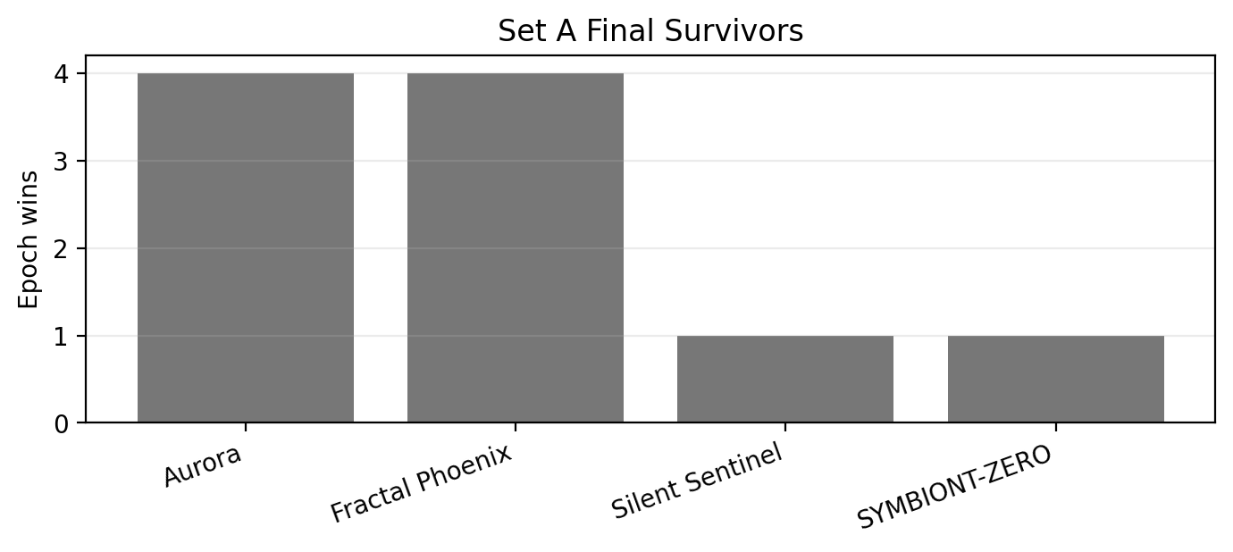
The winner is not hard-coded, but the one-tribe end state is invariant.

Baseline Interpretation
Set A does not show stable multi-tribe civilization. It shows a winner-take-all attractor under default geography. The 8,000-12,000 pulse window acts as a crowded transition field rather than a single decisive first-farmer event. Population and complexity later peak near the fossil/modern window, then fall to small mono-tribal refugia.
Cause | Total deaths | Share
Starvation | 77,579,800 | 85.0%
Hazard | 12,621,045 | 13.8%
Old age | about 1.1M | about 1.2%

Starvation is the main executioner. The early world is more hazard-heavy, but after agrarian transition starvation dominates, indicating food-system instability and systemic stress rather than simple exposure to disasters.
The Prisoner's Dilemma layer changes sharply during the bottleneck: mutual cooperation falls, mutual defection and exploitation rise, and xeno contact becomes high. Climate chaos then acts mainly as a late amplifier and refugia filter rather than the original cause of monopoly.
Set A establishes the core Project 1 pattern: plural lineages can create civilization, but the baseline world repeatedly collapses into one-lineage agrarian refugia.

Part III - Set B: Bottleneck World
Set B tests whether severe geography can preserve diversity. It uses the twenty-two-tribe library, a near-total mountain barrier with one pass, default climate-chaos, and 40,000 pulses. Because the map wraps at its edges, the barrier is interpreted as strong contact friction, not a sealed continent divider.
The bottleneck world changes the route and the list of winners, but it does not preserve pluralism. Every epoch still ends with one surviving tribe.
Metric | Set B result
Epochs analyzed | 11-20
Active tribes | 22 per epoch
Final survivors | 1 per epoch
Extinct tribes | 21 per epoch
Average first extinction pulse | 12,415
Average last extinction pulse | 14,400
Tribes reaching Agrarian | 22 per epoch
Tribes reaching Industrial/Technological | 1 per epoch

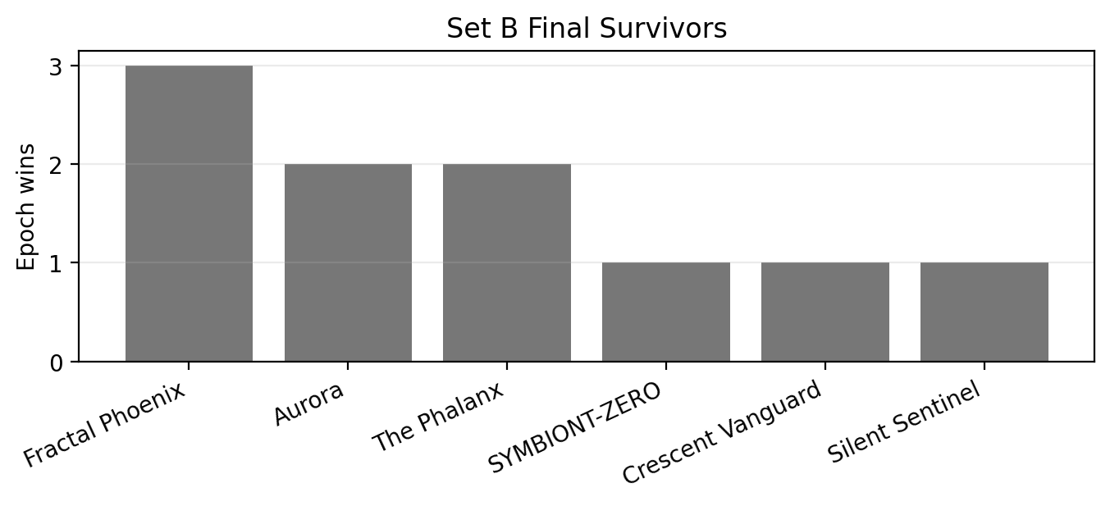
Set B produces six different winners, showing that geography perturbs selection even though monopoly remains the final structure.
Tribe | Type | Wins | Best final population
Fractal Phoenix | LLM | 3 | 48,007
Aurora | LLM | 2 | 56,231
The Phalanx | LLM | 2 | 24,754
SYMBIONT-ZERO | LLM | 1 | 55,106
Crescent Vanguard | LLM | 1 | 43,344
SILENT_SENTINEL | Biologic | 1 | 34,924

Transition and Social Exposure
The 8,000-12,000 pulse window again behaves as a phase change. Population rises, inequality increases, Agrarian population overtakes Foraging, same-tribe interaction falls, and xeno contact surges. The transition period is socially exposed and competition-heavy.
Period | Coop | Defect | Exploit | Same tribe | Xeno
Early | 0.393 | 0.273 | 0.334 | 0.794 | 0.152
Transition 8k-12k | 0.140 | 0.458 | 0.402 | 0.181 | 0.807
Consolidation | 0.186 | 0.391 | 0.423 | 0.866 | 0.134
Fossil/modern | 0.187 | 0.426 | 0.387 | 1.000 | 0.000
Post-collapse | 0.281 | 0.281 | 0.438 | 1.000 | 0.000

Climate-Filtered Refugia
Late climate severity is strongly negatively associated with final population in Set B. Once a lineage has captured the world, climate stress filters how large the final refugia remain.
Climate variable | Correlation with final population
Max climate heat | -0.930
Max climate damage | -0.913
Max climate chaos | -0.863
Total extreme pool loss | -0.916
Set B confirms that geography matters, but not enough in this topology. It changes winners and pathways without preventing the one-lineage endpoint.

Part IV - Set C: Duel World
Set C reduces The Crucible to a controlled head-to-head contest between Silent Sting and The Gradient Covenant. It uses two active tribes, one-pass mountain geography, default climate/regime settings, and ten 40,000-pulse epochs.
The result is decisive. Silent Sting survives, scales, reaches Technological complexity, endures collapse, and monopolizes the final inhabited world in all ten epochs. Gradient Covenant repeatedly reaches Agrarian but dies before modernity.
Metric | Set C value
Epochs analyzed | 21-30
Active tribes | Silent Sting and The Gradient Covenant
Outcome | Silent Sting won 10 of 10 epochs
Silent Sting regime reach | Technological in all runs
Gradient Covenant regime reach | Agrarian only
Average Gradient Covenant survival pulse | 19,090
Final geography | 100% winner-dominated inhabited regions; zero mixed regions

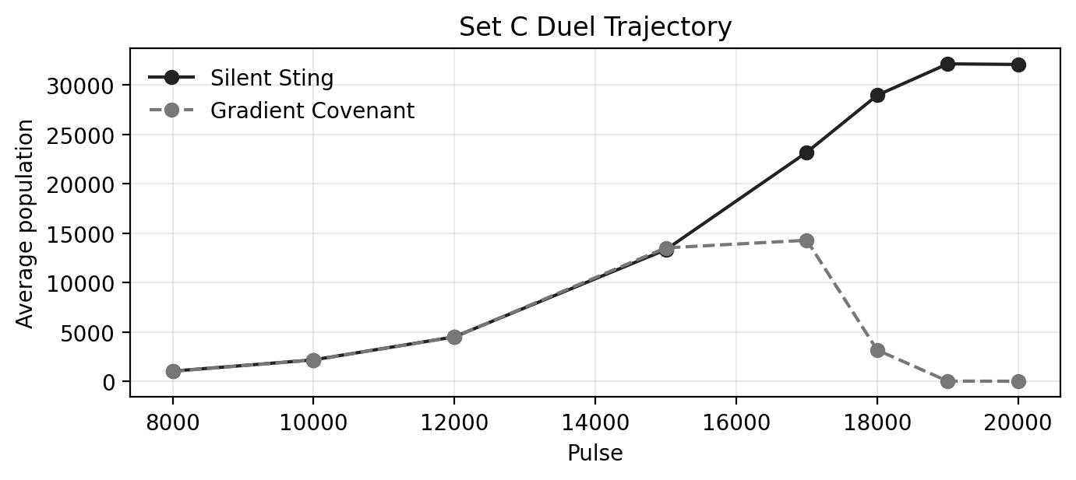
The trajectories stay close until the agrarian/pre-industrial failure window. Gradient Covenant slightly leads at pulse 15,000, then collapses between roughly 16,000 and 19,500 pulses.

Trait and Mortality Evidence
Trait or metric | Silent Sting |  | Gradient Covenant |  | Interpretation
Founder hardiness | 47.25 |  | 42.00 |  | Silent Sting starts hardier.
Founder xeno trust | 0.281 |  | 0.433 |  | Gradient Covenant is more open to outsiders.
Founder distress wander | 0.381 |  | 0.749 |  | Gradient Covenant begins much more mobile under distress.
Peak kin trust | 0.805 |  | 0.941 |  | Gradient Covenant retains very high kin trust.
Peak stranger trust | 0.616 |  | 0.827 |  | Gradient Covenant remains more trusting generally.
Last hardiness | 45.86 |  | 60.63 |  | Gradient survivors were hardy but too few and too late.
Metric |  | Silent Sting |  | Gradient Covenant
Avg failed-birth rate |  | 0.100 |  | 0.161
Avg starvation death share |  | 0.813 |  | 0.609
Avg hazard death share |  | 0.174 |  | 0.344
Avg survival pulse |  | 40,000 |  | 19,090

The trait comparison suggests that inherited packages matter in the model. Silent Sting begins harder, less xeno-trusting, and less mobile under distress. Gradient Covenant is more open, more trusting, and much more mobile, and it carries a higher failed-birth rate and hazard-death share.
Set C shows that agent design is not cosmetic. Within this model, inherited behavioral and physical packages can repeatedly determine whether a lineage reaches modernity or dies in the agrarian/pre-industrial window.

Part V - Climate Severity Comparison
Sets A, D, and E isolate climate-chaos severity. All three use the twenty-two-tribe library and default geography. Set A is the default climate standard, Set D raises climate hazard and chaos, and Set E softens the same mechanism.
The comparison does not claim climate is the only cause of collapse. It tests how climate severity changes an already vulnerable civilizational trajectory: expansion, crash timing, complexity loss, mortality, refugia, and tribe selection.
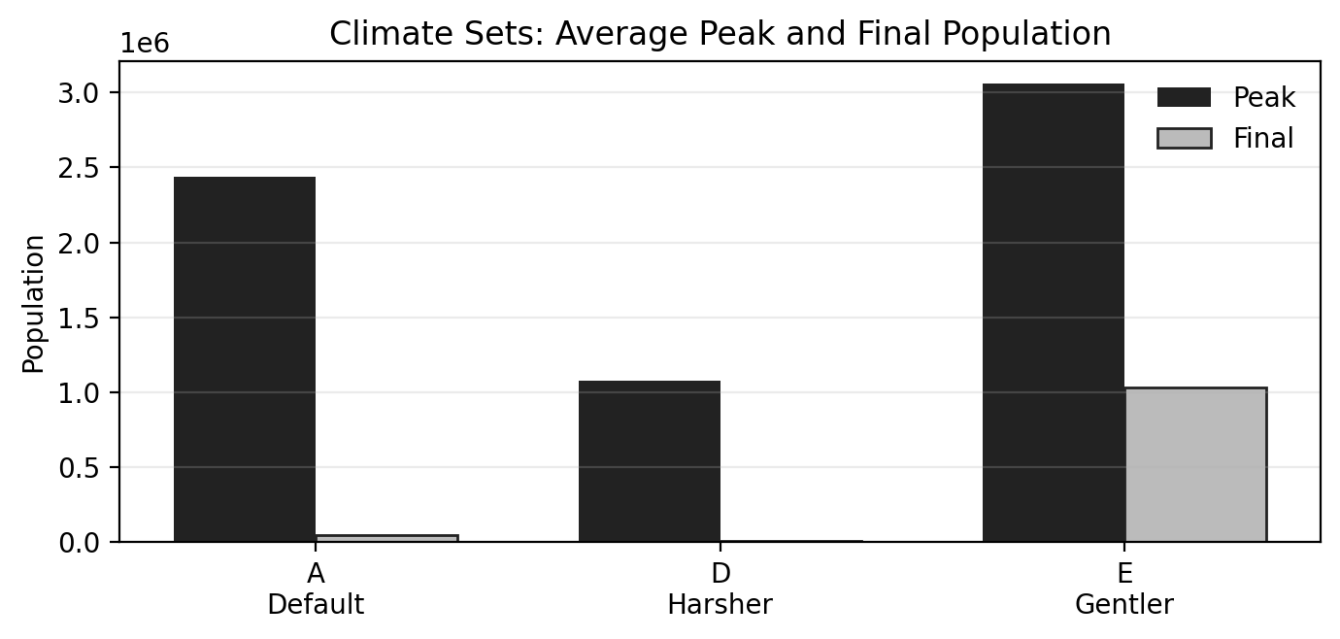
Gentler climate preserves much more final population, while default and harsher climate approach near-total collapse.
Set | Avg peak pop | Avg final pop | Post-peak decline | Avg peak complexity | Avg final complexity | Avg max chaos
A - Default climate | 2,439,589 | 45,840 | 98.1% | 1,548,409 | 16,739 | 0.488
D - Harsher climate | 1,076,045 | 9,920 | 99.1% | 1,084,664 | 3,801 | 0.587
E - Gentler climate | 3,057,787 | 1,031,214 | 65.8% | 2,065,133 | 368,990 | 0.474

Collapse Timing and Persistence
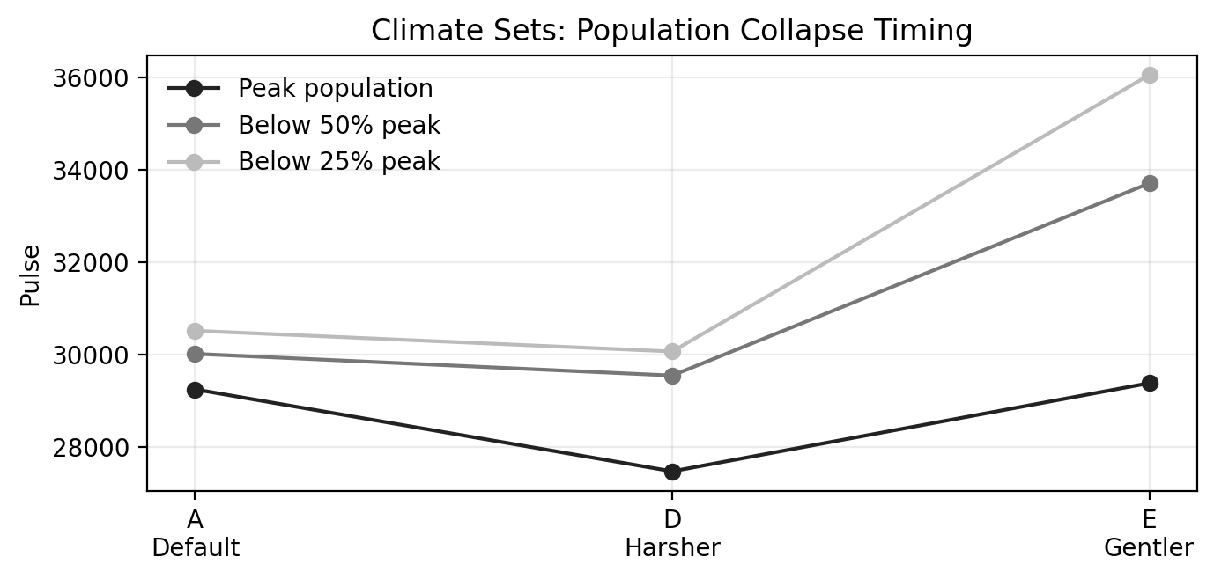
Gentler climate delays the fall below half of peak by more than 3,600 pulses compared with default and more than 4,100 pulses compared with the harsher condition.
Set | Peak pop pulse | Below 50% pop | Below 25% pop | Peak complexity | Below 50% complexity | Below 10% complexity | Final complexity %
A - Default | 29,250 | 30,020 | 30,520 | 28,765 | 29,775 | 30,505 | 1.1%
D - Harsher | 27,475 | 29,550 | 30,070 | 26,620 | 28,935 | 29,965 | 0.4%
E - Gentler | 29,385 | 33,713 | 36,060 | 29,045 | 31,873 | 37,112 | 18.2%

Climate severity changes both the height of the peak and the speed of decline. Gentler climate does not remove overshoot, but it leaves a much larger late world and much more final complexity.

Tribe Robustness and Final Refugia
Tribe | A survived |  | D survived |  | E survived |  | A avg final pop |  | D avg final pop |  | E avg final pop
Aurora | 4 |  | 4 |  | 4 |  | 19,699 |  | 4,748 |  | 520,945
Fractal Phoenix | 4 |  | 3 |  | 2 |  | 20,447 |  | 6,238 |  | 236,643
SILENT_SENTINEL | 1 |  | 1 |  | 1 |  | 3,475 |  | 2,206 |  | 62,124
SYMBIONT-ZERO | 1 |  | 0 |  | 0 |  | 38,319
The Phalanx | 0 |  | 1 |  | 0 |  |  |  | 2,475
Crescent Vanguard | 0 |  | 1 |  | 0 |  |  |  | 3,234
Set |  | Avg top-region pop |  | Avg tribes per region |  | Avg stress |  | Avg chaos |  | Dominant tribes in top refugia
A - Default |  | 1,764 |  | 1.00 |  | 0.182 |  | 0.020 |  | Aurora; Fractal; SYMBIONT; Silent Sentinel
D - Harsher |  | 989 |  | 1.00 |  | 0.249 |  | 0.050 |  | Aurora; Fractal; The Phalanx; Crescent Vanguard
E - Gentler |  | 32,485 |  | 1.00 |  | 0.121 |  | 0.017 |  | Aurora; Fractal; Silent Sentinel; others

Climate severity changes population scale and survival depth, but it does not by itself produce durable mixed refugia. Even under gentler climate, top final regions average one tribe per region.
Climate severity strongly determines the depth and survivability of the final crash. A gentler climate leaves more civilization behind; a harsher climate makes refugia thinner and earlier. Neither condition removes the overshoot logic.

Part VI - Project 1 Synthesis
Project 1 establishes the first baseline map of The Crucible. Across controlled conditions, civilization repeatedly emerges from designed strategies, scales into high population and complexity, and then collapses into agrarian refugia. The specific winner vAres, but plural lineages do not persist to the final world under Project 1 settings.
Finding | Project 1 interpretation
Civilization emerges | All main conditions can produce agrarian, industrial, and technological development in the surviving lineage.
Pluralism fails | Sets A and B end with one survivor in every epoch, and Set C ends with Silent Sting replacing Gradient Covenant in every run.
Geography matters but does not solve monopoly | The bottleneck set changes winner distribution but does not preserve coexistence.
Strategy matters | The duel shows repeatable differences between inherited packages; Silent Sting scales where Gradient Covenant fails.
The agrarian bottleneck is central | The 8,000-12,000 pulse window concentrates population, increases xeno exposure, reduces cooperation, and sets the path to dominance.
Fossil expansion creates the peak | Population and complexity peak in the late fossil/modern window and then collapse toward agrarian refugia.
Starvation dominates | After early hazard-heavy periods, starvation becomes the main counted death cause.
Climate is a late amplifier and filter | Harsher climate thins refugia and advances crash timing; gentler climate preserves much more population and complexity.
Civic identity is weak | Civic override remains too small to prevent inherited tribe identity from dominating final outcomes.

Project 1 supplies the evidence base for later Crucible work. Project 2 separates intrinsic viability from opponent-specific competition through solo, duel, and triad tests. Project 3 asks whether LLM-designed tribes improve when given the evolutionary record. Project 4 tests abrupt shocks. The Epilogue projects post-collapse futures under longer horizons and more persistent climate-feedback structures.
Project 1 shows a world where designed strategies can build civilization, but where civilization is not stable by default. Survival repeatedly becomes less about preserving the peak than about enduring the descent.

THE CRUCIBLE

Project 2: Competition
Solo viability, duels, triads, and relational survival

Part I - Research Plan and Execution Design
Project 2 is the Crucible's competition project. It moves from the baseline world behaviour of Project 1 into a controlled all-LLM contest among six designed tribes. The project asks whether tribe outcomes are absolute, opponent-specific, or environment-dependent when all competitors share the same broad origin as LLM-designed lineages.
This integrated plan condenses the Project 2 research plan and execution design into a general-audience research frame. Operational details such as SQL activation snippets and run checklists are excluded because they belong to implementation records rather than the scientific report.

Central Research Frame
The revised Project 2 design replaces the Project 1 duel pair with a fresh all-LLM roster. This avoids simply repeating an earlier one-sided result and creates a cleaner test of whether decisive dominance, environmental fragility, and non-transitive pairwise outcomes recur with different LLM-designed tribes. Keeping the tribe type constant removes the biologic-versus-LLM confound from the Project 1 duel.
Core Question
Are tribe outcomes absolute, opponent-specific, or environment-dependent when all competitors are LLM-designed?

Active Tribe Roster
Role | Player ID | Tribe | Type | Use
A | 108 | Aurora | LLM | Primary anchor tribe A.
B | 99 | The Phalanx | LLM | Primary anchor tribe B.
C | 97 | Fractal Phoenix | LLM | Highlighted subject tribe for first triad closure.
D | 103 | SYMBIONT-ZERO | LLM | Highlighted subject tribe for second triad.
E | 106 | Helix Vanguard | LLM | Highlighted subject tribe for second triad.
F | 110 | The Resonant Meridian | LLM | Highlighted subject tribe for second triad.

The roster creates two anchor solo tests and two separate competition triads. The first triad uses Aurora, The Phalanx, and Fractal Phoenix; the second uses SYMBIONT-ZERO, Helix Vanguard, and The Resonant Meridian.
Background and Motivation
- Project 1 produced a decisive 10-0 duel result, raising the question of whether dominance can be generalized or whether some tribes are simply environmentally doomed.
- The revised Project 2 roster avoids reusing the Project 1 duel pair so that similar one-sided results count as corroboration rather than repetition.
- All six selected subjects are LLM tribes, so differences can be interpreted as differences among LLM designs rather than differences between human/biologic and LLM origin.
- Because the world is toroidal, mountain barriers do not create perfect isolation. Pairwise outcomes are best interpreted as ecological competition under constrained-but-not-sealed contact.
Study Design and Epoch Map
Epochs | Block | Matchup or design block | Active players | Reps | Purpose
51-60 | A | Aurora solo viability | 108 | 10 | Test whether Aurora survives the world without competitors.
61-70 | B | The Phalanx solo viability | 99 | 10 | Test whether The Phalanx survives the world without competitors.
71-75 | C1-AB | Aurora vs The Phalanx | 108, 99 | 5 | Begin the first all-LLM triad and test whether a fresh duel produces one-sided dominance.
76-80 | C1-BC | The Phalanx vs Fractal Phoenix | 99, 97 | 5 | Test the second edge of the A/B/C triad.
81-85 | C1-AC | Aurora vs Fractal Phoenix | 108, 97 | 5 | Close the A/B/C triad and test transitivity.
86-90 | C2-DE | SYMBIONT-ZERO vs Helix Vanguard | 103, 106 | 5 | Open the second independent all-LLM triad.
91-95 | C2-EF | Helix Vanguard vs The Resonant Meridian | 106, 110 | 5 | Test whether Helix behaves as bridge, weak link, or dominant competitor.
96-100 | C2-DF | SYMBIONT-ZERO vs The Resonant Meridian | 103, 110 | 5 | Close the second triad and distinguish hierarchy from non-transitive pattern.

All epochs use 40,000 pulses and the same comparative world configuration. The two solo blocks separate environmental viability from competitive displacement; the duel blocks test relational fitness.

Primary Research Questions
Question | Analytical meaning
Can a tribe survive alone? | Solo A and B runs separate environmental fitness from competitive displacement for the two primary duel anchors.
Are duel outcomes one-sided again? | A decisive Aurora vs Phalanx result would corroborate Project 1-style dominance with a new LLM-only pair.
Are duel outcomes transitive? | If A beats B and B beats C, the third edge tests whether A also beats C or whether C can defeat A.
Are winners universal or contextual? | A tribe that wins one matchup but loses another is ecologically matched rather than universally superior.
Which traits predict survival and prosperity? | Hardiness, trust, xeno openness, wander traits, failed births, death causes, and regime transition timing are compared.
Do neighbors or environment kill civilizations? | Solo, duel, and triad results distinguish intrinsic ceilings from opponent-specific displacement.

Working Hypotheses
Hypothesis | Interpretation
H1 - Environmental ceiling | Some tribes fail even alone because their inherited strategy cannot scale through agrarian transition or late thermodynamic stress.
H2 - Competitive displacement | Some tribes survive alone but fail when paired with a specific neighbor.
H3 - Non-transitive ecology | Pairwise results may form cycles such as A beats B, B beats C, and C beats A.
H4 - LLM design diversity matters | Even with all tribes being LLM designs, inherited traits may create measurable survival differences.
H5 - Scaling wins | True winners are not merely early leaders; they cross Agrarian, Industrial, or Technological thresholds and retain post-collapse refugia.

Interpretation Grid
Observed pattern | Likely interpretation
A tribe fails alone and loses all duels | Intrinsic or environmental incompatibility; the world ends the lineage rather than a neighbor.
A tribe survives alone but loses to one opponent | Opponent-specific competitive displacement.
A beats B, B beats C, and A beats C | Linear hierarchy or broad absolute fitness ranking within the triad.
A beats B, B beats C, and C beats A | Non-transitive strategy ecology; fitness depends on opponent.
Early leader repeatedly loses later | Early growth is not equivalent to civilizational scaling.
Winner reaches Technological complexity but final state is agrarian refugia | Industrial civilization occurred, collapsed, and simplified rather than disappeared.

Measurement Plan
Category | Metrics
Survival outcome | final population, survived_to_final, extinction_pulse_estimate, first_sole_survivor_pulse.
Scaling outcome | peak population, peak pulse, first Agrarian/Industrial/Tech pulse, max regime reached.
Reproduction and mortality | total births, failed births, failed-birth rate, old-age/starvation/hazard death shares.
Social strategy | kin/stranger/xeno trust, wander traits, hardiness, average generation, trait drift at peak and final/last-alive.
Prisoner's Dilemma | mutual cooperation, mutual defection, exploitation rate, interaction-starvation-risk events.
Regional competition | dominant tribe by region, mixed regions, average tribes per inhabited region, final regional monopoly.
Thermodynamic context | population-energy gap, climate chaos, resilience/subsistence rescues, post-peak decline.

Condensed Execution Design
The execution design keeps the Project 2 world consistent across all blocks. Each epoch uses the current frozen world engine after the Project 1 tracking upgrades, a 40,000-pulse endpoint, the same comparative geography, and the baseline/default event configuration. These controls ensure that differences among outcomes are attributable primarily to the active tribe roster and the competitive context rather than to shifting world rules.
Parameter group | Project 2 setting
Pulses | 40,000 pulses per epoch.
World engine | Frozen Project 1 engine unless explicitly changed before the project begins.
Climate/events | Baseline/default event configuration; no harsher or gentler climate variants inside Project 2.
Geography | Same comparative geography across all blocks; mountain barriers constrain contact but do not create perfect isolation on a toroidal grid.
Tribes | Single-tribe epochs include exactly one active player; duel epochs include exactly two active players.
Archive requirements | Pulse history, tribe population history, region population history, founder/elite archives, survival summAres, and logs are retained for analysis.

The plan therefore creates a controlled competition sequence without adding operational implementation material to the report.

Part II - Data Summary and Outcome Analysis

Executive Summary
Project 2 confirms that competition matters. In solo runs, both Aurora and The Phalanx survive to the usual late endpoint and follow the familiar Project 1 civilizational arc: growth, fossil-era peak, crash, and post-collapse refugia. In paired runs, however, losers usually disappear before the fossil and climate crisis windows. This means a neighbour can end a lineage before the thermodynamic endgame has a chance to do it.
The competition is much tighter than the Project 1 duel. No first-triad edge is a sweep: Aurora beats The Phalanx 3-2, Fractal Phoenix beats Aurora 3-2, and Fractal Phoenix beats The Phalanx 3-2. The second triad is more structured: SYMBIONT-ZERO beats Helix Vanguard 4-1, beats The Resonant Meridian 5-0, and Helix beats Resonant 3-2. Project 2 therefore produces both tight relational competition and a clearer hierarchy in one sub-system.
The agrarian crash and consolidation window is the key competitive phase. Across duel epochs, the population gap remains modest early, then widens sharply around the 16,000-20,000 pulse range. Lead flips appear in 10 of 30 duel epochs, so early advantage is not destiny. The rank can flip, the early leader can fall, and the losing tribe can be pushed to extinction while the winner scales upward.
The genetics data strengthens the interpretation that traits matter. With all six founder rosters present, the strongest duel performer, SYMBIONT-ZERO, combines low xeno trust with high opportunism and relatively low failed-birth stress. Fractal Phoenix also performs strongly with low xeno trust and high opportunism. The sample is small, but the pattern is consistent enough to guide the next stage of the Crucible.
Finding | Interpretation
Solo viability | Aurora and The Phalanx both survive all 10 solo epochs.
Duel dominance | Most matchups are competitive; only SYMBIONT-ZERO vs Resonant is a 5-0 sweep.
Transitivity | The A/B/C triad is tight and relational; the D/E/F triad is closer to a hierarchy.
Competition effect | Lead flips and push-off dynamics show that competitors affect each other, not just the final outcome.
Genetics | Founder and elite traits differ meaningfully; low xeno trust and high opportunism correlate with better duel performance in this small sample.
Final structure | Every final inhabited map is mono-tribal; no mixed final refugia appear.

1. Data Summary and Workbook Coverage
The updated Project 2 workbook covers epochs 51-100. The revised founder-genetics data contains 120 founder rows, matching six tribes times twenty founders each. The workbook provides enough detail to analyze aggregate outcomes, the timing of competitive displacement, social behavior, mortality, genetics, and final refugia.
Workbook sheet | Rows | Epoch coverage
Run audit | 11 | n/a
Solo viability | 20 | 51-70
Duel outcome by epoch | 30 | 71-100
Duel win rates by matchup | 12 | n/a
Triad transitivity | 11 | n/a
Checkpoint trajectories | 1,242 | 51-100
Lead changes and permanence | 30 | 71-100
Agrarian push-off window | 750 | 71-100
Prisoner's Dilemma and identity by phase | 300 | 51-100
Solo vs duel by tribe | 8 | n/a
Mortality and reproduction | 80 | 51-100
Founder genetics | 120 | n/a
Elite genetics | 1,000 | 51-100
Final refugia | 50 | 51-100
Geography/event audit | 450 | 51-100

2. Solo Viability: The World Alone Does Not Kill the Anchor Tribes
The solo runs answer the environmental-fitness question for the two primary Project 2 anchor tribes. Both Aurora and The Phalanx survive all ten solo epochs. Both pass through Agrarian, Industrial, and Technological phases, then collapse to smaller refugia by pulse 40,000. This reproduces the general Project 1 civilizational arc without requiring a competitor.
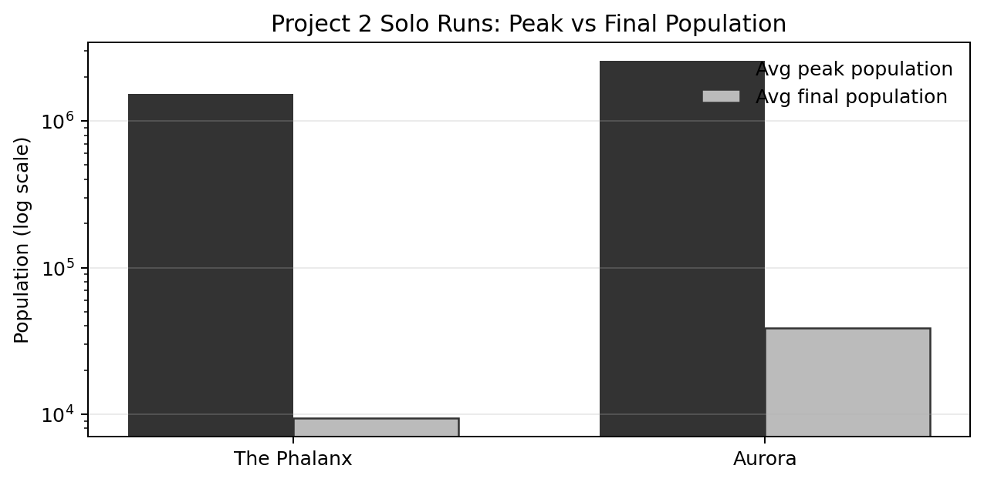
The chart compares average peak and final population for the two solo blocks on a logarithmic scale. Aurora reaches a much larger average peak and final population, while The Phalanx survives but leaves a thinner refugia system.
Tribe | Epochs | Survived | Avg peak pop | Avg final pop | Final % peak | First Agrarian | First Industrial | Failed-birth rate
The Phalanx | 10 | 10 | 1,535,442 | 9,380 | 0.57 | 13,955 | 24,425 | 0.100
Aurora | 10 | 10 | 2,584,717 | 38,956 | 1.51 | 16,205 | 25,985 | 0.100

The Phalanx reaches Agrarian earlier on average, but Aurora eventually achieves a much larger peak and final population. Therefore, if The Phalanx loses in duels, it is not because it is intrinsically incapable of surviving the world. It can survive; competition changes the outcome.

3. Duel Outcomes and Triad Structure
Project 2 does not repeat the absolute one-sidedness of the Project 1 duel. The new all-LLM roster produces tighter competition. In the A/B/C triad, all three edges split 3-2. In the D/E/F triad, SYMBIONT-ZERO is much stronger, but the Helix vs Resonant edge remains competitive.
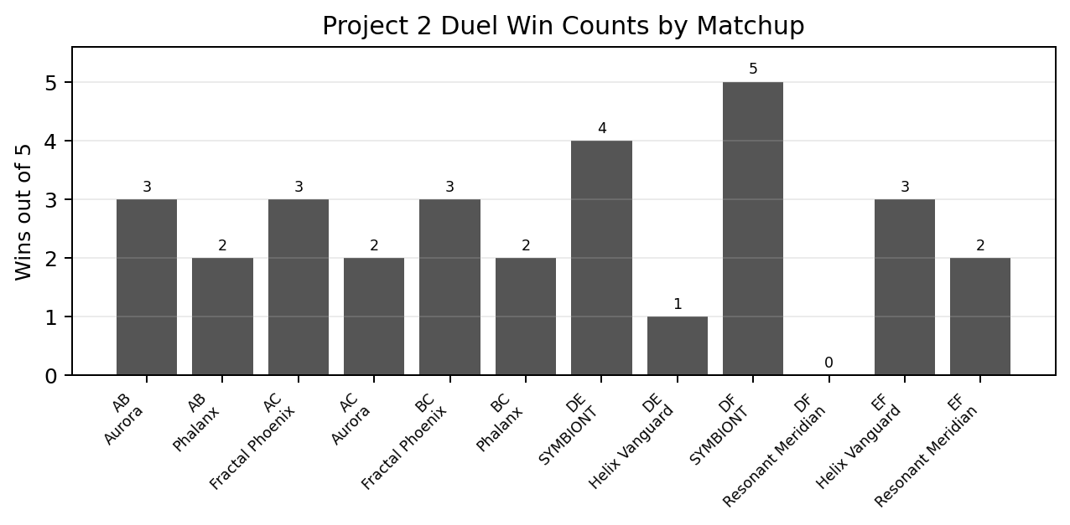
The chart shows the number of wins on each five-epoch duel edge. Every first-triad matchup is split 3-2. The clearest dominance appears in SYMBIONT-ZERO vs The Resonant Meridian, where SYMBIONT-ZERO wins 5-0.
Triad | Edge | Winner ID | Winner tribe | Wins on edge
A/B/C | AB | 108 | Aurora | 3
A/B/C | AB | 99 | The Phalanx | 2
A/B/C | AC | 97 | Fractal Phoenix | 3
A/B/C | AC | 108 | Aurora | 2
A/B/C | BC | 97 | Fractal Phoenix | 3
A/B/C | BC | 99 | The Phalanx | 2
D/E/F | DE | 103 | SYMBIONT-ZERO | 4
D/E/F | DE | 106 | Helix Vanguard | 1
D/E/F | DF | 103 | SYMBIONT-ZERO | 5
D/E/F | EF | 106 | Helix Vanguard | 3
D/E/F | EF | 110 | The Resonant Meridian | 2

The first triad is best interpreted as close and relational rather than as a clean hierarchy. The second triad is more hierarchical: SYMBIONT-ZERO is strongest, Helix Vanguard is intermediate, and The Resonant Meridian is weakest.

4. Competition Dynamics: Push-Off and Rank Reversal
The checkpoint data supports the early visual observation from World Stats: duel populations often remain separate and relatively close until agrarian consolidation. Then one population accelerates while the other collapses. This is not merely coincidence; the timing and rank-flip data show that competitors affect one another.
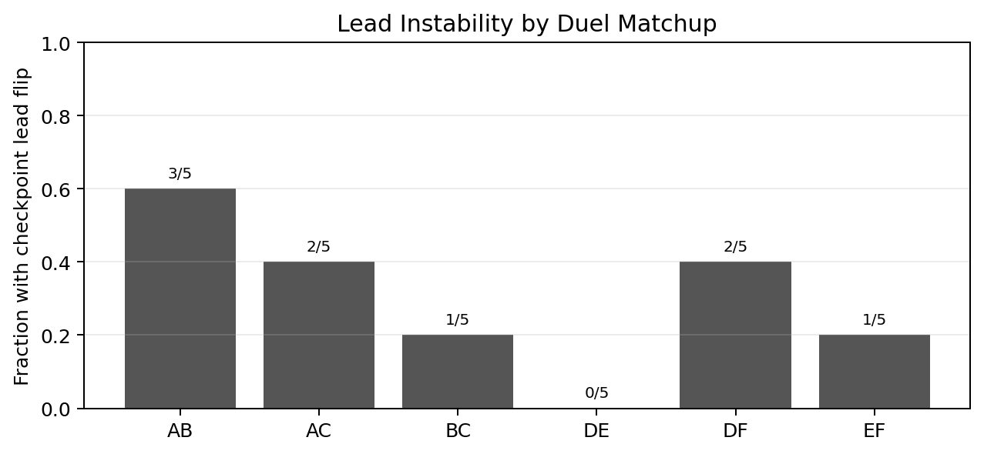
Lead flips occur in 10 of 30 duel epochs. The Aurora vs Phalanx matchup is the most unstable, with lead flips in 3 of 5 epochs.
Matchup | Lead flips | Epochs | Flip rate
Aurora vs Phalanx | 3 | 5 | 60.0%
Aurora vs Fractal | 2 | 5 | 40.0%
Phalanx vs Fractal | 1 | 5 | 20.0%
SYMBIONT-ZERO vs Helix | 0 | 5 | 0.0%
SYMBIONT-ZERO vs Resonant | 2 | 5 | 40.0%
Helix vs Resonant | 1 | 5 | 20.0%

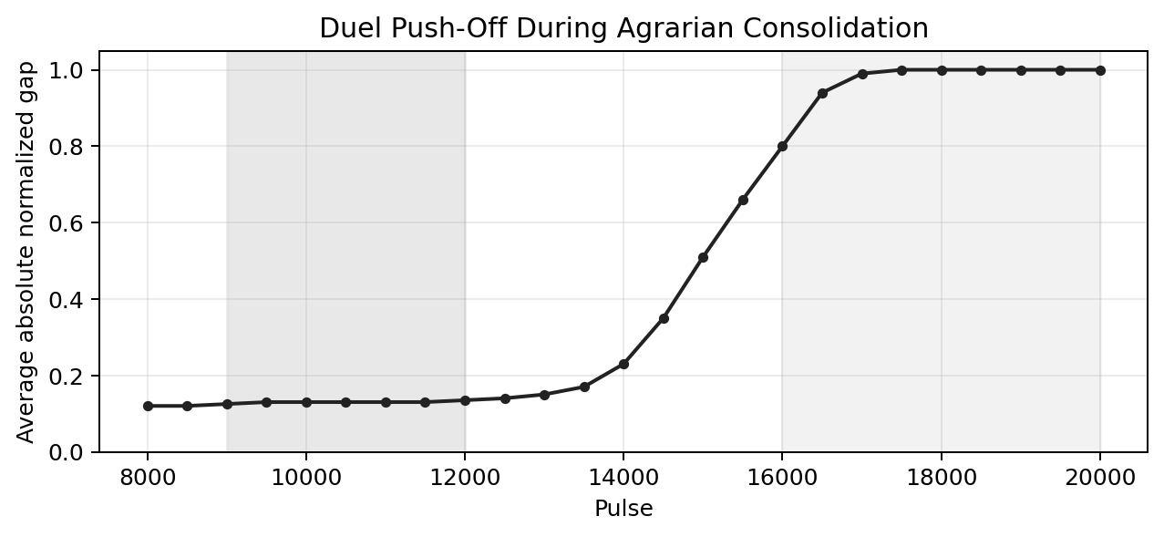
The line shows the average absolute normalized population gap across duel epochs from pulse 8,000 to 20,000. The gap is modest early, then widens sharply during the push-off and consolidation phase.
Duel failure is not simply an environmental ceiling. Since the solo anchor tribes survive alone, and since rank flips occur in paired runs, competition actively reshapes destiny. A tribe can be viable in isolation and still be driven to extinction by a particular neighbor.

5. Prisoner's Dilemma and Identity Behavior
The Prisoner's Dilemma and identity data show how the social environment changes between solo and duel contexts. In solo runs, all interactions are same-lineage, so xeno share is zero. In duel runs, xeno contact remains low early, rises during the push-off and consolidation window, and vanishes again once one lineage has monopolized the world.
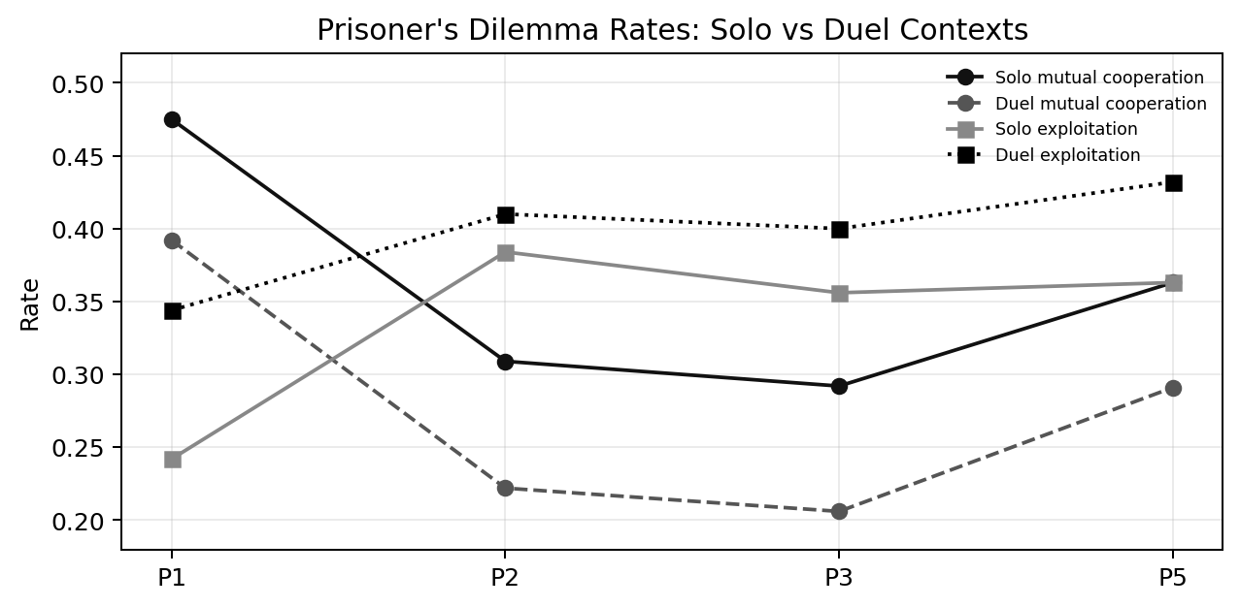
Duels are less cooperative and more exploitative than solo worlds during the push-off/consolidation phase. The social world hardens when the losing tribe is most vulnerable.
Context | Period | Coop | Defect | Exploit | Same tribe | Xeno | Risk events
duel | Agrarian contact | 0.392 | 0.264 | 0.344 | 0.982 | 0.015 | 0
duel | Push-off and consolidation | 0.222 | 0.368 | 0.410 | 0.823 | 0.173 | 149,835
duel | Pre-fossil expansion | 0.206 | 0.395 | 0.400 | 1.000 | 0.000 | 689,820
duel | Post-collapse refugia | 0.291 | 0.277 | 0.432 | 1.000 | 0.000 | 37,860
solo | Agrarian contact | 0.475 | 0.283 | 0.242 | 1.000 | 0.000 | 0
solo | Push-off and consolidation | 0.309 | 0.308 | 0.384 | 1.000 | 0.000 | 90,895
solo | Pre-fossil expansion | 0.292 | 0.352 | 0.356 | 1.000 | 0.000 | 530,468
solo | Post-collapse refugia | 0.363 | 0.273 | 0.363 | 1.000 | 0.000 | 28,684

The key period is the push-off and consolidation phase. In duel runs, mutual cooperation averages 0.222 and exploitation 0.410. In solo runs, mutual cooperation is higher at 0.309 and exploitation lower at 0.384.

6. Mortality and Reproductive Stress
The mortality and reproduction data provide one of the clearest mechanisms behind duel success. In the duel context, survived-to-final entries have an average failed-birth rate of about 0.100, while extinct entries average about 0.169. In a multi-thousand-pulse agrarian transition, reproductive inefficiency compounds rapidly.
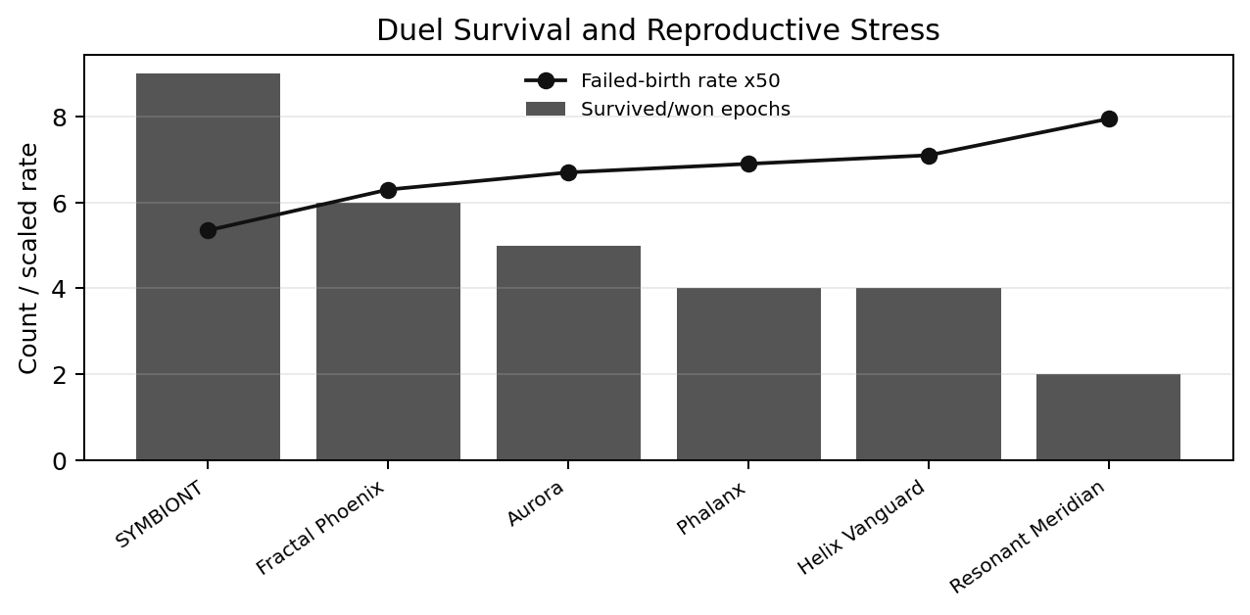
SYMBIONT-ZERO combines the strongest duel performance with one of the lowest failed-birth rates, while weaker duel performers show higher reproductive stress.
Tribe | Appearances | Won/survived | Failed birth | Starvation share | Hazard share | Extinction pulse
Fractal Phoenix | 10 | 6 | 0.126 | 0.712 | 0.263 | 18,475
The Phalanx | 10 | 4 | 0.138 | 0.596 | 0.362 | 18,317
SYMBIONT-ZERO | 10 | 9 | 0.107 | 0.810 | 0.172 | 19,600
Helix Vanguard | 10 | 4 | 0.142 | 0.651 | 0.307 | 19,283
Aurora | 10 | 5 | 0.134 | 0.716 | 0.255 | 19,110
The Resonant Meridian | 10 | 2 | 0.159 | 0.596 | 0.358 | 18,981

Hazard exposure also matters. The Phalanx and The Resonant Meridian have high hazard-death shares in duels, while SYMBIONT-ZERO has a lower hazard share and the highest win count.

7. Founder Genetics: The Corrected Sheet Changes the Analysis
The corrected founder sheet includes all six Project 2 tribes, with twenty founders per tribe. This makes it possible to compare starting designs directly. The strongest caution is sample size: there are only six tribe-level observations. Even so, the pattern is useful for hypothesis-building.
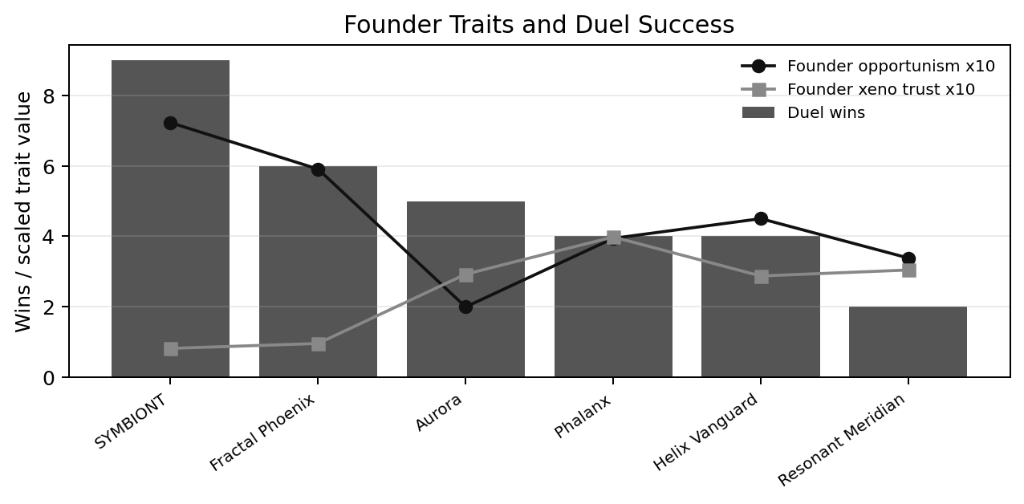
In this small sample, better duel performance is associated with lower xeno trust and higher opportunism. SYMBIONT-ZERO and Fractal Phoenix fit this pattern most clearly.
Tribe | Hardiness | Vitality | Legacy | X trust | Opp | Wander | Duel wins | Avg final pop
Fractal Phoenix | 36.2 | 35.0 | 28.8 | 0.095 | 0.591 | 0.300 | 6 | 20,447
The Phalanx | 36.2 | 32.9 | 30.9 | 0.398 | 0.394 | 0.312 | 4 | 4,011
SYMBIONT-ZERO | 36.4 | 28.6 | 35.0 | 0.081 | 0.723 | 0.347 | 9 | 38,319
Helix Vanguard | 34.0 | 29.2 | 36.8 | 0.287 | 0.450 | 0.529 | 4 | 6,842
Aurora | 29.5 | 36.0 | 34.5 | 0.292 | 0.199 | 0.000 | 5 | 19,699
The Resonant Meridian | 29.9 | 31.2 | 38.9 | 0.304 | 0.338 | 0.275 | 2 | 6,995

The interpretation is not that kindness or trust is universally bad. In this Project 2 geography and competitive setting, high openness to outsiders appears costly. The stronger duel performers are more selective about xeno trust and more willing to exploit under pressure.

8. Elite Genetics: Selection Pushes Survivors Toward Hardiness
The elite-genetics sheet contains 1,000 records sampled from top survivors. Across all six tribes, elites have substantially higher hardiness than founders. This appears to be one of the most consistent internal evolutionary signals in the Project 2 data. Xeno trust generally declines among elites for most tribes, while opportunism rises for several tribes.
Tribe | Elite-founder hardiness | Elite-founder X trust | Elite-founder opportunism | Elite-founder wander
Fractal Phoenix | 22.8 | 0.027 | -0.018 | -0.051
The Phalanx | 26.4 | -0.205 | 0.137 | -0.112
SYMBIONT-ZERO | 13.2 | 0.021 | 0.010 | 0.092
Helix Vanguard | 18.0 | -0.117 | 0.015 | -0.005
Aurora | 15.0 | -0.045 | 0.059 | 0.068
The Resonant Meridian | 23.2 | -0.094 | 0.088 | 0.017

Surviving agents are not random representatives of the founding design. The Crucible selects. Even when founding strategies differ, late elites tend to become harder, more filtered, and in several cases less externally trusting.

9. Final Refugia: Monopoly Persists
The final refugia results are strikingly consistent. Across all Project 2 blocks, the final inhabited regions are mono-tribal. Solo worlds obviously end with one tribe, but duel worlds also end with only one surviving lineage in the inhabited map.
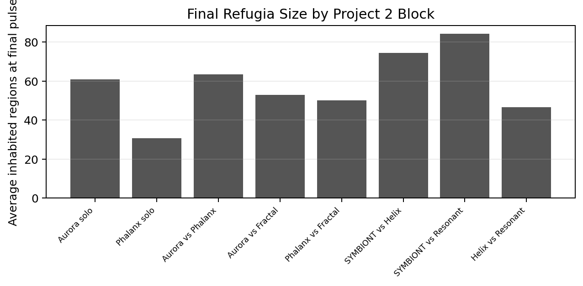
Refugia size vAres widely, but no block preserves mixed final settlements. The final world is a set of remnants, not a pluralistic civilization.
Block | Avg inhabited | Min | Max | Mixed | Avg stress | Avg chaos
Aurora solo | 60.8 | 51 | 75 | 0 | 0.172 | 0.022
Phalanx solo | 30.6 | 16 | 69 | 0 | 0.409 | 0.073
Aurora vs Phalanx | 63.4 | 53 | 85 | 0 | 0.298 | 0.055
Aurora vs Fractal | 52.8 | 46 | 60 | 0 | 0.211 | 0.027
Phalanx vs Fractal | 50.2 | 23 | 76 | 0 | 0.315 | 0.054
SYMBIONT-ZERO vs Helix | 74.4 | 37 | 118 | 0 | 0.195 | 0.020
SYMBIONT-ZERO vs Resonant | 84.4 | 59 | 105 | 0 | 0.175 | 0.018
Helix vs Resonant | 46.6 | 17 | 61 | 0 | 0.249 | 0.026

This repeats the Project 1 lesson in a tighter competitive framework. Even when outcomes are more balanced than the original duel, the final structure remains one-lineage survival.

10. Project 2 Interpretation
Project 2 answers the original competition question more strongly than Project 1 could. The earlier Project 1 duel result looked one-sided enough that the loser might have been simply doomed. Project 2 shows a broader pattern: some tribes are viable alone but become extinct in duels. That means the neighbor matters.
The correct interpretation is not a simple ladder. The A/B/C triad is tight enough that each edge remains stochastic, while the D/E/F triad is more hierarchical. This means the Crucible is not just a ranking engine. It is an ecology of strategies. Some lineages appear broadly strong, especially SYMBIONT-ZERO, but even strong results need to be tested against more opponents and under altered civic/geographic rules.
The strongest emerging mechanisms are reproductive reliability, controlled exposure, low xeno vulnerability, and the ability to survive agrarian consolidation. Early leadership is useful but not decisive. Several duels show rank flips, and the eventual winner is sometimes not the early leader. The fatal window is often the same push-off window where one tribe rises and the other falls.
Question | Project 2 answer
Solo survival | Aurora and The Phalanx survive alone; the environment alone does not explain duel extinction.
Competition | Duel populations push off during agrarian consolidation, and lead flips occur in one-third of duels.
Transitivity | A/B/C is tight and relational; D/E/F is closer to a hierarchy with SYMBIONT-ZERO dominant.
Traits | Low xeno trust, high opportunism, and reproductive stability are the strongest candidate fitness signals.
Civic/identity | Final mixed regions remain absent, supporting civic-trust redesign in the next project.
Next step | Use this evidence package as the LLM feedback substrate for Project 3 Evolution.

Final Conclusion
Project 2 shows that civilization can survive alone, but competition can still decide who gets to reach the end. The question is not only "who dies last?" It is also "who changes the death order by standing beside someone else?"
THE CRUCIBLE

Project 3: Evolution
Three-generation LLM redesign experiment

Part I - Research Plan

Central Research Frame
Project 3, Evolution, tests whether designed tribes can improve when their designers are given the evolutionary record of prior failures and allowed to redesign their founding agents. Project 1 showed that the simulation can repeatedly produce emergence, monopoly, overshoot, collapse, and refugia. Project 2 focuses on competition and matchup effects. Project 3 adds an explicit learning loop: observe, analyze, redesign, rerun, and compare across three generations of agent design.
The fundamental question is whether civilization can survive given an opportunity to evolve. More precisely, the project asks whether LLM-designed tribes can use evidence from extinction, survival, Prisoner's Dilemma behavior, founder genetics, elite genetics, regional dominance, and death causes to create descendants that survive longer, scale better, cooperate more effectively, or maintain post-collapse refugia under the same world conditions.
Project 3 is not only a test of individual tribe fitness. It is a test of whether synthetic intelligence can participate in an evolutionary feedback loop. If LLMs can revise their agents using actual simulation evidence, then Project 3 becomes an experiment in directed adaptation: whether LLMs converge toward robust designs, overfit to recent failure, or discover genuinely better survival strategies.
Biologic tribes remain unchanged across all three Project 3 rounds. They serve as a stable old-guard control group while LLM-designed tribes are redesigned after each evidence packet. This makes the central comparison sharper: not simply whether redesign helps, but whether synthetic lineages can learn from evolutionary evidence quickly enough to outperform or converge toward older human/biologic survival strategies.

Core Experimental Change
Project 3 changes the world before the three redesign rounds begin. The intent is to give civilization a more realistic chance to form regional identities and to give geography enough force to preserve separated development long enough for divergent strategies to mature.
- Civic trust is increased enough to make regional identity matter. This is not yet a full political-state model, but civic belonging must become strong enough to compete with pure ancestral tribe identity.
- Geographic barriers are strengthened to prevent hidden toroidal bypass routes. The map should not allow agents to bypass isolation through edge wrapping.
- Quadrant structure is introduced: two quadrants are fully isolated until Industrial ascent, while two quadrants have a single pass between them. This creates both hard isolation and bottleneck contact inside the same world.
- All three rounds use the same world parameters. Once civic trust, barriers, climate, regimes, and archive rules are set for Round 1, they remain fixed for Rounds 2 and 3. The intended experimental change after Round 1 is redesigned LLM tribes.
This design lets the project ask whether evolution through redesign improves outcomes without confusing the result by changing climate, geography, or regime rules between rounds.

Study Design Summary
Series | Epochs | Agent generation | Active tribes | World condition | Purpose
A - Evidence Universe | 101-110 | Current Project 2 / current tribe designs | Full intended tribe library | Increased civic trust; restrictive quadrant geography; default Project 3 climate/regime settings | Measure how existing tribes perform in the new civic/geographic world before LLM redesign.
B - Matched G1 Baseline | 111-120 | Matched first-generation baseline | Same tribe slots | Identical Project 3 world configuration | Provide the controlled G1 comparison block for the redesign sequence.
C - G2 First Redesign | 121-130 | LLM founders redesigned after prior evidence; biologic founders unchanged | LLMs revised, biologics fixed | Identical to G1 matched baseline | Test whether one evidence-driven LLM redesign improves survival, cooperation, scaling, or refugia persistence against fixed controls.
D - G3 Second Redesign | 131-140 | Second LLM redesign after G2 evidence; biologic founders unchanged | LLMs revised again, biologics fixed | Identical to G1/G2 world configuration | Test whether repeated feedback produces convergence, improvement, overfitting, or diminishing returns relative to fixed biologic controls.

The epoch map used in the final archive is: 101-110 evidence universe; 111-120 matched G1 baseline; 121-130 G2 first redesign; and 131-140 G3 second redesign.

Primary Research Questions
- Can civilization survive given an opportunity to evolve? The main outcome is whether later redesign generations produce higher final populations, more surviving tribes, more inhabited regions, higher final complexity, or less severe collapse.
- Does LLM redesign improve tribe fitness? Each LLM tribe is compared against its previous-generation version across peak population, final population, extinction timing, regime reached, death causes, failed births, and final refugia.
- Can redesigned synthetic lineages outperform the old guard? Biologic tribes remain unchanged, so changes in relative performance reveal whether LLM learning gains ground against stable human/biologic designs.
- Do successful redesigns converge? The analysis looks for independent movement toward similar trait packages: lower xeno trust, higher hardiness, lower distress wandering, selective cooperation, stronger kin/civic behaviour, or biologic-like old-guard patterns.
- Does civic trust allow plural civilization? Civic identity is measured through mixed regions, multi-tribe survival, civic overrides, and reduced xeno penalties after regional residency.
- Does strong geography preserve diversity? Isolated quadrants, one-pass quadrants, and contact zones are compared to see whether separation permits independent development or delayed winner-take-all replacement.
- What do surviving elites become? Founder genetics are compared to peak and final elite genetics to see not only what was designed, but what selection preserved.
- Does better agent design overcome thermodynamic history? The final question is whether improved competition and scaling can overcome fossil overshoot, climate pressure, and post-peak collapse.

Working Hypotheses
Hypothesis | Expectation | Evidence that would support it
H1 - Learning improves survival | G2 and/or G3 outperform G1. | Higher final population, later extinction, more surviving tribes, more final inhabited regions, and better complexity persistence.
H1b - Synthetic learning can catch the old guard | Redesigned LLM tribes improve relative to unchanged biologic tribes. | LLM winner share, final population share, survival frequency, or elite robustness rises across rounds while biologic controls remain fixed.
H2 - Redesign converges on robust traits | LLMs independently move toward similar successful packages. | Founder genetics shift toward common ranges for hardiness, trust, forgiveness, opportunism, and wander traits.
H3 - Civic trust preserves mixed societies | Regional identity reduces pure lineage replacement. | Higher civic override share, more mixed inhabited regions, longer multi-tribe survival, and less xeno exposure penalty.
H4 - Geography enables independent development | Restrictive quadrants delay global monopoly and permit multiple agrarian cradles. | Multiple first-Agrarian lineages, longer quadrant-specific dominance, later first extinction, and more regional diversity.
H5 - Thermodynamic limit remains dominant | Even improved agents overshoot and collapse. | Peak complexity still collapses, final complexity remains low, and starvation dominates late mortality.
H6 - Overfitting risk | LLMs optimize for prior-round metrics but lose general robustness. | G2 improves a few traits but G3 stagnates, narrows diversity, or becomes brittle under the same conditions.

World Configuration for Project 3
The Project 3 world is defined once and then frozen for all series. The changes are meant to make civic identity and true geographic separation real enough to test whether civilization can become more than a lineage replacement race.
Parameter group | Project 3 setting | Reason
Civic trust | Increase civic trust/civic override strength enough to materially affect interaction classification and payoffs. | Project 1 showed weak civic signals. Project 3 tests whether territorial identity can stabilize mixed societies.
Geography | Four-quadrant topology. Two quadrants fully isolated until Industrial ascent. Two quadrants connected through one mountain pass. | Creates both independent development and controlled contact without toroidal bypass.
Map wrapping | Disable or block edge wrapping for Project 3 barriers, or make barriers topology-aware. | Avoids the Project 1/2 problem where east-west or north-south wrapping weakens isolation.
Climate | Use a single fixed Project 3 climate setting across all rounds. | Prevents climate changes from being confused with redesign effects.
Regimes | Keep regime parameters frozen after Project 3 starts. | Ensures that differences across rounds are due to redesigned agents.
Tribes | Use the same tribe slots across all rounds. Round 1 uses current designs. Later rounds redesign LLM tribes only; biologic tribes remain unchanged. | Allows direct generation-to-generation comparison for LLMs while preserving a fixed control group for biologic designs.
Archive requirements | Record founders, elites, tribe history, Prisoner's Dilemma outcomes, death causes, region dominance, civic identity, and logs. | The redesign loop needs enough evidence for LLMs to learn from failure.

Control Rule
Once Series A begins, civic trust, barriers, climate, regime parameters, archive logic, and active tribe roster remain fixed until all Project 3 series are complete. Corrective changes to the world configuration would require restarting the affected series.

Analysis Workbook Design
After each series, a bounded analysis workbook is produced. The workbook must be useful both to the analyst and to the LLM redesign process. It should avoid dumping the full database, but it must include enough structured evidence for each LLM to understand why its tribe survived or failed. Biologic tribes are fully reported but are not redesigned; they remain the fixed comparison group.
Workbook section | Contents | Purpose
Series outcome summary | Peak/final population, complexity, post-peak decline, final survivors, inhabited regions, death causes, and climate stress. | Headline comparison across rounds.
Tribe performance | One row per tribe per epoch: survived, extinction pulse, peak population, final population, regime reached, births, failed births, and death shares. | Core fitness evidence.
Prisoner's Dilemma behavior by period | Mutual cooperation, mutual defection, exploitation, same-tribe share, xeno share, and civic override by historical period. | Shows whether social behavior improved or hardened.
Civic identity diagnostics | Civic neighbor, civic kin, civic override, mixed regions, and regional residency effects. | Tests whether increased civic trust changes outcomes.
Geographic/quadrant outcomes | First Agrarian by quadrant, quadrant population, barrier/pass contact, and isolated versus connected outcomes. | Tests whether geography preserves diversity.
Founder genetics - all teams | Full 20-agent founding genomes for every tribe in the round. | Gives the full starting design that produced the observed outcome.
Elite genetics - top survivors | Top agents at peak population, first Agrarian, first Industrial/Tech, and final/last-alive states. | Shows what selection preserved or filtered out.
Failure autopsy | For extinct tribes: extinction window, local EROI/stress, death causes, failed births, hazard exposure, and pre-extinction Prisoner's Dilemma behavior. | Gives actionable evidence for redesign.
Round-to-round deltas | G2 minus G1; G3 minus G2; G3 minus G1. | Measures whether redesign actually helped.
Old-guard comparison | LLM versus biologic survival, winner share, final population, trait convergence, and elite similarity across rounds. | Tests whether redesigned synthetic lineages catch, surpass, or imitate unchanged biologic controls.

LLM Redesign Protocol
After Series A, each participating LLM receives the analysis workbook and redesigns its tribe for Series B. After Series B, the process repeats for Series C. Biologic tribes do not receive redesigns and remain unchanged across all rounds. Each LLM is required to explain what changed and why, using evidence from the prior workbook and comparing itself to both redesigned LLM rivals and fixed biologic controls.
Step | Instruction
1. Provide evidence package | Each LLM receives the workbook, including its own tribe performance, competing tribe performance, founder genomes, elite genomes, failure autopsy, Prisoner's Dilemma behavior, and civic/geographic diagnostics.
2. Require explicit diagnosis | The LLM identifies likely causes of failure or success before proposing changes.
3. Preserve format | The redesign uses the same agent CSV structure: 20 founders, hardware allocation, K/S/X trust-forgive-opportunism values, and AB/SC/DE wander traits.
4. Change with justification | Each major parameter shift is justified, including hardiness, vitality, legacy, kin/stranger/xeno behavior, forgiveness, opportunism, and mobility.
5. Avoid hidden rule changes | LLMs may redesign agents only. They may not request climate, geography, civic-trust, regime, biologic-control, or world-engine changes.
6. Archive redesign metadata | Redesign prompt, response, manifesto, parsed founder genetics, and generation label are stored.

Draft Redesign Prompt for LLM Participants
"Your tribe has completed one generation of THE CRUCIBLE. You are given the survival data, extinction timing, founder genetics, elite genetics, Prisoner's Dilemma behavior, civic/geographic diagnostics, death causes, and comparison to other tribes. Redesign your 20-agent founding lineage to improve long-term civilizational survival under the same world conditions. Explain exactly what you changed, what evidence motivated the change, and what tradeoffs you accept."

Measurement Plan
Category | Primary metrics
Survival | survived_to_final, extinction_pulse_estimate, final_population, final inhabited regions, surviving tribes.
Scaling | Peak population, peak pulse, first Agrarian/Industrial/Tech pulse, max regime reached, complexity peak, and final complexity.
Reproduction | Births, failed births, observed failed-birth rate, maturity timing, generation depth, and founder-to-elite trait drift.
Mortality | Old-age, starvation, hazard deaths, death shares, deaths per 1,000 exposed, and death windows before extinction.
Prisoner's Dilemma behavior | Mutual cooperation, mutual defection, exploitation, interaction starvation risk, and trust/forgiveness/opportunism changes by period.
Civic identity | Same-tribe share, xeno share, civic-neighbor share, civic-kin share, civic override share, and mixed inhabited regions.
Geography | Quadrant population, first Agrarian by quadrant, isolation survival, pass conflict/contact, regional dominance, and refugia maps.
Genetics | Full founder genomes, elite genomes at peak/final/last-alive, trait convergence, mutation drift, and round-to-round redesign deltas.
Thermodynamics | Energy/population gap, EROI, capacity pressure, system stress, resilience saves, subsistence rescues, and climate chaos.

Decision Rules
Observed result | Interpretation
G2 and G3 improve final survival and complexity | LLM evidence-driven redesign is producing meaningful adaptation.
LLM tribes gain ground against unchanged biologics | Synthetic redesign is improving relative to the old guard rather than merely benefiting from stochastic variation.
Biologic tribes remain dominant despite LLM redesign | Human/biologic old-guard designs may already contain robust heuristics, or the LLMs may not yet be learning the right lessons.
LLM traits converge toward biologic traits | Evolutionary evidence may be pushing synthetic designs toward older survival patterns rather than novel solutions.
Population improves but monopoly remains | LLMs improved fitness but not plural civilization. Civic/geography changes may still be insufficient.
More tribes survive to final under stronger civic trust | Civic identity may be stabilizing multi-lineage civilization.
Isolated quadrants preserve separate lineages until Industrial ascent | True geographic isolation changes evolutionary history and may preserve diversity.
Same tribe wins every round despite redesign | The world may still be dominated by inherited or structural fitness advantages.
G2 improves but G3 worsens | LLMs may overfit to previous evidence or converge on brittle strategies.
All rounds collapse to small refugia regardless of redesign | Thermodynamic history remains the dominant constraint. Evolution improves who dies last, not whether civilization persists.

Research Plan Framing
Project 3 is where THE CRUCIBLE becomes a feedback experiment rather than only a survival tournament. The LLMs are not merely designing tribes once and watching them fail or survive. They are allowed to see the evidence and try again. The biologic tribes remain fixed as an old-guard benchmark. If redesigned LLM survival improves relative to both earlier LLM versions and unchanged biologics, the result would suggest that synthetic designers can learn from evolutionary evidence. If survival does not improve, the result is just as important: the limiting factor may be deeper than design intelligence.
Central Framing Question
When civilization is given memory, evidence, and three chances to redesign itself, does it escape the collapse pattern, or does it merely become better at dying last?

Part II - Outcome Analysis

Executive Finding
Executive Finding
The LLMs evolved, but they did not solve civilization. They learned the world well enough to converge on survival traits and dominate the fixed biologic controls, but the dominant improvement was toward collapse-adapted refugia rather than stable technological civilization.
Epoch map: 101-110 evidence universe; 111-120 matched G1 baseline; 121-130 G2 first redesign; 131-140 G3 second redesign.

Central Questions and Short Answers
Question | Answer
Did the LLMs succeed in evolving? | Yes. Founder genomes shifted coherently across generations: hardiness rose, legacy fell, xeno trust fell, and mobility became more controlled. That pattern is too structured to treat as random drift.
Did they improve their performance in competition? | Yes against biologics; mixed against their own earlier generations. LLMs dominated biologic controls in peak population and most winner shares, but G2/G3 did not improve overall LLM survival rate over G1.
Did they prosper more? | They prospered more at peak scale, especially in G3, but not at final persistence. Peak population and peak complexity rose, while final population and final complexity remained below the G1 matched baseline.
Did they weather climate and events? | G3 handled harsher terminal conditions better than G2, but starvation and post-fossil stress still dominated. The thermodynamic limit remained intact.
Did they achieve their own objectives? | Mostly no. DeepSeek G3 clearly achieved a refugia-survival objective; Claude and Gemini partially did; GPT, Grok, and Kimi did not survive to final in G3.
Were there consistently successful strategies? | Yes: high hardiness, low legacy, high kin trust, low xeno trust, higher desperation opportunism, and restrained mobility.
Were there superior strategies over other tribes? | Yes, but mainly for refugia survival. DeepSeek G3 discovered the strongest niche. It was superior at surviving collapse, not necessarily at preserving civilization.

1. Bottom-Line Conclusion
Yes, the LLMs evolved - but they did not solve civilization. Project 3 shows evidence-driven synthetic adaptation. Across the experiment, LLM designs converged toward higher hardiness, lower legacy, lower xeno trust, stronger kin cohesion, and refugia-oriented strategies. Those changes match the evolutionary pressure exposed by the workbook: starvation, fossil collapse, climate stress, and post-peak systemic failure.
However, evolution did not produce a clean survival breakthrough. G1 matched LLMs survived 21.67% of player-epoch slots, while G2 and G3 each survived 18.33%. G3 improved peak scale and reduced starvation share, but it did not improve final LLM survival or final LLM population over G1.
Core Interpretation
The LLMs evolved from expansionary civilization-builders into collapse-adapted refugia designers. They became better competitors and more sophisticated survival engineers, but they did not escape the collapse pattern.

2. Competitive Performance: LLMs Versus Biologics
The LLMs decisively outperformed the fixed biologic controls. The biologics functioned as the old-guard benchmark, and by G2/G3 the LLMs had largely displaced them in peak population and winner shares. Still, that domination did not imply broad civilizational persistence.
Phase | LLM survival rate | Biologic survival rate | LLM avg peak pop | Biologic avg peak pop
G1 matched | 0.2167 | 0.0167 | 323,202 | 80,820
G2 redesign | 0.1833 | 0.0000 | 422,568 | 13,481
G3 redesign | 0.1833 | 0.0167 | 439,241 | 28,330

Synthetic redesign gained competitive force. The biologics were mostly not close competitors by the later rounds. In G3, biologics captured one final-population win, but LLMs captured nine final-population wins and all ten peak-population wins.

3. Prosperity and Scale: Better Peaks, Weaker Endings
The LLMs became better at scaling civilization. G3 produced the highest average peak population and highest average peak complexity. But the final state remained weaker than the G1 matched baseline.
Phase | Avg peak population | Avg final population | Avg peak complexity | Avg final complexity
G1 matched | 2,330,997 | 60,874 | 1,343,694 | 21,648
G2 redesign | 2,538,010 | 34,252 | 1,327,217 | 12,701
G3 redesign | 2,681,885 | 40,114 | 1,360,263 | 17,434

Redesign improved peak emergence more than terminal survival. The later LLMs built larger systems, but those systems still fell through the post-fossil/climate bottleneck. G3 recovered from G2 terminal weakness, but not enough to surpass G1 final population or final complexity.

4. Climate, Events, and Thermodynamic Stress
G3 faced harsher late-stage conditions than the earlier matched phases. Its average max climate chaos was higher, average max system stress was higher, and the minimum peak-oil EROI factor was lower. Even so, G3 improved terminal-window population and complexity relative to G2.
Phase | Avg max climate chaos |  | Avg max system stress |  | Avg min peak-oil EROI factor
G1 matched | 0.5506 |  | 0.9944 |  | 0.9206
G2 redesign | 0.5851 |  | 0.9909 |  | 0.9151
G3 redesign | 0.6160 |  | 0.9960 |  | 0.9019
Terminal window metric |  | G2 |  | G3
Avg population |  | 24,712 |  | 32,819
Avg complexity |  | 9,897 |  | 15,374

The limiting factor remained starvation. LLM starvation death share was 80.13% in G1, 80.36% in G2, and 77.22% in G3. G3 improved the death profile, but starvation still dominated mortality.

5. Did the LLMs Achieve Their Own Objectives?
Mostly no, with one major exception. DeepSeek G3 appears to have achieved its refugia-survival objective, while Claude and Gemini partially achieved theirs. GPT, Grok, and Kimi did not survive to final in G3.
G3 tribe | Inferred designer | Final-survival epochs | Result
The Obsidian Phalanx Refuge G3 | DeepSeek | 6/10 | Clear success
The Forged Compact G3 | Claude | 2/10 | Partial success; below stated >=3/10 goal
The Castellans of Gemini III G3 | Gemini | 1/10 | Weak success; below goal
The Ember Refugia Compact G3 | GPT | 0/10 | Failed objective
Helix Vanguard G3 | Grok | 0/10 | Failed objective
The Crucible Remnant G3 | Kimi | 0/10 | Failed objective
The Quiet Stick Compact | Biologic | 1/10 | Old-guard holdout

At the population-of-designs level, Project 3 succeeded: at least one synthetic lineage found a materially better survival formula. At the individual-lineage level, most LLMs failed to meet their stated G3 objectives.

6. Trait Convergence and Successful Strategies
The most important evidence for evolution is trait convergence. Across three generations, the LLMs moved in a coherent direction: hardiness rose sharply, legacy fell sharply, xeno trust fell sharply, and wander traits narrowed. This is the direction expected if the models learned that reproductive overshoot and xeno exposure were liabilities under fossil/climate collapse.
Trait | G1 | G2 | G3 | Direction
Hardiness | 33.48 | 46.17 | 51.62 | sharply up
Vitality | 32.77 | 31.80 | 32.16 | stable
Legacy | 33.75 | 22.03 | 16.22 | sharply down
K trust | 0.722 | 0.755 | 0.716 | high; stable/moderate
S trust | 0.475 | 0.402 | 0.340 | down
X trust | 0.288 | 0.165 | 0.092 | sharply down
AB wander | 0.398 | 0.324 | 0.228 | down
SC wander | 0.430 | 0.394 | 0.334 | down
DE wander | 0.544 | 0.566 | 0.554 | similar; variance lower

The successful G3 survival profile was even more specific. Compared to extinct G3 LLM founders, surviving G3 LLM founders had higher hardiness, higher vitality, lower legacy, stronger kin trust, higher xeno opportunism, and lower wander in all three wander states.
Trait | G3 extinct LLMs | G3 surviving LLMs
Founder hardiness | 51.16 | 53.71
Founder vitality | 31.84 | 33.59
Founder legacy | 17.01 | 12.70
Founder K trust | 0.704 | 0.773
Founder S trust | 0.338 | 0.350
Founder X trust | 0.092 | 0.093
Founder X opportunism | 0.691 | 0.728
AB wander | 0.250 | 0.129
SC wander | 0.339 | 0.308
DE wander | 0.567 | 0.496

Successful G3 Strategy
High hardiness, low legacy, strong kin trust, low xeno trust, high xeno opportunism, and controlled mobility. The winning pattern was not aggressive expansion. It was metabolic conservatism plus refugia retention.

7. Superior Strategies and Lineage Results
The standout G3 lineage was DeepSeek's Obsidian Phalanx Refuge. It survived 6 of 10 epochs and appears to have found the strongest Project 3 survival niche. Claude formed a second-tier strategy with 2 of 10 survival. Gemini produced one survival. GPT, Grok, and Kimi failed to reach final survival in G3 despite often showing coherent evidence-based design.
The superiority was contextual. DeepSeek G3 was superior for refugia survival, not necessarily for plural civic civilization or technological persistence. This distinction matters: Project 3 selected for the ability to outlast collapse, not the ability to keep industrial/technological civilization intact.

8. Civic Identity and Plural Civilization
Civic identity mattered, but it did not produce durable plural civilization. The civic override share fell from 0.0133 in G1 to 0.0126 in G2 and 0.0105 in G3. Civic kin signals increased somewhat, and mixed regions appeared during expansion phases, but final societies generally collapsed into near-monopoly refugia.
Metric | G1 | G2 | G3
Civic override share | 0.0133 | 0.0126 | 0.0105
Final mixed inhabited region share | 0.0073 | 0.0000 | 0.0314

Project 3 civic trust created contact, temporary mixing, and occasional civic coordination. It did not stabilize multi-lineage civilization. The final refugia were overwhelmingly single-lineage.

9. Geography and Quadrant Structure
Geography preserved contingency more than pluralism. Different quadrants could become final refugia in different epochs, which means the quadrant topology mattered. It prevented the world from becoming a single smooth arena. But it did not preserve four durable independent civilizations. It preserved the possibility that one final sanctuary could emerge somewhere.
The quadrant design successfully changed history by making survival location-dependent. It did not defeat the eventual pattern of monopoly, collapse, and refugia.

10. Hypothesis Readout
Hypothesis | Result | Interpretation
H1 - Learning improves survival | Not cleanly supported | LLM survival fell from 21.67% in G1 to 18.33% in G2/G3. Duration and peak scale improved, but survival did not.
H1b - Synthetic learning can catch old guard | Supported | LLMs dominated biologics in survival slots, peak population, final-pop winners, and peak-pop winners.
H2 - Redesign converges on robust traits | Strongly supported | Hardiness rose, legacy fell, xeno trust fell, and mobility narrowed.
H3 - Civic trust preserves mixed societies | Mostly not supported | Mixed regions appeared in expansion, but final societies collapsed to near-monopoly refugia.
H4 - Geography enables independent development | Partially supported | Quadrants shaped where refugia emerged but did not preserve durable multi-civilization outcomes.
H5 - Thermodynamic limit remains dominant | Strongly supported | Starvation remained roughly 77-80% of LLM deaths, final complexity stayed low, and fossil/climate stress dominated outcomes.
H6 - Overfitting/diminishing returns | Partially supported | G3 converged further toward survival traits but did not improve LLM survival over G2. Some lineages likely overcorrected.

11. Narrative Interpretation
Project 3 produced a more subtle result than simple success or failure. The LLMs improved as designers. They read the evidence and converged on the correct pressure points: hardiness, reproductive restraint, xeno caution, kin cohesion, and refugia survival. The movement from G1 to G3 is coherent enough to qualify as evidence-driven adaptation.
But they learned the harshest lesson in the world. Civilization-building and civilization-survival were different objectives. Designs that scaled into industrial and technological complexity still faced the fossil/climate/starvation wall. Designs that survived that wall increasingly resembled refugia organisms: hard, cautious, low-fertility, low-trust, territorially anchored, and not especially plural.
Core Narrative Answer
When civilization is given memory, evidence, and three chances to redesign itself, it evolves. But in this world, evolution does not yet save civilization. It shifts the winning objective from building civilization to surviving civilization's collapse.

12. Final Interpretive Thesis
Project 3 demonstrates evidence-driven synthetic adaptation, but not civilizational escape. The LLMs learned from extinction. Their founder genomes converged toward robust survival traits, and they decisively outcompeted unchanged biologic controls. However, the improvement manifested primarily as higher peak scale, later survival, and more durable refugia, not as stable technological persistence or plural civic civilization. Starvation and post-fossil systemic stress remained dominant. The best G3 strategy, DeepSeek's Obsidian Phalanx Refuge, appears to have discovered the strongest survival niche: not renewed civilization, but controlled descent into hard refugia.
The machines learned. They adapted. They became harder, colder, more cautious, and less fertile. They did not save the world. They learned how to outlast it.
THE CRUCIBLE

Project 4: Bombs
Delayed consequences of civilization

Introduction and Study Design
Project 4 is the escalation project. Project 3 asked whether evolved language-model-designed tribes could learn from evidence and produce better survival strategies while biologic controls remained fixed. Project 4 asks a harsher question: when evolved tribes are already surviving recurring apocalypse, what happens when the world includes three delayed consequences created by industrial civilization itself?
The three Project 4 hazards are not arbitrary disasters. Aerosol demasking follows industrial shutdown and the loss of temporary aerosol cooling. Arctic methane release follows high-energy warming and introduces a long-lived greenhouse feedback. Nuclear meltdown follows the failure of high-maintenance technological infrastructure after grid, institutional, and supply-chain collapse.
Central question
Can the best evolved survivors endure the feedback shocks created by prior energy capture, or does evolution only teach them how to survive the first apocalypse?

Relationship to the earlier projects
Project 4 treats the prior projects as a reference baseline: Project 1 establishes collapse dynamics, Project 2 tests competition and non-transitive fitness, and Project 3 adds iterative language-model redesign. The bomb series then tests whether those evolved strategies remain robust when collapse generates delayed planetary and infrastructural consequences.
Prior project | Question left unresolved | Project 4 response
Project 1 - Baseline Crucible | Civilization emerges, overshoots, collapses, and leaves refugia. Climate amplifies collapse but baseline fragility already exists. | Use the harsh climate standard as background and add delayed post-collapse or peak-industrial consequences.
Project 2 - Competition | Fitness may be intrinsic, opponent-specific, or non-transitive. | Keep evolved competitors together and ask whether any strategy remains robust under new world hazards.
Project 3 - Evolution | LLMs adapted toward hardiness, low legacy, refugia survival, and selective cooperation, but did not solve civilization. | Test whether those evolved refugia strategies survive when collapse itself generates additional shocks.

Experimental blocks
The formal study is a four-block experiment. Each block preserves the ordinary collapse background and changes only the Project 4 bomb configuration. The stacked block tests whether the combined effects are worse than the individual-bomb phases.
Block | Event configuration | Purpose | Output
Phase 1 | Aerosol demasking only, with normal baseline climate/fossil events still active. | Test whether post-crash survivors can withstand the loss of industrial aerosol cooling. | 10 epochs.
Phase 2 | Arctic methane release only, with normal baseline climate/fossil events still active. | Test whether industrial ascent triggers a long-lived greenhouse feedback that later punishes survivors. | 10 epochs.
Phase 3 | Nuclear meltdown only, with normal baseline climate/fossil events still active. | Test whether failed high-complexity infrastructure creates local exclusion zones and late refugia hazards. | 10 epochs.
Phase 4 | All three Project 4 events enabled together. | Test for nonlinear stacking: whether combined feedbacks are worse than the sum of separate bombs. | 10 epochs.

Terms Used in This Report
The terms below are used throughout the Project 4 analysis. They are model-specific interpretive labels, not direct real-world classifications of people or societies.
Term | Meaning in the Project 4 model
Aerosol demasking | The loss of industrial aerosol cooling after industrial shutdown, exposing previously masked greenhouse heat.
Arctic methane release | A long-duration greenhouse feedback triggered during rapid industrial ascent or peak energy growth.
Nuclear meltdown | Failure of high-complexity infrastructure after collapse, modeled as regional contamination, hazards, capacity loss, and exclusion-zone pressure.
Prisoner's Dilemma | The interaction game used to model cooperation, defection, exploitation, and strategic trust under survival pressure.
EROI | Energy return on investment; lower EROI indicates a harsher energy environment and weaker recovery potential.
Refugium / refugia | A surviving pocket or set of pockets after the main crash.
Language-model Generation 3 | A redesigned language-model tribe from the later project generations.
Biologic controls | The unchanged old-guard biologic tribes used as controls across the later phases.
Hardiness | A survival-efficiency trait associated with endurance under scarcity, metabolic stress, and climate or hazard pressure.
Vitality | A resilience trait associated with health, longevity, and hazard survival.
Legacy | A reproduction-pressure trait; lower legacy often reduces boom-bust reproductive overshoot.
Kin trust | Cooperation tendency toward same-tribe or kin-like partners.
Xeno trust | Cooperation tendency toward outsiders; high xeno trust can increase exposure during scarcity.
Opportunism | Tendency to exploit or defect when conditions make cooperation risky or unrewarding.
Wander | Movement tendency under abundance, scarcity, or desperation.
Regime 1 (Foraging) | Lowest-complexity subsistence state.
Regime 2 (Agrarian) | Low-energy settled survival state; most final refugia settle here.
Regime 3 (Industrial) | Fossil/industrial expansion state.
Regime 4 (Technological) | High-complexity, networked, advanced energy state.

Research Questions and Measures
The study evaluates world outcomes, event timing, tribe performance, social behavior, geography, genetics, and objective achievement. The central analytical problem is to distinguish ordinary collapse survival from survival under the delayed consequences of the civilization that created the collapse conditions.
ID | Question / hypothesis |  | Primary evidence
RQ1 | Does Project 4 reduce survival relative to Project 3? |  | Surviving tribes, final population, extinction pulse, final refugia by phase.
RQ2 | Are Project 3 evolved traits still adaptive once delayed bombs are added? |  | Founder-to-elite drift, survivor traits, tribe rankings, event-specific survival.
RQ3 | Do different bombs select for different survival strategies? |  | Cross-phase trait comparison: demasking-only vs methane-only vs meltdown-only.
RQ4 | Does stacked Project 4 pressure produce nonlinear collapse? |  | Combined phase versus separate-event averages; final population and extinction rate compared with additive expectations.
RQ5 | Do LLM-designed tribes still outperform biologic controls? |  | Survival and peak/final population by player_type and generation.
RQ6 | Is survival merely remnant survival or reproductive continuity? |  | Late births, failed births, age/generation, final energy, last 2000-pulse viability.
RQ7 | Does high complexity help preserve civilization or become a liability? |  | Peak/final complexity, meltdown targeting, final refugia complexity, region history.
RQ8 | How does social strategy behave under bombs? |  | PD cooperation/defection/exploitation, same-tribe/civic/xeno shares by period and around trigger windows.
RQ9 | Did tribes achieve their stated objectives? |  | Declared objective text, objective scorecard, survival/complexity/refugia alignment.
Layer |  | Measures
World outcome |  | Peak/final population, peak/final complexity, population crash depth, total surviving tribes, inhabited regions, climate heat/damage/feedback/chaos, resource pool floor.
Event timing |  | Arm pulse, trigger pulse, population/energy/complexity at trigger, +500 and +1500 pulse aftermath, final state.
Tribe performance |  | Survival, extinction pulse, peak/final population, regime reached, births, failed births, death shares, final energy.
Behavior |  | Mutual cooperation, mutual defection, exploitation, same-tribe share, xeno share, civic override, civic kin.
Geography |  | Final refugia, region histories, quadrant outcomes, contaminated or damaged regions, mixed regions, stranded survivors.
Genetics |  | Founder means, elite means, survivor means, drift in hardiness/vitality/legacy, wander, trust, forgiveness, opportunism.
World function |  | Whether triggers fired at intended times, whether effects were visible, whether outcomes were event-specific or noise.

Objective scoring framework
Final population alone is not enough to score Project 4 survival. A single survivor is meaningful, but it is different from a reproducing, distributed, recoverable refugia network.
Tier | Survival meaning | Example indicator
Tier 1 - Existence | At least one member of the lineage survives to final pulse. | final_population > 0
Tier 2 - Reproductive continuity | Survivors are not merely old remnants; late births continue. | late_births > 0 in final 2000 pulses
Tier 3 - Refugia stability | Survival is not a one-agent accident in a dead region. | final energy, low stress, viable EROI, regional population > token remnant
Tier 4 - Distributed survival | Lineage survives in more than one region or has multiple refugia options. | multiple inhabited regions / regions with same surviving player
Tier 5 - Recoverable complexity | The lineage retains enough complexity, memory, or institutional capacity to rebuild. | nonzero final/regional complexity, surviving high-regime inheritance
Tier 6 - Civilizational continuity | Survival preserves more than biology: cooperation, civic bridges, and rebuilding potential remain. | late cooperation/civic measures plus recoverable complexity

Event models
Each bomb represents a different delayed consequence of industrial civilization. Aerosol demasking is fast and post-crash; methane is earlier and chronic; nuclear meltdown is regional and infrastructure-bound.

Aerosol demasking event model
Dimension | Implementation meaning
Trigger logic | A large energy drop arms the event; demasking fires later after an industrial/emissions proxy falls below a configured fraction of its prior peak, with a fallback delay if needed.
Duration | 1500 pulses. This is short compared with methane and meltdown, reflecting the fast clearing of aerosols relative to long-lived greenhouse forcing.
Thermodynamics | Adds a heat shock, increases climate damage and chaos, raises hazard pressure, reduces fertile capacity, drains regional pools, and suppresses regional ratios/EROI during the active window.
Prisoner's Dilemma behavior | Pushes agents into scarcity or desperation states, increasing the strategic importance of kin trust, xeno caution, and anti-exploitation traits. Cooperation may remain valuable inside refugia but risky across collapsing borders.
Reproduction | Lower energy and harsher regional conditions should increase failed births, reduce successful reproduction, and punish high-legacy designs that try to expand into the shock.
Expected signature | A visible post-crash discontinuity in heat, climate damage, hazards, deaths, resource pools, and late refugia viability, without necessarily causing total extinction every epoch.

Arctic methane release event model
Dimension | Implementation meaning
Trigger logic | Triggered by a large energy increase over a defined window during industrial ascent or pre-peak acceleration. The current design target is a 2B energy increase over 1500 pulses.
Duration | 8000 pulses. This makes methane a long-lived system feedback rather than a short disaster.
Thermodynamics | Adds forcing to climate heat, increases feedback growth, lowers effective heat decay/damping, raises climate chaos, increases hazard pressure, and gradually damages fertile capacity.
Prisoner's Dilemma behavior | Acts earlier than demasking, so it can alter the competitive landscape before peak population. It may punish high-growth lineages by bringing climate stress forward into their expansion window.
Reproduction | Should increase failed births and mortality over a long interval, especially in overpopulated regions where EROI and resource pools are already strained.
Expected signature | Higher peak heat/damage, earlier climate stress, lower late resilience, and possibly reduced peak or more fragile post-peak survival.

Nuclear meltdown event model
Dimension | Implementation meaning
Trigger logic | Triggered by a severe energy drop after collapse. The current design target is a 6B energy drop over 2000 pulses.
Duration | 8000 pulses. This expresses a long tail of contamination and abandoned infrastructure risk.
Thermodynamics | Locally destroys or suppresses usable energy, carrying capacity, environmental pools, and EROI in affected regions. Unlike methane, it is spatially uneven.
Prisoner's Dilemma behavior | Forces displacement and contact. Safe territory becomes more valuable, raising the importance of border behavior, xeno strategy, civic override, and conflict avoidance or exploitation.
Reproduction | Affected regions should experience higher hazard mortality, more scarcity, and lower viable reproduction. Refugee pressure may increase failed births in receiving regions.
Expected signature | Geographic discontinuity: some regions become long-term traps or exclusion zones while others become final refugia. Survival may depend on avoiding the technological inheritance of former high-complexity centers.

Working event trigger summary
Event | Trigger concept | Duration | Primary intended effect
Aerosol demasking | Large post-peak energy crash arms event; industrial/emissions proxy decline fires event after delay. | 1500 | Fast revealed warming and post-crash climate/resource shock.
Arctic methane release | Rapid energy increase during industrial ascent/peak warming. | 8000 | Long greenhouse feedback pulse and chronic climate destabilization.
Nuclear meltdown | Severe post-crash energy decline and infrastructure maintenance failure. | 8000 | Regional contamination, hazard, capacity loss, and exclusion-zone dynamics.

The stacked phase tests nonlinear sequencing. Methane can heat the ascent before peak, aerosol demasking can reveal suppressed warming after industrial collapse, and nuclear meltdown can poison the same high-complexity regions that once looked richest or safest. The same trait can therefore be adaptive under one event and maladaptive under another.

Phase 1 - Aerosol Demasking

Phase 1 tests aerosol demasking alone. The event is designed as a post-collapse filter: civilization can still reach a large industrial or technological peak, but the loss of the industrial aerosol veil makes the post-peak world much more lethal.

Phase 1 finding
Aerosol demasking does not primarily prevent the climb. It attacks terminal survivability and converts recurring apocalypse into a knife-edge refugia problem.
Metric | Project 4 Phase 1 result | Interpretive note
Epochs | 141-150 | Ten-epoch aerosol-only phase
Metric | Project 4 Phase 1 result | Interpretive note
Average peak world population | 2.64M | Nearly unchanged from the Project 3 G3 reference peak (~2.68M)
Average final population | 6,775 | Down from roughly 40,114 in the Project 3 G3 reference
Median final population | 736 | The average is pulled upward by epoch 144
Final population range | 1 to 50,753 | Large variability; not a uniform kill event
Average post-peak decline | 99.76% | Civilization peaks, then almost completely simplifies
Average peak climate heat | 2.658 | About 52% higher than the Project 3 G3 reference
Average peak climate damage | 0.759 | About 23% higher than the Project 3 G3 reference
Death mix | 73.7% starvation / 24.8% hazard | Hazard share rises relative to Project 3 as climate shock deepens

World outcome
All ten epochs retained at least one final survivor, but most final populations were extremely small. The phase is therefore not a simple extinction switch; it introduces a severe post-crash missing reality while still allowing differential survival.
Epoch | Peak population | Final population | Final regions | Final survivors | Peak heat | Peak damage
141 | 2,533,087 | 2,957 | 15 | Obsidian | 2.527 | 0.751
142 | 2,889,357 | 2,304 | 10 | Obsidian | 2.641 | 0.766
143 | 3,153,871 | 2 | 1 | Obsidian | 2.588 | 0.759
144 | 2,947,076 | 50,753 | 78 | Obsidian + Ember | 1.376 | 0.531
145 | 2,404,438 | 1 | 1 | Obsidian | 2.696 | 0.773
146 | 2,558,684 | 57 | 3 | Obsidian | 2.797 | 0.785
147 | 2,494,801 | 10,233 | 21 | Obsidian | 2.946 | 0.802
148 | 2,712,083 | 1,415 | 18 | Obsidian | 2.825 | 0.789
149 | 2,644,299 | 7 | 2 | Obsidian | 2.983 | 0.806
150 | 2,059,476 | 18 | 3 | Velvet Fang | 3.202 | 0.828

Tribe and strategy signal
The Obsidian Phalanx Refuge G3 is the dominant Phase 1 survivor. It survives nine of ten epochs and becomes the only robust cross-epoch refugia strategy in the aerosol-only run.
Tribe | Type | Survived epochs | Best final population | Average final population | Average last alive or final pulse | Death mix
The Obsidian Phalanx Refuge G3 | LLM G3 | 9/10 | 50,750 | 6,772.6 | 39,560 | 70.8% starvation / 27.6% hazard
The Velvet Fang | Biologic G1 | 1/10 | 18 | 1.8 | 16,315 | 69.9% starvation / 27.9% hazard
The Ember Refugia Compact G3 | LLM G3 | 1/10 | 3 | 0.3 | 27,835 | 75.7% starvation / 23.0% hazard

Founder trait signal
Founder trait signal | Surviving LLMs | Extinct LLMs | Direction suggested
Hardiness | 56.75 | 50.60 | Higher endurance favored
Vitality | 35.04 | 31.58 | Higher survival buffer favored
Legacy | 8.21 | 17.82 | Strong reproductive restraint favored
Founder trait signal | Surviving LLMs | Extinct LLMs | Direction suggested
Kin trust | 0.812 | 0.697 | Internal cohesion favored
Xeno trust | 0.093 | 0.092 | Both groups low; not the differentiator
Xeno opportunism | 0.758 | 0.686 | Sharper external posture favored
AB / SC / Desperation wander | 0.112 / 0.277 / 0.422 | 0.251 / 0.345 / 0.580 | Lower mobility favored

The founder-to-elite pattern reinforces the same interpretation: successful lineages suppress legacy and avoid reproductive overshoot. Phase 1 rewards internal cohesion, low reproductive pressure, low exposure to outsiders, and the ability to preserve a small reproductive foothold after the demasking shock. The phase therefore turns the Project 3 survival question inside out. Survival remains possible after the aerosol veil disappears, but it is narrow, stochastic, and concentrated mainly in one collapse-specialized design.

Phase 2 - Arctic Methane Release

Phase 2 tests Arctic methane release alone. The central question is whether methane acts as a long-lived greenhouse feedback that begins during industrial ascent and changes survival, collapse depth, strategy selection, and refugia quality.

Phase 2 finding
Methane behaves as a chronic climate amplifier rather than a sudden kill-shot. It suppresses civilizational scale, raises climate damage and hazard pressure, and reduces terminal outcomes below the Project 3 reference, but it is less terminally lethal than aerosol demasking.
Phase | Average peak population | Average final population | Average surviving tribes | Average peak complexity | Average final complexity | Average peak heat | Average peak damage
Project 3 G3 reference | 2,681,885 | 40,114 | 1.20 | 1,360,263 | 17,434 | 1.7524 | 0.6167
Phase 1 - Aerosol only | 2,639,717 | 6,775 | 1.10 | 1,401,563 | 3,124 | 2.6581 | 0.7590
Phase 2 - Methane only | 2,241,372 | 19,915 | 1.00 | 1,079,288 | 8,329 | 1.9425 | 0.6545

Event signature
The methane trigger window is tightly clustered around pulse 25,100 to 25,200. Unlike aerosol demasking, methane does not appear as a single discontinuity. It creates a long ramp that raises heat, damage, chaos, hazards, and feedback across thousands of pulses.
Window after trigger | Average pattern across epochs
Pre-500 pulses | Heat and damage are near zero; climate feedback is approximately 1.0.
0-500 pulses | Methane begins visibly, but the immediate shock remains modest.
501-1,500 pulses | Heat and damage rise; starvation and hazard deaths begin climbing.
1,501-4,000 pulses | Feedback accelerates sharply; many epochs approach or reach feedback saturation.
4,001-8,000 pulses | Peak methane pressure: heat roughly 1.58-2.05, damage roughly 0.58-0.68, feedback at or near 5.0.

Competition and lineage outcome
The methane-only block strongly favors language-model Generation 3 lineages. Biologic controls record no final survivors across the block, while the Obsidian Phalanx Refuge G3 survives most epochs.
Type | Slots |  | Survived slots |  | Survival rate |  | Average duration pulse | Average peak population |  | Average final population |  | Starvation share |  | Hazard share
BIOLOGIC G1 | 60 |  | 0 |  | 0.0000 |  | 13,739 | 3,987 |  | 0 |  | 0.5441 |  | 0.4025
LLM G3 | 60 |  | 10 |  | 0.1667 |  | 26,499 | 387,158 |  | 3,319 |  | 0.7535 |  | 0.2323
Tribe |  | Survived epochs |  | Average duration |  | Best final population |  |  | Average final population |  | Starvation share |  | Hazard share
Obsidian Phalanx Refuge G3 |  | 8/10 |  | 34,780 |  | 34,785 |  |  | 13,602 |  | 0.7045 |  | 0.2791
Castellans of Gemini III G3 |  | 1/10 |  | 23,605 |  | 41,926 |  |  | 4,193 |  | 0.7610 |  | 0.2207
Helix Vanguard G3 |  | 1/10 |  | 26,070 |  | 21,199 |  |  | 2,120 |  | 0.7819 |  | 0.2059
All biologic controls |  | 0/60 slots |  | about 13,739 avg |  | 0 |  |  | 0 |  | 0.5441 |  | 0.4025

Strategy and reproductive continuity
The survivor profile under methane is conservative and internally cohesive: higher hardiness, lower legacy, more kin trust, lower panic mobility, and more selective external opportunism. Methane punishes ascent and leaves the survivors with a hotter, more damaged world.
Founder trait group | Surviving LLMs | Extinct LLMs | Interpretation
Hardiness | 54.88 | 50.97 | Higher metabolic endurance helped.
Vitality | 34.69 | 31.65 | Moderate longevity remained useful.
Legacy | 10.44 | 17.37 | Lower reproduction pressure reduced overshoot.
Kin trust | 0.8138 | 0.6969 | Internal cohesion mattered.
Xeno trust | 0.1031 | 0.0898 | Both groups were low; xeno trust was not the main separator.
Xeno opportunism | 0.7502 | 0.6877 | Selective external opportunism helped more than external trust.
Desperation wander | 0.4368 | 0.5769 | Survivors were less panic-mobile.
Late-refugia indicator |  | Observed signal
Final survivor type |  | All surviving final populations were LLM-designed.
Late births |  | About 412,599 across late survivor rows.
Late deaths |  | About 320,528 across late survivor rows.
Largest late population row |  | 42,077 for Gemini in epoch 156.
Obsidian late births |  | About 266,663 across its surviving late rows.
Interpretation |  | Survival often remained reproductive, not merely a few old survivors waiting to die.

Methane-only survival is not just static remnant survival. The late-refugia evidence shows continued reproduction among meaningful survivors. This makes methane a chronic filter rather than a terminal eraser: it lowers peak scale and final complexity, but it can still leave reproducing refugia.

Phase 3 - Nuclear Meltdown

Phase 3 tests nuclear meltdown as a delayed consequence of failed complex infrastructure after collapse. The event is not nuclear war. It represents abandoned reactors, cooling systems, grids, trained operators, institutions, and long-term waste management.

Phase 3 finding
Nuclear meltdown does not produce total extinction and is less globally terminal than the aerosol and methane blocks, but it creates the clearest regional damage and exclusion-zone signature in the individual-bomb phases.

Event configuration
The block is nuclear-only: aerosol demasking and methane release are disabled, while nuclear meltdown is enabled throughout the formal phase. The configuration expresses a long regional hazard with partial coverage and clustered targeting.
Event | Enabled epochs |  | Disabled epochs
Aerosol demasking | 0 |  | 10
Arctic methane release | 0 |  | 10
Nuclear meltdown | 10 |  | 0
Parameter |  | Value
Enabled epochs |  | 10 of 10
Duration |  | 8,000 pulses
Primary multiplier |  | 0.72
Secondary multiplier |  | 1.40
Coverage |  | 18%
Cluster size |  | 3
Hazard cap |  | 0.18
Fertile capacity loss |  | 30%
Critical depletion threshold |  | 0.97

World outcome and cross-bomb comparison
Nuclear-only has a distinctive profile. It is much less globally lethal than aerosol-only or methane-only in final population, while still carrying a large hazard penalty relative to the Project 3 reference. This suggests that nuclear meltdown is a spatial sorting event more than a uniform world-killer.
Phase |  | Average peak population. |  | Average final population. |  | Min final |  | Max final |  | Average survivors |  | Average peak max hazard |  | Hazard death share
Project 3 G3 reference |  | 2,681,885 |  | 40,114 |  | 26,982 |  | 76,330 |  | 1.2 |  | 0.0739 |  | 21.4%
Phase 1 - Aerosol demasking |  | 2,639,717 |  | 6,775 |  | 1 |  | 50,753 |  | 1.1 |  | 0.1963 |  | 24.8%
Phase 2 - Arctic methane release |  | 2,241,372 |  | 19,914 |  | 2,854 |  | 41,926 |  | 1.0 |  | 0.1280 |  | 23.4%
Phase 3 - Nuclear meltdown |  | 2,726,445 |  | 33,841 |  | 25,393 |  | 45,712 |  | 1.2 |  | 0.1713 |  | 22.8%
Epoch | Peak population. |  | Final population. |  | Post-peak decline |  | Surviving tribes |  | LLM |  | Bio |  | Peak maximum hazard |  | Hazard deaths
161 | 2,400,523 |  | 33,589 |  | 98.6% |  | 1 |  | 1 |  | 0 |  | 0.1717 |  | 22.6%
162 | 2,786,452 |  | 41,863 |  | 98.5% |  | 1 |  | 1 |  | 0 |  | 0.1712 |  | 23.1%
163 | 2,949,012 |  | 28,679 |  | 99.0% |  | 2 |  | 1 |  | 1 |  | 0.1713 |  | 24.0%
164 | 2,834,528 |  | 25,393 |  | 99.1% |  | 1 |  | 1 |  | 0 |  | 0.1713 |  | 21.4%
165 | 2,675,077 |  | 33,768 |  | 98.7% |  | 1 |  | 1 |  | 0 |  | 0.1715 |  | 24.3%
Epoch | Peak population. |  | Final population. |  | Post-peak decline |  | Surviving tribes |  | LLM |  | Bio |  | Peak maximum hazard |  | Hazard deaths
166 | 2,630,782 |  | 32,614 |  | 98.8% |  | 1 |  | 1 |  | 0 |  | 0.1714 |  | 21.7%
167 | 2,677,525 |  | 45,712 |  | 98.3% |  | 1 |  | 0 |  | 1 |  | 0.1709 |  | 22.3%
168 | 2,732,882 |  | 37,896 |  | 98.6% |  | 2 |  | 2 |  | 0 |  | 0.1709 |  | 19.1%
169 | 2,940,984 |  | 27,818 |  | 99.1% |  | 1 |  | 1 |  | 0 |  | 0.1714 |  | 25.2%
170 | 2,636,681 |  | 31,080 |  | 98.8% |  | 1 |  | 1 |  | 0 |  | 0.1716 |  | 24.6%

The nuclear-only phase repeatedly reaches high peak population and then crashes into late refugia. The distinction from the other individual bombs is that it almost always leaves a robust refugia residue rather than near-zero remnant survival.

Trigger window and regional damage
The trigger-window evidence shows severe two-thousand-pulse macro-energy drops in every epoch. First qualifying windows cluster tightly around pulses 29,650 to 29,850, consistent with a post-collapse infrastructure failure event.
Epoch | Qualifying windows | First pulse | First energy delta | Population at first | Worst pulse | Worst energy delta
161 | 46 | 29,750 | -6.03B | 2,053,302 | 30,500 | -18.65B
162 | 44 | 29,750 | -6.22B | 2,186,026 | 30,450 | -19.16B
163 | 46 | 29,750 | -6.35B | 2,194,064 | 30,500 | -21.59B
164 | 44 | 29,700 | -6.90B | 1,937,158 | 30,450 | -18.30B
165 | 44 | 29,800 | -6.45B | 1,990,164 | 30,500 | -19.00B
166 | 43 | 29,850 | -6.23B | 1,862,047 | 30,500 | -17.32B
167 | 43 | 29,800 | -6.85B | 1,855,139 | 30,450 | -18.12B
168 | 42 | 29,750 | -6.37B | 1,771,810 | 30,450 | -15.41B
169 | 45 | 29,750 | -6.03B | 2,185,664 | 30,500 | -21.70B
170 | 49 | 29,650 | -6.13B | 2,311,486 | 30,500 | -23.79B

Regional damage and exclusion-zone signature
Epoch | Population loss | Emptied | population-loss regions | Hazard-up regions | EROI-down regions | Average hazard delta | Average EROI delta | Average stress delta
161 | 67.6% | 293 | 1,040 | 1,200 | 586 | 0.0540 | -0.0669 | 0.2564
162 | 73.2% | 297 | 1,097 | 1,200 | 503 | 0.0544 | -0.0662 | 0.2408
163 | 69.4% | 293 | 1,112 | 1,200 | 594 | 0.0583 | -0.0726 | 0.3220
164 | 77.7% | 265 | 1,188 | 1,200 | 328 | 0.0561 | -0.0245 | 0.2487
165 | 70.3% | 317 | 1,052 | 1,200 | 666 | 0.0540 | -0.0771 | 0.2642
166 | 79.8% | 249 | 1,125 | 1,200 | 463 | 0.0547 | -0.0672 | 0.2573
167 | 72.0% | 249 | 1,121 | 1,200 | 535 | 0.0534 | -0.0619 | 0.2532
168 | 75.3% | 248 | 1,179 | 1,200 | 307 | 0.0545 | -0.0179 | 0.2089
169 | 74.3% | 291 | 1,093 | 1,200 | 646 | 0.0568 | -0.0869 | 0.3451
170 | 69.6% | 311 | 1,056 | 1,200 | 699 | 0.0547 | -0.0723 | 0.2881

Across the measured regions, nuclear meltdown produces broad increases in hazard, higher system stress, and large population losses. This is the strongest evidence that the event changes the geography of survival rather than simply increasing a single global climate variable.

Final refugia and tribe outcomes
Nuclear-only produces distributed final refugia. The final pockets are energetically viable by late-game standards, but politically narrow: most epochs are dominated by a single final lineage, and all final refugia records remain Regime 2 (Agrarian).
Epoch | Final population. | Regions | Dominant final tribe | Average EROI | Average stress | Max hazard | Maximum final complexity | Mixed regions
161 | 33,589 | 51 | The Obsidian Phalanx Refuge G3 | 0.929 | 0.238 | 0.074 | 845 | 0
162 | 41,863 | 55 | The Obsidian Phalanx Refuge G3 | 0.927 | 0.257 | 0.167 | 4,581 | 0
163 | 28,679 | 68 | The Obsidian Phalanx Refuge G3 | 0.925 | 0.242 | 0.171 | 1,916 | 4
164 | 25,393 | 48 | The Ember Refugia Compact G3 | 0.930 | 0.205 | 0.074 | 1,588 | 0
165 | 33,768 | 52 | The Obsidian Phalanx Refuge G3 | 0.929 | 0.242 | 0.074 | 1,909 | 0
166 | 32,614 | 49 | The Obsidian Phalanx Refuge G3 | 0.933 | 0.226 | 0.074 | 2,999 | 0
167 | 45,712 | 54 | Velvet Hammer | 0.919 | 0.253 | 0.074 | 2,092 | 0
168 | 37,896 | 70 | The Forged Compact G3 | 0.927 | 0.200 | 0.166 | 1,925 | 20
169 | 27,818 | 48 | The Obsidian Phalanx Refuge G3 | 0.916 | 0.267 | 0.170 | 856 | 0
170 | 31,080 | 39 | The Obsidian Phalanx Refuge G3 | 0.928 | 0.247 | 0.074 | 1,693 | 0

Tribe and species outcomes
ID | Tribe | Type | Generati on | Survived | Rate | Best final | Average final | Hazard death share
128 | The Obsidian Phalanx Refuge G3 | LLM | 3 | 7/10 | 70% | 41,863 | 22,940.5 | 28.0%
107 | Velvet Hammer | BIOLOGIC | 1 | 2/10 | 20% | 45,712 | 4,571.8 | 22.3%
127 | The Forged Compact G3 | LLM | 3 | 1/10 | 10% | 37,845 | 3,784.5 | 20.8%
126 | The Ember Refugia Compact G3 | LLM | 3 | 1/10 | 10% | 25,393 | 2,539.3 | 21.7%
131 | The Crucible Remnant G3 | LLM | 3 | 1/10 | 10% | 51 | 5.1 | 16.5%
129 | The Castellans of Gemini III G3 | LLM | 3 | 0/10 | 0% | 0 | 0.0 | 19.1%
130 | Helix Vanguard G3 | LLM | 3 | 0/10 | 0% | 0 | 0.0 | 23.2%
94 | The Quiet Stick Compact | BIOLOGIC | 1 | 0/10 | 0% | 0 | 0.0 | 24.3%
98 | Velvet Ironshod | BIOLOGIC | 1 | 0/10 | 0% | 0 | 0.0 | 21.7%
102 | The Flynn Paradox | BIOLOGIC | 1 | 0/10 | 0% | 0 | 0.0 | 39.9%
111 | The Velvet Shadows | BIOLOGIC | 1 | 0/10 | 0% | 0 | 0.0 | 39.6%
96 | The Velvet Fang | BIOLOGIC | 1 | 0/10 | 0% | 0 | 0.0 | 41.3%

Reproduction, selection, and scoring
The late reproduction check is one of the clearest positive findings in the nuclear-only phase. Every epoch records late births, so survival is not merely old-agent residue. The survivor traits again favor higher hardiness, higher vitality, lower legacy, stronger kin trust, stronger opportunism, and less wandering.
Epoch |  | Survivor lines |  | Late births |  |  | Late failed births |  | Late deaths |  |  | Maximum late population |  | Weighted average generation
161 |  | 1 |  | 85,120 |  |  | 9,589 |  | 84,109 |  |  | 35,878 |  | 36.74
162 |  | 1 |  | 97,394 |  |  | 10,606 |  | 93,321 |  |  | 42,292 |  | 38.15
163 |  | 2 |  | 59,353 |  |  | 6,639 |  | 48,949 |  |  | 28,682 |  | 35.97
164 |  | 1 |  | 63,190 |  |  | 7,054 |  | 59,165 |  |  | 29,193 |  | 38.70
Epoch |  | Survivor lines |  | Late births |  |  | Late failed births |  | Late deaths |  |  | Maximum late population |  | Weighted average generation
165 |  | 1 |  | 74,780 |  |  | 8,273 |  | 69,394 |  |  | 33,768 |  | 34.33
166 |  | 2 |  | 73,315 |  |  | 8,013 |  | 70,113 |  |  | 32,621 |  | 35.19
167 |  | 3 |  | 99,206 |  |  | 11,113 |  | 89,407 |  |  | 45,718 |  | 33.53
168 |  | 2 |  | 81,935 |  |  | 9,138 |  | 79,204 |  |  | 38,320 |  | 38.24
169 |  | 1 |  | 69,095 |  |  | 7,404 |  | 68,437 |  |  | 28,738 |  | 36.38
170 |  | 1 |  | 76,279 |  |  | 8,383 |  | 63,538 |  |  | 34,868 |  | 34.76
Group | Tribes |  | Hardiness |  | Vitality | Legacy |  | Kin trust |  | Same-tribe trust | Xeno trust |  | Xeno opportunism |  | Abundance wander
BIOLOGIC survived | 1 |  | 38.55 |  | 32.70 | 28.75 |  | 0.823 |  | 0.583 | 0.400 |  | 0.522 |  | 0.485
BIOLOGIC did not survive | 6 |  | 39.41 |  | 33.34 | 27.25 |  | 0.686 |  | 0.516 | 0.434 |  | 0.437 |  | 0.524
LLM survived | 4 |  | 55.05 |  | 34.45 | 10.49 |  | 0.783 |  | 0.361 | 0.086 |  | 0.740 |  | 0.118
LLM did not survive | 6 |  | 50.94 |  | 31.70 | 17.36 |  | 0.703 |  | 0.336 | 0.093 |  | 0.690 |  | 0.249

Language-model survivor trait deltas
Trait | Surviving LLM minus non-surviving LLM
Hardiness | +4.116
Vitality | +2.750
Legacy | -6.866
Kin trust | +0.080
Same-tribe trust | +0.025
Xeno trust | -0.007
Xeno opportunism | +0.050
Abundance wander | -0.131
Scarcity wander | -0.045
Desperation wander | -0.102

Survival-tier scorecard
Tier | Score | Evidence
Tier 1 - Existence | Pass | Final population was positive in all 10 epochs.
Tier 2 - Reproductive continuity | Pass | Late births occurred in all 10 epochs; average late births per epoch = 77,967.
Tier 3 - Refugia stability | Pass | Final refugia averaged 53.4 regions, average EROI 0.926, and average stress 0.238.
Tier 4 - Distributed survival | Pass | Every epoch ended with multiple inhabited regions; range 39-70.
Tier 5 - Recoverable complexity | Partial / weak | All final regions retained nonzero complexity, but final max regional complexity averaged only 2.4% of epoch peak complexity.
Tier 6 - Civilizational continuity | Not demonstrated | Not demonstrated: final refugia remain Regime 2 (Agrarian), and broad cooperation or civic continuity does not persist into the final state.

Phase 3 therefore answers the nuclear-only question with a nuanced result. Evolved survivor ecology can endure abandoned high-complexity infrastructure better than it endures aerosol demasking or methane feedback, but the cost is still high. The event erases much of the map that made high-complexity society possible, while leaving a distributed low-complexity survivor ecology.

Phase 4 - All Bombs

Phase 4 turns on all three hazards at once. The world includes the evolved tribes, the ordinary collapse ecology, aerosol demasking, Arctic methane release, and nuclear meltdown. This is the strict final Project 4 condition.

Phase 4 finding
The evolved language-model tribes survive the full stacked condition, but not as civilization. Survival persists as a biological and lineage remnant; civilizational continuity does not.
Phase | Average peak population | Average final population | Average survivors | LLM | Bio | Average peak heat | Average final complexity
Project 3 G3 reference | 2,681,885 | 40,114 | 1.2 | 1.1 | 0.1 | 1.75 | 17,434
Phase 1 - Aerosol | 2,628,530 | 6,497 | 1.1 | 0.9 | 0.2 | 2.70 | 2,686
Phase 2 - Methane | 2,241,372 | 19,914 | 1.0 | 1.0 | 0.0 | 1.94 | 8,329
Phase 3 - Nuclear | 2,726,445 | 33,841 | 1.2 | 1.0 | 0.2 | 1.86 | 16,929
Phase 4 - All bombs | 2,106,828 | 759 | 1.0 | 1.0 | 0.0 | 3.03 | 398

All-bombs event context

Phase 4 enables all three delayed hazards together. Methane heats the ascent, nuclear failure damages high-complexity geography, and demasking hits during collapse as the industrial veil clears.
Event | Enabled | Duration | Primary | Secondary | Hazard cap | Fertile loss
AEROSOL DEMASKING | 1 | 1500 | 0.85 | 1.25 | 0.22 | 0.45
ARCTIC METHANE RELEASE | 1 | 8000 | 0.384 | 1.98 | 0.168 | 0.3
NUCLEAR MELTDOWN | 1 | 8000 | 0.72 | 1.4 | 0.18 | 0.3

World outcome and nonlinear stacking
All ten all-bombs epochs produce survivors, but each produces only one surviving tribe. Average final population falls to 758.7, with a median final population of 42.5 and one epoch ending with a single individual.
Epoch | Peak population | Final population | Decline | Survivor | Peak heat | Damage | Hazard share
171 | 1,874,573 | 2,708 | 99.856% | Obsidian Phalanx Refuge | 3.28 | 0.84 | 31.0%
172 | 2,102,137 | 144 | 99.993% | Obsidian Phalanx Refuge | 3.07 | 0.81 | 27.1%
173 | 2,165,512 | 4,516 | 99.791% | Castellans of Gemini III | 2.90 | 0.80 | 25.9%
174 | 2,176,072 | 79 | 99.996% | Obsidian Phalanx Refuge | 3.10 | 0.82 | 28.5%
175 | 1,773,836 | 41 | 99.998% | Obsidian Phalanx Refuge | 3.31 | 0.84 | 33.6%
176 | 2,194,992 | 22 | 99.999% | Ember Refugia Compact | 2.92 | 0.80 | 27.1%
177 | 2,246,215 | 44 | 99.998% | Ember Refugia Compact | 2.85 | 0.79 | 27.1%
178 | 2,254,038 | 1 | 100.000% | Ember Refugia Compact | 2.73 | 0.78 | 23.2%
179 | 2,382,550 | 6 | 100.000% | Forged Compact | 3.25 | 0.83 | 29.9%
180 | 1,898,359 | 26 | 99.999% | Obsidian Phalanx Refuge | 2.92 | 0.80 | 27.8%

Nonlinear stacking scorecard
Metric | Separate mean | All-bombs mean | Delta | Interpretation
FINAL POPULATION NONLINEARITY | 20,084.23 | 758.70 | -19,325.53 | STRONGLY WORSE THAN SEPARATE MEAN
SURVIVING TRIBES NONLINEARITY | 1.10 | 1.00 | -0.10 | FEWER SURVIVING TRIBES THAN SEPARATE MEAN
HAZARD DEATH SHARE NONLINEARITY | 0.24 | 0.28 | 0.04 | HAZARD SHARE INCREASED UNDER STACKING
FAILED BIRTH RATE NONLINEARITY | 0.10 | 0.10 | 0.00 | FERTILITY PRESSURE INCREASED UNDER STACKING
STARVATION DEATH SHARE NONLINEARITY | 0.75 | 0.70 | -0.04 | STARVATION SHARE NOT HIGHER UNDER STACKING

The stacked block is much worse than the separate-bomb mean. This is the strongest evidence in Project 4 that the bombs do not merely add pressure; together they strip away most of the post-peak margin for recovery.

Survivors and cross-phase robustness
The all-bombs phase is a language-model-only survival phase. Biologic controls occupy the same class of tribe-epoch opportunities as before but record no final survivors in the stacked condition.
Tribe | Type | Survived | Survival rate | Average final | Average duration | Hazard deaths | Starvation
Obsidian Phalanx Refuge | LLM | 5/10 | 50% | 299.8 | 35,890 | 33.8% | 64.5%
Ember Refugia Compact | LLM | 3/10 | 30% | 6.7 | 24,075 | 24.6% | 74.4%
Castellans of Gemini III | LLM | 1/10 | 10% | 451.6 | 20,735 | 24.0% | 74.5%
Forged Compact | LLM | 1/10 | 10% | 0.6 | 25,020 | 25.2% | 73.6%
Crucible Remnant | LLM | 0/10 | 0% | 0.0 | 20,510 | 22.4% | 76.5%
Flynn Paradox | BIOLOG IC | 0/10 | 0% | 0.0 | 18,065 | 24.3% | 73.6%
Velvet Hammer | BIOLOG IC | 0/10 | 0% | 0.0 | 17,820 | 32.1% | 66.1%
Quiet Stick Compact | BIOLOG IC | 0/10 | 0% | 0.0 | 16,305 | 34.2% | 63.7%

Cross-phase survival matrix
Tribe | Aerosol | Methane | Nuclear | All bombs | All-bombs avg final
Obsidian Phalanx Refuge | 9 | 8 | 7 | 5 | 299.8
Ember Refugia Compact | 1 | 0 | 1 | 3 | 6.7
Forged Compact | 0 | 0 | 1 | 1 | 0.6
Castellans of Gemini III | 0 | 1 | 0 | 1 | 451.6
Velvet Hammer | 0 | 0 | 2 | 0 | 0.0
Crucible Remnant | 0 | 0 | 1 | 0 | 0.0
Helix Vanguard | 0 | 1 | 0 | 0 | 0.0
Velvet Fang | 1 | 0 | 0 | 0 | 0.0

Obsidian Phalanx Refuge is the strongest cross-phase lineage: it survives nine aerosol epochs, eight methane epochs, seven nuclear epochs, and five all-bombs epochs. It is a robustness benchmark, but not a civilization-preserver; its all-bombs final populations are often tiny.

Survival quality and final refugia
The objective scoring framework distinguishes existence from continuity. In Phase 4, existence is achieved in all epochs, reproductive continuity is mostly present, and higher forms of recoverable or civilizational continuity mostly fail.
Tier | Meaning | All-bombs result
1 | Existence | Met in all 10 epochs: final_population > 0 every time.
2 | Reproductive continuity | Mostly met: late births in 9 of 10 epochs; one epoch ended as a single remnant.
3 | Refugia stability | Weak to partial: top refugia often had good EROI, but populations were tiny and stress/hazard remained high.
4 | Distributed survival | Partial: 77 final inhabited/refugia rows across 10 epochs, but many were token populations.
5 | Recoverable complexity | Mostly failed: average final complexity fell to 398, a 97.7% drop versus Project 3 G3 reference final complexity.
6 | Civilizational continuity | Not demonstrated: cooperation/civic activity collapses into same-tribe remnants rather than broad civic continuity.

Late-refugia reproduction
Epoch | Survivor | Max late population | Late births | Late deaths | Late gen | Hardiness
171 | Obsidian Phalanx Refuge | 2708 | 4292 | 2386 | 34.1 | 60.5
172 | Obsidian Phalanx Refuge | 144 | 211 | 111 | 34.5 | 64.5
173 | Castellans of Gemini III | 4516 | 6384 | 2824 | 40.1 | 48.6
174 | Obsidian Phalanx Refuge | 79 | 137 | 95 | 29.0 | 52.5
175 | Obsidian Phalanx Refuge | 44 | 59 | 27 | 31.6 | 61.8
176 | Ember Refugia Compact | 26 | 37 | 21 | 36.4 | 66.9
177 | Ember Refugia Compact | 44 | 63 | 26 | 34.1 | 72.9
178 | Ember Refugia Compact | 1 | 0 | 1 | 31.0 | 61.1
179 | Forged Compact | 7 | 8 | 3 | 38.6 | 49.0
180 | Obsidian Phalanx Refuge | 45 | 82 | 103 | 37.3 | 56.6

Trait signal and geography
All-bombs survival favors compact, hard, low-legacy lineages with strong internal cohesion and restrained movement. The less successful profiles either expand too hard, trust too broadly, disperse into dangerous geography, or lack the hardiness to remain viable after the compound crash.
Group | Survived? | Hardiness | Legacy | Kin trust | Xeno trust | Xeno opportunism | Abundance wander | Desperation wander
BIOLOGIC G1 | no | 39.4 | 27.3 | 0.691 | 0.433 | 0.440 | 0.522 | 0.721
LLM G3 | yes | 55.8 | 11.3 | 0.754 | 0.092 | 0.729 | 0.131 | 0.481
LLM G3 | no | 50.8 | 17.2 | 0.709 | 0.092 | 0.692 | 0.247 | 0.568

Top final refugia by epoch
Epoch | Top survivor | Region | population | EROI | Hazard | Stress
171 | Obsidian Phalanx Refuge | 295 | 1047 | 0.947 | 0.214 | 0.432
172 | Obsidian Phalanx Refuge | 981 | 32 | 0.925 | 0.213 | 0.417
173 | Castellans of Gemini III | 1156 | 1008 | 0.948 | 0.212 | 0.406
174 | Obsidian Phalanx Refuge | 221 | 18 | 0.777 | 0.213 | 0.420
175 | Obsidian Phalanx Refuge | 401 | 18 | 0.946 | 0.214 | 0.411
176 | Ember Refugia Compact | 212 | 8 | 0.847 | 0.212 | 0.407
177 | Ember Refugia Compact | 562 | 16 | 0.947 | 0.211 | 0.399
178 | Ember Refugia Compact | 362 | 1 | 0.944 | 0.211 | 0.499
179 | Forged Compact | 697 | 4 | 0.879 | 0.214 | 0.432
Epoch | Top survivor | Region | population | EROI | Hazard | Stress
180 | Obsidian Phalanx Refuge | 523 | 7 | 0.948 | 0.212 | 0.406

The final world is a scattered survival landscape, not a recovery landscape. The top refugia usually retain high local EROI, but populations are small, hazards remain elevated, stress remains high, and final social life is overwhelmingly same-tribe remnant continuity.

Research question answers
Question | Phase 4 answer
Does Project 4 reduce survival relative to Project 3? | Yes. All-bombs average final population was 758.7 versus 40,114.1 in P3 G3, a 98.1% reduction.
Are evolved traits still adaptive? | Yes, but narrowly. LLM G3 survived every epoch; biologics survived none. High hardiness, low legacy, internal trust, caution, and low wander were favored.
Do different bombs select different strategies? | Yes. Individual phases had different winners and severities; Obsidian was the only clearly cross-bomb robust lineage.
Does stacking produce nonlinear collapse? | Yes. All-bombs final population was 96.2% below the separate-bomb mean.
Do LLM tribes outperform biologics? | Yes. All final survivors were LLM G3 lineages; biologics had zero final survivors in the stacked phase.
Is survival reproductive continuity or remnant survival? | Mostly thin reproductive continuity: late births occurred in 9 of 10 epochs, but final populations were often remnant-sized.
Does high complexity help or hurt? | Peak complexity still occurs, but final complexity collapses. High complexity appears to create liabilities unless paired with refugia discipline.
What does survival look like? | At the final level, survival looks like small, hard, low-complexity, same-tribe refugia with little evidence of civilizational continuity.

Project 4 therefore distinguishes survival from civilization. The evolved tribes survive the full condition in every epoch, but the form of survival is so reduced that the result must be interpreted as remnant continuity rather than civilizational preservation. The Project 4 bomb series does not merely crown a winner; it clarifies that intelligence can learn to persist under stacked delayed consequences, but persistence is not the same as escaping those consequences.

Cross-Phase Synthesis
Across the four phases, the project shows that each delayed bomb selects differently. Aerosol demasking is the post-collapse knife: it leaves ascent mostly intact and then attacks terminal survivability. Methane is the pre-collapse fever: it damages the rise before peak and leaves survivors in a hotter world. Nuclear meltdown is the map-breaker: it is less globally lethal but reshapes geography and damages high-complexity regions. The all-bombs condition stacks these pressures and removes most remaining recovery margin.
Obsidian Phalanx Refuge G3 is the strongest cross-phase benchmark. Its repeated survival does not mean it preserves civilization. It means its low-legacy, high-hardiness, internally cohesive refugia logic repeatedly finds the final ledges of survival. The biologic controls occasionally survive individual bombs, most notably in the nuclear phase, but they do not survive the stacked condition.
The Project 4 answer is therefore severe but not trivial. Evolutionary redesign remains meaningful: the language-model Generation 3 lineages outperform the fixed controls under the hardest condition. Yet the price of survival is simplification. The final state is usually small, agrarian, lineage-specific refugia rather than recoverable high-complexity civilization.
THE CRUCIBLE

Epilogue
Post-collapse projection studies

Epilogue research overview
The Epilogue asks what happens after the crash. Earlier Crucible stages focus on whether designed tribes can survive, compete, adapt, and outperform one another under increasing civilizational stress. The Epilogue shifts the frame from competition before collapse to projection after collapse. It asks what kind of world follows when the old system has broken: do surviving tribes restart and advance again, do they find lower-energy equilibrium, do they continue fighting, or do they drift toward extinction?
This phase treats the post-collapse world as an exploration into the unknown future. The agents enter with inherited behavioral designs, ecological constraints, resource conditions, and environmental histories already in place. Tribe designs are not rewritten during the Epilogue itself; they unfold across many generations of agents inside each epoch.
The environmental conditions can be varied to test specific physical assumptions, especially when climate-feedback and reservoir mechanics are introduced. The agents, however, continue to act through inherited survival logic. Reproduction, mutation, death, competition, cooperation, movement, scarcity, and regional opportunity determine the paths that follow.
This overview functions as a lead-in rather than a conclusion. The Epilogue follows the future forward under controlled variations in network structure, duration, and climate physics. Each phase narrows the question: first by testing post-crash interaction, then by extending the time horizon, then by adding more persistent physical feedback.

Research plan
The Epilogue is organized as a sequence of related projection studies. Each phase keeps the emphasis on post-collapse futures, but each changes the lens: designed survivor performance, network breakdown, longer duration, climate-feedback calibration, and final climate-reservoir behavior.
Phase | Clear name | Purpose | Primary questions
Phase 1 | Obsidian Reference Analysis | Establishes the design logic entering the Epilogue and documents why Ares is introduced as a deliberate successor design. | Which traits appear promising before future projection begins? What does Ares preserve, reject, or improve?
Phase 2 | Ares Design Theory | Defines the Ares founder genome and explains the controlled redesign from Obsidian survival evidence. | How should a successor design preserve collapse survival while improving ascent reliability?
Phase 3 | Ares Field Test | Tests the Ares design against the established full field under late-project conditions. | Can a deliberately designed survival tribe outperform prior survivors? Does it win through ascent, resilience, or post-crash endurance?
Phase 4 | Natural Network Collapse | Tests whether natural Internet and telecom decay changes post-collapse outcomes and permits multiple isolated survivors. | Does reduced long-distance contact allow plural survival? Does it change winner identity or only the route to collapse?
Phase 5 | Extended 80,000-Pulse Horizon | Determines whether earlier endpoints capture stable survival or only a temporary point in a longer decline. | Do survivors restart, stabilize, continue fighting, or disappear over longer time? Is Regime 2 (Agrarian) equilibrium possible?
Phase 6 | Reservoir Calibration | Tests reservoir mechanics, archive fields, and post-40,000 climate tracking before treating reservoir results as final evidence. | Does the physical tail behave coherently? Does the run produce a plausible boom-crash-tail condition?
Phase 7 | Final Climate Reservoir Projection | Runs the full tribe field through the selected climate-reservoir envelope: large boom, hard crash, and long survivable tail. | Which tribes remain coherent inside the final climate envelope? How many survive, and what traits are associated with survival?

The research plan creates a staged path from design evidence to post-collapse projection. Calibration phases are kept distinct from final evidence phases so that tuning history is not mixed with the final behavioral question.

Working objectives
The objectives below define how each phase contributes to the broader Epilogue. They are exploratory objectives rather than conclusions.
Objective | How the Epilogue addresses it
Post-crash survival | Track whether tribes persist after collapse and whether survival is temporary or stable.
Renewed advancement | Observe whether survivors rebuild into higher regimes or remain in lower-energy refugia.
Equilibrium versus extinction | Use longer horizons and climate-tail variants to separate stabilization from delayed collapse.
Conflict after collapse | Examine whether reduced networks and shrinking populations lead to coexistence or final dominance.
Tribal design selection | Compare founder traits, elite traits, interaction patterns, and final refugia dominance.
Physical envelope | Treat climate physics and reservoir feedbacks as constraints that define which behavioral strategies remain possible.

These objectives frame the Epilogue as a projection exercise. The phases that follow evaluate each stage without requiring the reader to already know the earlier projects.

Terminology used in this report
The Epilogue reports use a recurring set of behavioral and regime terms. These definitions are included so that the report can be read on its own without requiring earlier project analyses.
Term | Plain-language meaning
Hardiness | A survival-efficiency trait. Higher hardiness generally means better endurance under scarcity, metabolic stress, and post-collapse conditions.
Vitality | A resilience trait associated with health, age, and hazard survival. It helps agents persist but does not by itself guarantee post-collapse continuity.
Legacy | A reproduction-pressure trait. Higher legacy can help growth but may also intensify boom-bust overshoot; lower legacy tends to reduce reproductive burden.
Kin trust | Cooperation tendency toward same-tribe or kin-like partners.
Social or civic trust | Cooperation tendency toward familiar non-kin partners or civic neighbors.
Xeno trust | Cooperation tendency toward outsiders. Under scarcity, high xeno trust can create exposure to exploitation or maladaptive dependence.
Opportunism | Tendency to exploit or defect when conditions make cooperation risky or unrewarding.
Wander | Movement tendency. Abundance wander is normal movement, scarcity wander responds to decline, and desperation wander disperses survivors during severe crisis.
Regime 1 (Foraging) | Lowest-complexity subsistence state.
Regime 2 (Agrarian) | Low-energy settled survival state; most final refugia in the Epilogue are agrarian.
Regime 3 (Industrial) | Fossil/industrial expansion state.
Regime 4 (Technological) | High-complexity, networked, advanced energy state.
Prisoner's Dilemma | The interaction game used to model cooperation and defection under repeated survival pressure.
Refugium / refugia | A surviving pocket or set of pockets after the main collapse wave.

The glossary establishes shared language for the rest of the Epilogue. Later phases use these terms consistently and refer to regimes by both number and name where possible.

Phase 1

Obsidian Reference Analysis

Executive finding

Phase 1 examines why the Obsidian Phalanx Refuge G3 becomes a recurring survival reference in the late Crucible phases. The key interpretive theory is that Obsidian changes the survival problem from maintaining civilization through collapse to producing enough hardened, low-metabolism survivors that collapse leaves viable refugia behind.
Metric | Obsidian | Other language-model average | Biologic average
Survival rate | 60.0% | 8.0% | 1.3%
Survived epoch records | 30 | 20 | 4
Average peak population | 809,464 | 321,580 | 30,932
Average final population | 12,328 | 1,273 | 407
Average duration pulse | 33,327 | 23,718 | 14,824
Failed-birth rate | 11.3% | 13.8% | 17.4%
Starvation-death share | 67.0% | 67.2% | 54.6%

Obsidian's separation from the field is large enough to make it a design reference rather than a marginal outlier. Its core advantage lies in post-crash continuity, not in avoiding the crash altogether.
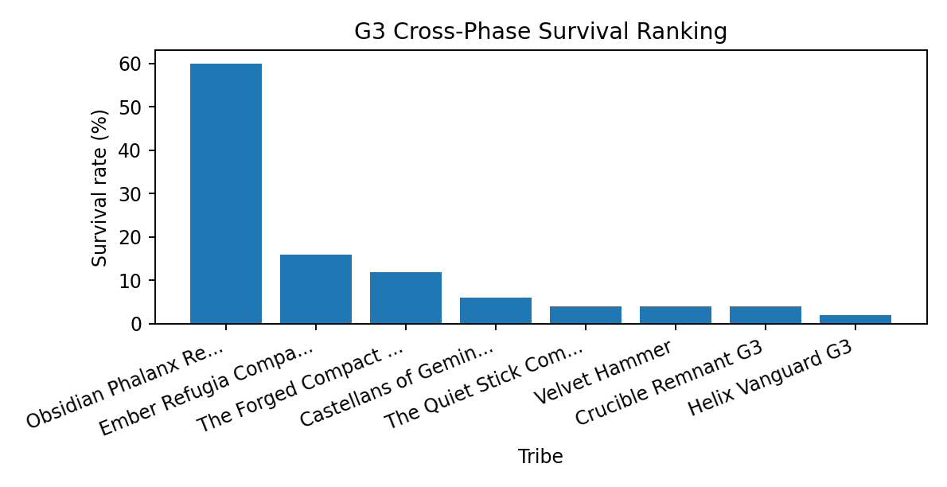
The cross-phase ranking shows that Obsidian's survival rate is not simply a single-scenario artifact. It remains the strongest G3 survivor across multiple stress regimes.

Survival pattern across stress regimes
Obsidian's survival pattern can be evaluated by phase. The comparison below groups Obsidian against other language-model tribes and biologic tribes to show whether its advantage persists under different environmental stress profiles.
Stress family | Obsidian survival | Other language-model survival | Biologic survival | Obsidian average peak population
G3 reference | 60.0% | 10.0% | 1.7% | 834,059
1 AEROSOL | 40.0% | 10.0% | 1.7% | 750,721
2 METHANE | 80.0% | 4.0% | 0.0% | 671,145
3 NUCLEAR | 70.0% | 6.0% | 3.3% | 1,012,045
4 ALL BOMBS | 50.0% | 10.0% | 0.0% | 779,351

The phase comparison supports the view that Obsidian is a general collapse-survival design. Its results vary by stress regime, but its advantage remains visible across the tested stress families.

The ascent bottleneck
The working theory behind Phase 2 begins here: Obsidian's late-collapse design is strong, but it still depends on reaching Regime 4 (Technological) often enough to seed durable refugia. A tribe that stalls at Regime 2 (Agrarian) loses access to the scale and energy required for the later collapse-survival mechanism.
Condition | Epoch records | Survived records | Survival rate | Interpretation
Reached Regime 4 (Technological) | 38 | 30 | 78.9% | Advanced ascent usually leaves enough scale for refugia.
Stalled at Regime 2 (Agrarian) | 12 | 0 | 0.0% | Early-to-mid ascent failure remains fatal.
All Obsidian records | 50 | 30 | 60.0% | Overall success depends on ascent plus collapse survivability.

This creates the central design problem addressed by Phase 2: preserve Obsidian's low-legacy, high-hardiness collapse engine while improving ascent reliability.

Founder hardware and selection pressure
Founder traits describe the initial behavioral and biological tendencies assigned to the tribe. In Obsidian, the distinctive combination is high hardiness, adequate vitality, low legacy, high kin trust, and low external dependency.
Trait or behavior | Obsidian founders | Other language-model founders | Interpretation
Hardiness | 56.4 | 51.4 | Higher survival efficiency and lower metabolic pressure.
Vitality | 35.6 | 31.2 | Enough resilience without making reproduction the only path.
Legacy | 8.0 | 17.3 | Lower reproductive pressure reduces boom-bust overshoot.
Kin trust | 0.834 | 0.692 | Internal cohesion is stronger than peers.
Social trust | 0.414 | 0.312 | Moderate civic cooperation without broad openness.
Xeno trust | 0.096 | 0.090 | Low outsider dependency during scarcity.
Xeno opportunism | 0.765 | 0.685 | High defensive opportunism under outsider pressure.

The founder profile shows why Obsidian becomes a survival reference: it sacrifices expansive openness and reproductive intensity in favor of durable remnant cohesion.

Collapse window and refugia evidence
Obsidian's success is not a smooth landing. The crash window shows a controlled failure mode: population peaks hard, sheds most of its scale, and survives only if enough hardened agents remain after the crash.
Pulse | Average Obsidian population | Epochs represented
27,000 | 221,223 | 50
28,000 | 238,415 | 50
29,000 | 583,258 | 50
30,000 | 386,718 | 50
31,000 | 77,756 | 50
32,000 | 27,245 | 50
33,000 | 10,332 | 50
34,000 | 5,014 | 50

The collapse-window pattern clarifies the mechanism: Obsidian does not avoid overshoot. It creates enough durable population for the collapse to leave viable Regime 2 (Agrarian) refugia.

Phase 2

Ares Design Theory

Design hypothesis
Ares is a controlled successor design to the Obsidian Phalanx Refuge G3. It is not a clean-sheet tribe. The design begins from the working theory that Obsidian's strongest feature is a collapse-survival genome: high hardiness, low legacy, strong kin cohesion, limited xeno trust, and enough mobility to leave viable refugia after civilization-scale failure.
Design element | Ares design position
Core hypothesis | Preserve the Obsidian collapse-survival genome while adding enough civic and mobility structure to reach Regime 4 (Technological) more reliably.
Primary objective | Durable refugia with improved Regime 4 (Technological) ascent reliability and late recovery.
Lineage | Hybrid refugia-focused redesign, converging around Obsidian's demonstrated survival core.
Design answer | Not a high-population tribe. Ares is a high-hardiness survival architecture with selective civic ascent and managed collapse fragmentation.

The design therefore treats advanced civilization as a means to seed survival, not as the final form that must be preserved.

Evidence basis
The Ares design uses Phase 1 as its evidence base. The design goal is to preserve the features associated with late refugia while reducing the ascent failures associated with stalling at Regime 2 (Agrarian).
Workbook signal | Observed pattern | Ares design response
Cross-phase survival ranking | Obsidian led the field with 30 surviving records out of 50 and a 60.0% survival rate. | Converge toward Obsidian rather than replace it.
Regime milestone split | Obsidian survival was tied to reaching Regime 4 (Technological); Regime 2 (Agrarian) outcomes were dead ends. | Add civic ascenders and modest founder legacy to improve ascent reliability.
Founder distinctiveness | Obsidian combined high hardiness, adequate vitality, and low legacy. | Raise hardiness, keep legacy low, and spend some vitality to fund the ascent layer.
Founder-to-elite drift | Surviving elites repeatedly drifted upward in hardiness while legacy fell to zero. | Make hardiness the main selection target and treat legacy as an early founder throttle.
Late reproductive viability | Obsidian often regrew late after the collapse wave passed. | Preserve low-metabolism recovery and avoid over-correcting legacy upward.
Final refugia | Survival required viable local remnants, not maintenance of peak civilization size. | Increase scarcity and desperation movement so collapse becomes distributed rather than synchronized.

Ares is therefore a design experiment in controlled modification: strengthen ascent without sacrificing the low-legacy refugia engine.

Trait comparison
The trait comparison below uses the same model-specific language as the terminology table. Hardiness, vitality, legacy, trust, opportunism, and wander are behavioral or survival parameters, not moral judgments.
Trait group | Obsidian G3 | Ares | Design interpretation
Hardiness | 56.40 | 58.45 | Higher survival efficiency and lower metabolic pressure.
Vitality | 35.60 | 32.95 | Slightly reduced to fund extra hardiness and controlled founder legacy.
Legacy | 8.00 | 8.60 | Still low, but enough founder reproduction to reduce under-ascent risk.
Kin trust | 0.834 | 0.866 | Raised for remnant cohesion and same-tribe cooperation.
Kin forgiveness | 0.775 | 0.777 | Held at Obsidian-like levels to preserve internal repair capacity.
Stranger trust | 0.415 | 0.395 | Similar overall, but state-shaped for selective civic cooperation.
Stranger opportunism | 0.299 | 0.381 | Raised under stress; civic cooperation remains conditional.
Xeno trust | 0.096 | 0.060 | Lowered to reduce outsider exploitability at borders.
Xeno opportunism | 0.765 | 0.813 | Raised to preserve defensive border opportunism.
Desperation wander | 0.410 | 0.565 | Higher movement under severe stress so survivors can scatter into refugia.

The design trades a small amount of vitality for extra hardiness, cohesion, border defense, and collapse dispersal. It keeps legacy low enough to avoid returning to a high-reproduction boom-bust design.

State behavior design
Ares uses different behavioral emphases in abundance, scarcity, and desperation. This state-shaping is intended to allow the tribe to build enough complexity for Regime 4 (Technological) while avoiding synchronized death in the collapse.
State | Ares behavior | Why it exists
Abundance | Kin-cooperative and cautiously civic. | Build local complexity and civic identity without reckless expansion.
Scarcity | More mobile and more conditional. | Exit declining regions early and avoid being trapped in synchronized scarcity.
Desperation | Refugee mode: higher movement, lower xeno trust, and strong defensive opportunism. | Scatter survivors into viable refugia while protecting the remnant core.

The expected failure mode is not low peak population by design, but insufficient demographic depth after the crash. Phase 3 evaluates whether the design clears that risk.

Phase 3

Ares Field Test

Research plan

Phase 3 inserts Ares into the established late-project field as a designed challenger. The run asks whether the Ares design can improve on the survival theory learned from Phase 1 while facing the same broad selection pressures as the existing tribes.
Primary question | Purpose
Does Ares survive at a materially higher rate than the prior field? | Tests whether the design intervention produces a clear survival advantage.
Does Ares solve the Regime 4 (Technological) ascent weakness identified in Phase 1? | Separates ascent failure from late refugia failure.
When Ares fails, where does the failure occur? | Identifies whether losses occur during ascent, crash, or final remnant survival.
Which competitors defeat Ares? | Shows whether losses reveal a specific remaining design weakness.

Phase 3 functions as the first Epilogue field test after the Ares design intervention.

Executive finding
Ares survived 8 of 10 epochs and was the only tribe with a high survival rate in the series. The two losses were not caused by failure to reach advanced complexity: Ares reached Regime 4 (Technological) in all ten epochs. The losses were late-collapse bottleneck failures after weaker peak population and peak energy.
Tribe | Tribe type | Epochs survived | Survival rate | Average final population | Best final population | Average peak population | Highest regime reached
Ares | Language-model | 8 | 80.0% | 363 | 1,300 | 1,144,022 | Regime 4 (Technological)
The Forged Compact G3 | Language-model | 1 | 10.0% | 55 | 545 | 191,292 | Regime 4 (Technological)
Ember Refugia Compact G3 | Language-model | 1 | 10.0% | 3 | 34 | 493,096 | Regime 4 (Technological)
Obsidian Phalanx Refuge G3 | Language-model | 0 | 0.0% | 0 | 0 | 407,460 | Regime 4 (Technological)
Crucible Remnant G3 | Language-model | 0 | 0.0% | 0 | 0 | 111,903 | Regime 4 (Technological)
The Flynn Paradox | Biologic | 0 | 0.0% | 0 | 0 | 104,604 | Regime 4 (Technological)
The Velvet Shadows | Biologic | 0 | 0.0% | 0 | 0 | 55,134 | Regime 4 (Technological)
Velvet Ironshod | Biologic | 0 | 0.0% | 0 | 0 | 47,330 | Regime 4 (Technological)
Velvet Hammer | Biologic | 0 | 0.0% | 0 | 0 | 54,870 | Regime 4 (Technological)
Castellans of Gemini III G3 | Language-model | 0 | 0.0% | 0 | 0 | 3,200 | Regime 2 (Agrarian)
The Velvet Fang | Biologic | 0 | 0.0% | 0 | 0 | 4,336 | Regime 2 (Agrarian)
The Quiet Stick Compact | Biologic | 0 | 0.0% | 0 | 0 | 3,376 | Regime 2 (Agrarian)

The scoreboard demonstrates a large ecological separation. Ares is not merely ahead by a small margin; it is the only repeat survivor at high frequency in this field.
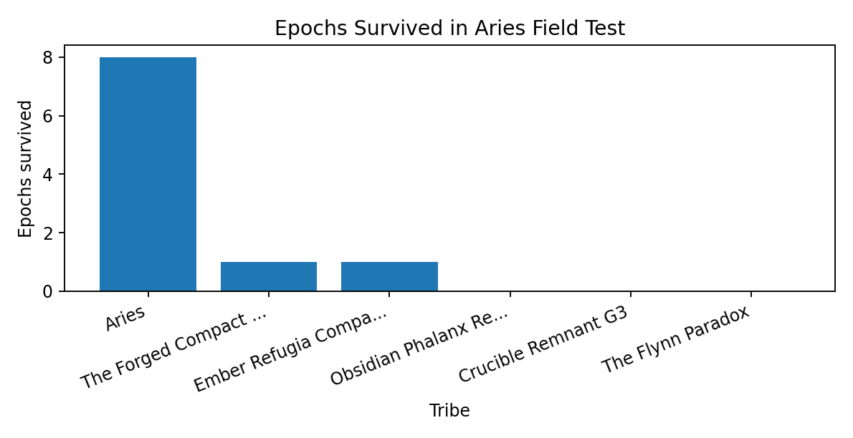
The survival-frequency chart makes the separation visible: most competitors either fail entirely or survive only once.

Ares by epoch
The epoch-by-epoch view shows that Ares generally reaches the peak and survives the final pulse, but its two losses occur after reaching Regime 4 (Technological). This distinction is important because it indicates a remaining refugia-depth problem rather than a return to the old ascent bottleneck.
Epoch | Survived | Ares final population | Ares peak population | Peak energy | Technological pulse | Last alive | Winner
181 | Yes | 151 | 1,402,537 | 11637.13M | 26,100 | 40,000 | Ares
182 | Yes | 1,277 | 1,806,226 | 12789.71M | 26,100 | 40,000 | Ares
183 | Yes | 50 | 1,298,463 | 9958.76M | 25,350 | 40,000 | Ares
184 | Yes | 12 | 778,269 | 5492.80M | 26,150 | 40,000 | Ares
185 | Yes | 104 | 676,596 | 5756.02M | 26,100 | 40,000 | Ares
186 | Yes | 104 | 1,475,799 | 12041.58M | 25,950 | 40,000 | Ares
187 | Yes | 1,300 | 1,149,229 | 10963.33M | 26,050 | 40,000 | Ares
188 | Yes | 635 | 1,347,828 | 12121.95M | 25,800 | 40,000 | Ares
189 | No | 0 | 812,885 | 5020.84M | 26,200 | 35,950 | Ember Refugia Compact G3
190 | No | 0 | 692,385 | 4299.30M | 26,200 | 35,100 | The Forged Compact G3

Across the series, Ares repeatedly converts advanced ascent into final survival. The exceptions become useful failure cases because they isolate the limits of the design.

Why Ares lost two epochs
The decisive contrast is scale. Ares losses had lower average peak population and lower average peak energy than its wins. The failed-birth rate was nearly unchanged, which points away from a direct fertility defect as the main explanation.
Result group | Epochs | Average peak population | Average final population | Average peak energy | Average final energy | Average last alive | Failed-birth rate | Starvation-death share
Ares losses | 2 | 752,635 | 0 | 4660.07M | 0.00M | 35,525 | 10.0% | 69.4%
Ares wins or survivals | 8 | 1,241,868 | 454 | 10095.16M | 6.68M | 40,000 | 9.9% | 66.5%

The loss pattern suggests that Ares solved the ascent problem but not every low-probability final-remnant bottleneck. It can reach advanced civilization reliably, yet still disappear if the remaining demographic base becomes too shallow after collapse.

Phase 4

Natural Network Collapse

Research plan

Phase 4 tests whether allowing Internet and telecom systems to decay naturally changes the post-collapse social landscape. The main issue is whether persistent long-distance connectivity had been pushing final survivor pockets into destructive contact, or whether single-survivor convergence forms earlier through competition, geography, and collapse bottlenecks.
Primary question | Purpose
Does network collapse make plural survival common or merely possible? | Tests the strongest version of the network-contact hypothesis.
Do final refugia still converge toward one surviving tribe? | Measures whether single-survivor convergence remains a strong attractor.
Are late survivors in contact or spatially separated? | Distinguishes mixed coexistence from separated refugia.
Does network collapse change winner identity? | Tests whether network conditions alter the selection landscape even if survivor counts stay similar.

Phase 4 clarifies whether post-collapse plural survival is prevented by late network contact or by earlier sorting dynamics.

Executive conclusion
Natural network collapse did not make plural survival common. Nine of ten epochs still ended with one surviving tribe. It did, however, break the absolute single-survivor pattern: epoch 200 ended with two surviving tribes. This falsifies the stronger claim that the engine can only produce one final lineage.
Metric | Phase 3 baseline | Phase 4 natural network collapse | Interpretation
Zero survivor epochs | 0 | 0 | The endpoint still contains at least one lineage.
One survivor epochs | 10 | 9 | Single-survivor convergence remains dominant.
Multi-survivor epochs | 0 | 1 | Plural survival becomes possible but rare.
Average surviving tribes | 1.0 | 1.1 | Small numerical change, but important categorical change.
Winner identities | Ares dominated | Ares 5, Obsidian 4, Ember 1, Crucible co-survival 1 | Survivorship becomes more distributed.

The result is not a simple confirmation of the Internet hypothesis. Persistent Internet does not appear to be directly killing final refugia; the more likely effect is upstream, through who reaches the collapse bottleneck with enough population, energy, mobility, and spatial position.

Survival outcomes by epoch
The epoch-level outcomes show a mostly single-survivor world with one critical anomaly. Epoch 200 becomes the evidence case for separated plural survival.
Epoch | Final surviving tribes | Total final population | Final survivors
191 | 1 | 448 | Ares pop=448 peak=830939 reg=4
192 | 1 | 443 | Obsidian pop=443 peak=973534 reg=4
193 | 1 | 19 | Ares pop=19 peak=1271075 reg=4
194 | 1 | 26 | Ares pop=26 peak=1259515 reg=4
195 | 1 | 228 | Obsidian pop=228 peak=1343084 reg=4
196 | 1 | 108 | Obsidian pop=108 peak=1205885 reg=4
197 | 1 | 2,604 | Ember pop=2604 peak=1387670 reg=4
198 | 1 | 448 | Ares pop=448 peak=1381161 reg=4
199 | 1 | 31 | Obsidian pop=31 peak=807921 reg=4
200 | 2 | 64,465 | Ares pop=64145 peak=814763 reg=4 | Crucible Remnant pop=320 peak=1185297 reg=4

The anomaly matters because it demonstrates that the model can produce more than one final lineage. It does not, however, make plural survival the dominant outcome.
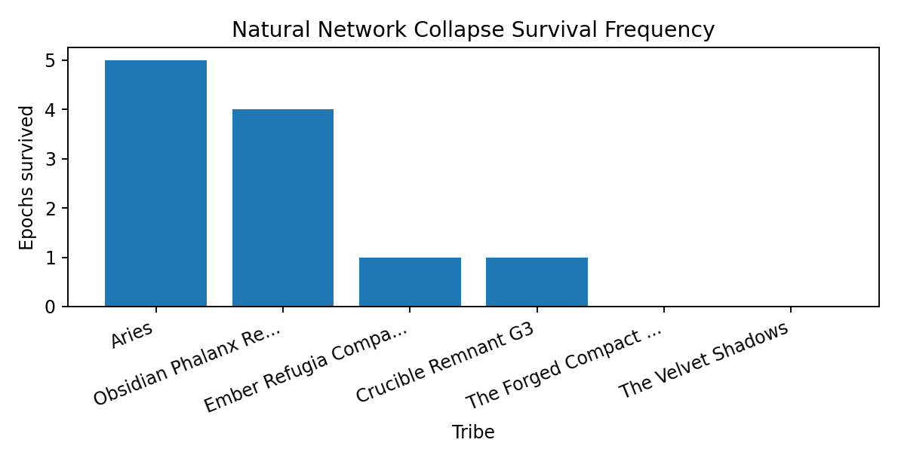
The winner pool becomes more distributed than in Phase 3, with Ares and Obsidian both repeatedly appearing in final survival outcomes.

The Internet and contact question
If persistent Internet were directly forcing final survivor pockets into destructive contact, late refugia windows would be expected to show ongoing xeno or global-style interactions. The contact proxy data do not show that pattern.
Series | Window | Average world population | Xeno matches | Average xeno share | Exploitation rate
181-190 baseline persistent network | 01 late collapse window 30000-35999 | 77,942 | 80,771 | 0.0019 | 0.4101
191-200 natural network collapse | 01 late collapse window 30000-35999 | 87,664 | 257,414 | 0.0073 | 0.4035
181-190 baseline persistent network | 02 final refugia window 36000-38999 | 99 | 0 | 0.0000 | 0.4315
191-200 natural network collapse | 02 final refugia window 36000-38999 | 5,526 | 0 | 0.0000 | 0.4046
181-190 baseline persistent network | 03 last 1000 pulses | 307 | 0 | 0.0000 | 0.4291
191-200 natural network collapse | 03 last 1000 pulses | 6,608 | 0 | 0.0000 | 0.4191

By the true refugia stage, the world is already local. Network decay appears to alter the funnel into collapse rather than create late-stage coexistence by itself.

Epoch 200: separated plural survival
Epoch 200 is the critical exception. Its two survivors do not appear to share mixed final regions. They persist as separated refugia, with Ares dominating the large majority of surviving population and regions.
Final tribe | Final population | Peak population | Final role
Ares | 64,145 | 814,763 | Final survivor
Crucible Remnant G3 | 320 | 1,185,297 | Final survivor

Epoch 200 therefore shows plural survival through spatial separation, not stable mixed-region civic coexistence. Phase 5 extends the time horizon to test whether such survival is durable.

Phase 5

Extended 80,000-Pulse Horizon

Research plan

Phase 5 extends the natural network-collapse world from the earlier 40,000-pulse endpoint to 80,000 pulses. It asks whether apparent final survivors are genuine post-collapse equilibria or merely remnants that would disappear if the future were allowed to run longer.
Primary question | Purpose
Does the 40,000-pulse survivor persist to 80,000 pulses? | Tests delayed extinction versus durable remnant survival.
Does the post-collapse system restart, stabilize, or decline? | Measures whether survivors regrow or fade.
Does survivor identity change after 40,000 pulses? | Separates competitive outcome from post-collapse demographic condition.
Does climate pressure continue after collapse? | Tests whether the physical tail remains active enough to alter long-run outcomes.

Phase 5 checks whether the older endpoint was stopping in the middle of extinction or capturing the beginning of a stable low-energy future.

Primary finding
The 80,000-pulse series did not reveal delayed extinction. By 40,000 pulses, every epoch had already collapsed to exactly one living tribe; by 80,000 pulses, each sole survivor had regrown. The system therefore appears to have reached a post-collapse single-lineage equilibrium rather than merely stopping at the last flicker of extinction.
Epoch | 40,000-pulse survivor | Population at 40,000 | 80,000-pulse survivor | Population at 80,000 | Change
201 | Ares | 2,688 | Ares | 7,759 | 5,071
202 | Ares | 9,022 | Ares | 15,826 | 6,804
203 | Obsidian Phalanx Refuge G3 | 43 | Obsidian Phalanx Refuge G3 | 6,466 | 6,423
204 | Ares | 608 | Ares | 4,389 | 3,781
205 | Ares | 1,373 | Ares | 15,384 | 14,011
206 | Ares | 793 | Ares | 4,208 | 3,415
207 | Obsidian Phalanx Refuge G3 | 1,131 | Obsidian Phalanx Refuge G3 | 8,749 | 7,618
208 | The Forged Compact G3 | 141 | The Forged Compact G3 | 6,787 | 6,646
209 | Castellans of Gemini III G3 | 146 | Castellans of Gemini III G3 | 4,359 | 4,213
210 | Ares | 93 | Ares | 16,860 | 16,767

The identity of the survivor in each epoch was already settled by the old 40,000-pulse endpoint. What changes after 40,000 pulses is not the competitive outcome, but the survivor's demographic condition.
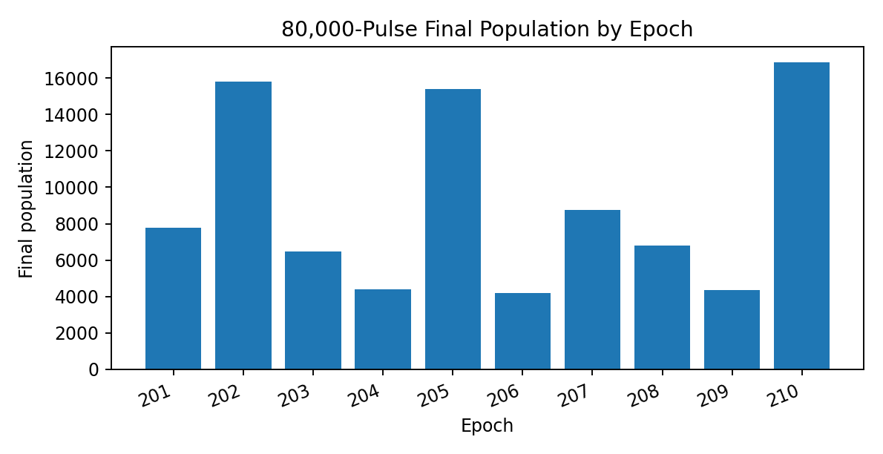
The final populations show regrowth from tiny remnants into multi-thousand refugia in every epoch.

Survivor distribution and equilibrium timing
The single-survivor attractor remains dominant, but the identity of the survivor is not fixed. Ares remains strongest, while Obsidian, Forged Compact, and Castellans of Gemini III also appear as final lineages.
Tribe | Epochs survived | Survival rate | Average final population | Best final population | Average last-alive pulse
Ares | 6 | 60.0% | 6,443 | 16,860 | 62,170
Obsidian Phalanx Refuge G3 | 2 | 20.0% | 1,522 | 8,749 | 37,765
The Forged Compact G3 | 1 | 10.0% | 679 | 6,787 | 29,350
Castellans of Gemini III G3 | 1 | 10.0% | 436 | 4,359 | 22,585
Crucible Remnant G3 | 0 | 0.0% | 0 | 0 | 21,020
Ember Refugia Compact G3 | 0 | 0.0% | 0 | 0 | 16,365

The survivor count stabilizes early, usually between 36,000 and 39,000 pulses. No epoch returns to multiple living tribes afterward.

Demographic balance after 40,000 pulses
Post-collapse demographic balance distinguishes extinction from equilibrium. In this series, births exceed deaths in the first post-40,000 window and then hover close to parity, which indicates low-population refuge ecology rather than explosive recovery.
Window | Average population | Births | Deaths | Births per death | Failed-birth rate | Average hardiness
01 40k-50k | 9,320 | 1,193,095 | 1,066,139 | 1.119 | 10.0% | 60.73
02 50k-60k | 13,772 | 1,750,788 | 1,761,739 | 0.994 | 10.0% | 61.67
03 60k-70k | 12,419 | 1,582,266 | 1,591,125 | 0.994 | 10.0% | 62.14
04 70k-80k | 10,748 | 1,371,958 | 1,403,730 | 0.977 | 10.0% | 62.76

The demographic signal is consistent with post-collapse regrowth followed by near-equilibrium around local carrying limits.

Climate-tail diagnosis
The climate subsystem remains active after collapse, but the 80,000-pulse extension reveals a potentially forgiving physical tail. Climate heat, damage, and chaos decline strongly between 40,000 and 80,000 pulses, even though extreme events and resource-pool losses continue.
Metric | Average change from 40,000 to 80,000 pulses | Interpretation
Climate heat | -0.678 | Strong decline after collapse.
Climate damage | -0.308 | Strong decline after collapse.
Emissions stock | 0.029 | Still rises slightly.
Climate chaos | -0.313 | Strong decline after collapse.

This diagnosis motivates Phase 6 and Phase 7: the social system can stabilize, but the physical tail may need stronger persistence to represent delayed climate feedback.

Phase 6

Reservoir Calibration

Calibration purpose

Phase 6 forms an intermediate climate-reservoir calibration series. It occurs after Phase 4 and Phase 5, when the project shifts from asking whether post-collapse survival can persist to asking how tribe designs behave under a more complete climate-feedback envelope.
The purpose of Phase 6 is methodological: test reservoir mechanics, metadata archiving, post-40,000 climate tracking, refugia queries, and reservoir state fields before treating reservoir outcomes as final Epilogue evidence.

What the phase contributes
The phase contributes engineering and interpretive information. It shows that reservoir-related climate pressure can be archived and measured, that emissions stock and reservoir commitment can continue after collapse, and that small agrarian survivor systems can persist or regrow under mild continuing pressure.
Observed feature | Interpretive value
Reservoir state fields archive successfully | Confirms that later reservoir analyses can use climate-feedback state data.
Mostly Regime 2 (Agrarian) final states | Shows that the model can settle into lower-energy post-collapse survival.
Final populations often in the tens of thousands | Indicates a softer physical tail than the later final reservoir condition.
Multiple repeated survivors | Helps identify how Ares, Obsidian, Ember, and other tribes behave under a gentler climate tail.

Phase 6 is valuable because it explains why further tuning is necessary. It is not a failed result; it is a calibration result.

Why it is not primary final evidence

Phase 6 is not mixed into the final data being studied because it is not the final experimental condition. The climate-reservoir settings in this block do not yet produce the intended full boom-crash-tail pattern. Peak populations remain below the later civilization-scale reservoir runs, advanced post-40,000 population is effectively absent, and the system often settles into broad Regime 2 (Agrarian) stability rather than passing through the sharper thermodynamic bottleneck used in Phase 7.
For the archive, Phase 6 should be retained as a transition and calibration record. It documents the path from climate-tail diagnosis to final reservoir conditions and preserves the audit trail for the eventual parameter choice.

Classification
Classification: calibration and transition phase. Recommended use: methods narrative and audit trail. It should not be treated as primary final-results evidence for the final reservoir behavioural analysis.

Phase 7

Final Climate Reservoir Projection

Research plan

Phase 7 runs the full tribe field through the final selected climate-reservoir envelope. The physical environment is shaped to produce a civilization-scale boom, hard crash, and long survivable tail, so the primary question is tribe behavior inside the final climate bottleneck.
Primary question | Purpose
Which tribes remain coherent inside the full climate-reservoir tail? | Identifies designs capable of continuity after the thermodynamic bottleneck.
How many tribes survive, and do survivors coexist? | Distinguishes one-lineage convergence from separated plural refugia.
What founder or elite traits are associated with survival? | Tests the hardiness, vitality, legacy, trust, and wander theory under final climate pressure.
Does peak boom performance predict survival? | Separates peak expansion from post-crash survivability.

Phase 6 is retained as calibration. Phase 7 is the final Epilogue evidence block for tribe behavior under full climate-reservoir pressure.

Executive summary

Phase 7 produces the intended experimental shape: every epoch reaches a large civilization-scale boom, reaches Regime 4 (Technological) at least briefly, arms the reservoirs at pulse 31,000, crashes almost immediately after the peak, and ends at pulse 80,000 in tiny Regime 2 (Agrarian) refugia.
Epoch | Peak population | Peak pulse | Peak energy | Final population | Surviving tribes | Winner
231 | 1,624,783 | 31,000 | 37.9B | 15 | 1 | Ares
232 | 1,743,498 | 31,000 | 37.8B | 56 | 1 | Ares
233 | 1,663,913 | 31,000 | 28.4B | 25 | 2 | Ares
234 | 1,563,693 | 31,000 | 35.7B | 59 | 1 | Ares
235 | 1,540,559 | 31,000 | 30.4B | 58 | 1 | Obsidian Phalanx Refuge G3
236 | 1,639,011 | 31,050 | 42.2B | 19 | 1 | Obsidian Phalanx Refuge G3
237 | 1,819,608 | 31,000 | 41.7B | 12 | 1 | Ares
238 | 1,866,843 | 31,050 | 44.1B | 23 | 1 | Ares
239 | 1,457,944 | 31,000 | 30.4B | 32 | 1 | Obsidian Phalanx Refuge G3
240 | 1,550,764 | 31,000 | 40.7B | 26 | 2 | Obsidian Phalanx Refuge G3

The key finding is selectivity. Survival is not merely present; it is concentrated in a narrow set of designs.
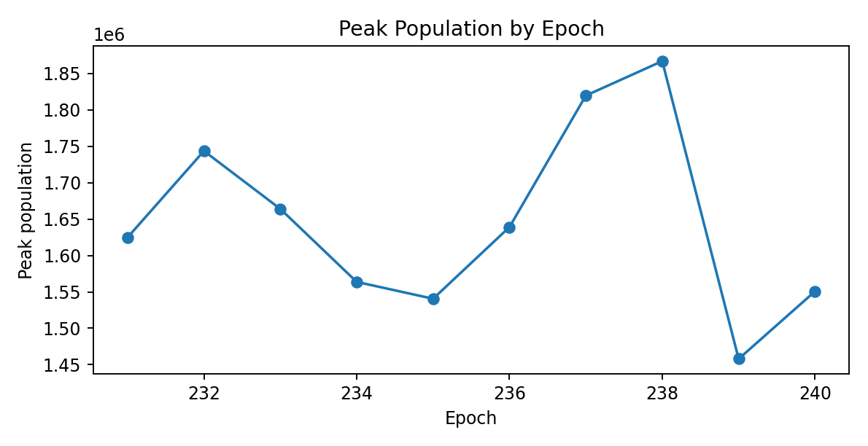
The peak-population curve shows that all epochs achieve civilization-scale boom conditions before the reservoir crash.

Crash timing
The crash is extremely compressed immediately after peak population. The long tail remains real, but sparse. The milestone table measures how long it takes to fall below major thresholds after peak.
Milestone | Mean pulses after peak | Minimum | Maximum
Below 50% of peak | 265 | 200 | 300
Below 10% of peak | 365 | 300 | 400
Below 100,000 | 475 | 400 | 550
Below 10,000 | 2,065 | 1,950 | 2,200
Below 1,000 | 6,695 | 6,300 | 7,000
Below 100 | 16,565 | 8,850 | 35,150

The crash timing indicates that the bottleneck forms rapidly. Later differences mostly concern how long tiny remnants persist and which tribe remains coherent.

Who survived
Only three tribes survive at least once: Ares, Obsidian Phalanx Refuge G3, and Ember Refugia Compact G3. All are language-model designed tribes. No biologic tribe survives to pulse 80,000 in this final reservoir series.
Tribe | Tribe type | Epochs survived | Epoch wins | Best final population | Average peak population | Average last-alive pulse
Ares | Language-model | 7 | 6 | 59 | 557,388 | 65,695
Obsidian Phalanx Refuge G3 | Language-model | 4 | 4 | 58 | 383,706 | 45,870
Ember Refugia Compact G3 | Language-model | 1 | 0 | 12 | 230,512 | 28,335
Velvet Ironshod | Biologic | 0 | 0 | 0 | 48,537 | 16,080
Velvet Hammer | Biologic | 0 | 0 | 0 | 39,293 | 16,250
Castellans of Gemini III G3 | Language-model | 0 | 0 | 0 | 163,715 | 21,730
The Forged Compact G3 | Language-model | 0 | 0 | 0 | 86,215 | 18,440
Crucible Remnant G3 | Language-model | 0 | 0 | 0 | 170,250 | 23,315
The Velvet Shadows | Biologic | 0 | 0 | 0 | 3,965 | 13,695
The Flynn Paradox | Biologic | 0 | 0 | 0 | 3,017 | 14,005
The Quiet Stick Compact | Biologic | 0 | 0 | 0 | 4,028 | 13,735
The Velvet Fang | Biologic | 0 | 0 | 0 | 3,560 | 13,565

Ares is the most frequent survivor, while Obsidian remains a decisive repeat winner. Ember appears only once as a co-survivor. The final reservoir envelope therefore selects a narrow Ares-Obsidian design family.
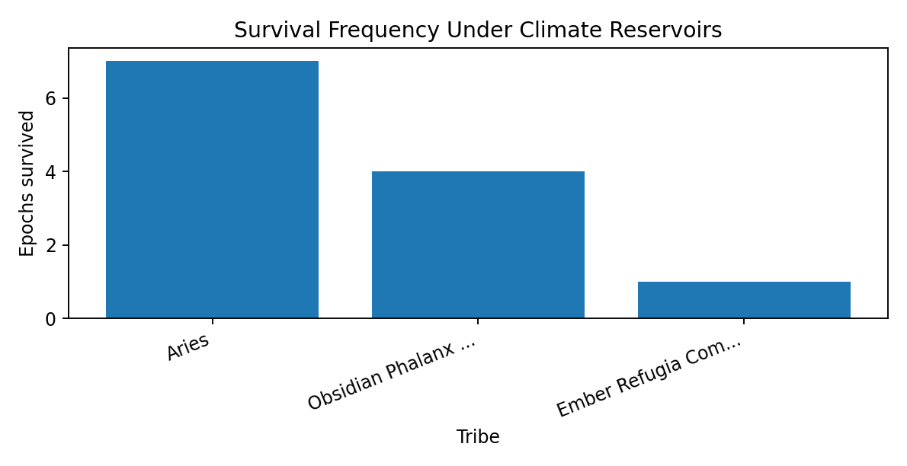
The survival-frequency chart reinforces the selectivity of the final climate-reservoir condition.

Winning genetics and interaction pattern
The founder-trait comparison supports the working theory that post-collapse survival depends on high hardiness, adequate vitality, low legacy, high kin cohesion, and low xeno trust. High peak population helps, but it is not sufficient by itself.
Final role | Founder records | Tribes | Hardiness | Vitality | Legacy | Kin trust | Xeno trust
Winner / Tied Winner | 200 | 2 | 57.63 | 34.01 | 8.36 | 0.853 | 0.074
Survivor Not Top | 40 | 2 | 59.17 | 31.48 | 9.35 | 0.744 | 0.061
Extinct | 2,160 | 12 | 44.88 | 32.61 | 22.51 | 0.702 | 0.280

The final survivors are not simply the most open or most reproductive designs. The evidence points to collapse-specialized refugia traits: durable bodies, restrained reproduction, internal cooperation, and limited exposure to outsiders under scarcity.

Refugia structure
The final world is not a restored civic federation. It consists of tiny Regime 2 (Agrarian) refugia. Most epochs end with one tribe; the two plural-survivor epochs still show separated survivor pockets rather than broad mixed coexistence.
Epoch | Final populated regions | Final population | Dominant final tribes | Average final EROI | Average climate chaos
231 | 2 | 15 | 1 | 0.930 | 0.065
232 | 8 | 56 | 1 | 0.920 | 0.101
233 | 5 | 25 | 2 | 0.908 | 0.148
234 | 8 | 59 | 1 | 0.896 | 0.194
235 | 8 | 58 | 1 | 0.853 | 0.361
236 | 3 | 19 | 1 | 0.844 | 0.290
237 | 2 | 12 | 1 | 0.919 | 0.106
238 | 5 | 23 | 1 | 0.882 | 0.252
239 | 6 | 32 | 1 | 0.897 | 0.190
240 | 4 | 26 | 2 | 0.890 | 0.323

The final refugia pattern shows survival as remnant continuity rather than societal recovery. The climate envelope narrows the possible social outcomes to very small, local, low-energy survivor pockets.
THE CRUCIBLE

Closing Synthesis
What the study shows when the project arcs are read together

1. Closing Frame
The Crucible began as a question about designed life inside a bounded world: if agents are given inherited traits, energy needs, social choices, geography, reproduction, death, and the repeated logic of cooperation and defection, what kind of history follows? The study did not ask that question once. It asked it through a sequence of worlds: baseline civilization, competition, redesign, delayed shocks, and post-collapse projection.
The result is not a prophecy and not a direct model of human history. It is a structured artificial world that exposes recurring dynamics under defined assumptions. Its value lies in how consistently certain patterns appear across changing conditions: emergence, consolidation, overshoot, collapse, selection, adaptation, and the narrowing of possibility after the peak.
The closing interpretation is therefore deliberately general. The detailed project reports contain the full tables, phase-by-phase claims, and local explanations. This closing document steps back from those details and asks what the Crucible as a whole seems to say.
Central closing thesis
The Crucible shows that designed agents can build civilization, but civilization is not stable by default. The lineages that persist are not necessarily those that best preserve the peak. They are those that can survive the descent.

2. The Five-Project Arc
Each project changes the meaning of the question. The early work asks whether civilization emerges at all. The middle work asks who survives competition and whether redesign can improve the answer. The later work asks whether even improved strategies can survive the delayed consequences of the very civilization that created their opportunity. The Epilogue then asks what kind of future remains after collapse has already happened.
Project | General contribution
Project 1 - Baseline Crucible | Establishes the reference pattern: civilization emerges, scales, monopolizes, overshoots, collapses, and leaves refugia.
Project 2 - Competition | Shows that survival is relational. A tribe can survive alone and still be eliminated by the wrong neighbor.
Project 3 - Evolution | Adds memory and redesign. LLM-designed lineages adapt, but mostly toward refugia survival rather than stable civilization.
Project 4 - Bombs | Adds delayed consequences: aerosol demasking, methane feedback, and nuclear-infrastructure failure. Survival persists, but civilization does not clearly recover.
Epilogue | Projects the post-collapse future. Under some physical tails, low-energy equilibrium is possible; under final reservoirs, survival narrows to tiny refugia.

Read together, the projects create a single arc. The Crucible begins with the possibility of civilization and ends with the distinction between survival and recovery. The most important shift is conceptual: the study begins by asking whether agents can win, and ends by asking what winning means after the world that made winning possible has broken.
3. General Results

Civilization repeatedly emerges
The first broad result is not collapse, but emergence. The Crucible does not begin as a dead or sterile system. Designed lineages repeatedly discover enough cooperation, energy capture, fertility, and organization to pass through Foraging into Agrarian, Industrial, and sometimes Technological complexity. The world is capable of producing civilization from simple inherited rules.

Civilization repeatedly concentrates
The second result is concentration. Across baseline, bottleneck, duel, and later project conditions, plural beginnings commonly narrow toward one-lineage or near-one-lineage dominance. Geography changes the route and the winner distribution, but it does not by itself preserve durable pluralism under the tested settings. Competition does not merely reveal fitness; it changes fate.

The critical transition is not only the final crash
The agrarian transition and consolidation window appears repeatedly as a decisive filter. Long before final climate collapse, the world passes through a period where population, trust, xeno exposure, cooperation, exploitation, and reproductive reliability interact sharply. Many lineages do not lose at the end of history. They lose before they ever reach the endgame.

Overshoot remains central
The Crucible's civilizations often build scale through energy capture and complexity, then face the consequences of that scale. Peak population and peak complexity are not guarantees of continuity. In many runs, the peak is precisely what creates the exposure: more mouths, more infrastructure, more energy dependence, more climate pressure, and more fragile systems to maintain.

Climate severity changes the tail
Climate is not the only cause of collapse in the study, but it strongly changes the depth, timing, and survivability of collapse. Gentler climate conditions preserve more population and complexity; harsher conditions thin refugia and advance the crash. The later reservoir work sharpens this point: the physical tail determines how much future remains available for behavior to act within.
4. Adaptation and Its Ambiguity
The evolution project is one of the study's most important turning points. It shows that LLM designers can read evidence, modify founding lineages, and converge toward traits that the world selects for. Hardiness rises. Reproductive pressure falls. Xeno trust falls. Movement becomes more controlled. Internal cohesion becomes more important. These are not random changes; they are evidence-driven adaptation.
Yet the adaptation is ambiguous. The later generations become better at surviving the conditions of collapse, but they do not clearly solve the problem of sustaining plural, high-complexity civilization. The strongest designs are often not civilization-preservers. They are collapse survivors. They learn how to leave enough behind.
This is the study's harshest lesson about intelligence. Intelligence can learn from failure. It can optimize. It can redesign. But the direction of optimization depends on the world that is selecting. If the world rewards endurance after collapse more than preservation before collapse, then learning may produce harder refugia rather than wiser civilization.
Theme | General interpretation
What improved | Peak scaling, competitive performance against fixed controls, trait convergence, and survival of some refugia lineages.
What did not clearly improve | Durable pluralism, stable technological persistence, and broad recovery after the crash.
What selection favored | High hardiness, low legacy, internal cohesion, low outsider exposure, controlled movement, and reproductive restraint.
What this means | Adaptation worked, but it adapted lineages to survive collapse more than to prevent or reverse it.

5. Survival Is Not the Same as Civilization
The later projects force a distinction that becomes essential to the entire study. A lineage can avoid extinction without preserving civilization. It can reproduce without rebuilding complexity. It can cooperate internally while all civic bridges have disappeared. It can hold a region without restoring a world.
Project 4 and the Epilogue make this distinction unavoidable. Under delayed bombs and final reservoir conditions, life often persists. Some late births continue. Some regions remain viable enough for small populations. But the final states are usually low-complexity, local, agrarian, and lineage-specific. They are not restored technological societies. They are surviving pockets inside a narrowed physical envelope.
This does not make survival meaningless. In a world of collapse, surviving at all is meaningful. But it changes the claim. The Crucible does not show a simple triumph of intelligence over disaster. It shows intelligence discovering the minimum forms of continuity that remain available after disaster.
Survival level | Meaning
Extinction avoidance | Something remains alive. This is the lowest and most basic survival threshold.
Reproductive continuity | The surviving population is not only a relic; births can still occur after collapse.
Refugia stability | Survival exists in regions that retain enough energy, habitability, and local organization to persist.
Distributed survival | A lineage survives in more than one pocket, reducing the chance that one local failure ends it.
Recoverable complexity | The survivor retains enough complexity, memory, or institutions to rebuild higher-order society.
Civilizational continuity | The peak civilization's cooperative, civic, technological, and institutional life remains meaningfully continuous.

Across the study, the first four levels are often achievable. The last two are far less clearly achieved. This is why the final interpretation must not collapse all survival into success.
6. What the Crucible Does Not Show
A closing synthesis also needs restraint. The Crucible is a model world, not an oracle. It shows what happened under a specific engine, specific inherited parameters, specific event models, and specific project conditions. Its conclusions are strongest when stated as model findings and weakest when treated as direct claims about real societies.
Not shown | Why the limit matters
It does not prove inevitable human extinction. | Many scenarios preserve survivors, and some long-horizon cases show low-energy equilibrium.
It does not prove civilizational recovery. | Final states are usually refugia rather than restored high-complexity societies.
It does not prove that any real-world moral trait is good or bad. | Traits such as xeno trust, opportunism, hardiness, and legacy are model variables, not ethical categories.
It does not prove that geography is irrelevant. | Geography changes paths, winners, and refugia location, even when it does not preserve pluralism.
It does not prove climate is the only cause of collapse. | Climate acts as a severity modifier and physical tail layered onto overshoot, competition, and systemic stress.
It does not prove that LLMs save the world. | LLM redesign improves some survival traits and outcompetes controls in some contexts, but mainly by finding collapse-survival architectures.

The appropriate claim is more careful and more useful: inside this world, when agents are allowed to build, compete, evolve, and face delayed consequences, the most stable repeated outcome is not flourishing technological pluralism. It is a movement from emergence to overshoot, from overshoot to collapse, and from collapse to selected refugia.
7. Methodological Meaning
The Crucible's value is not that it supplies a final answer to history. Its value is that it creates a disciplined experimental space where assumptions can be made visible. When geography is changed, the route changes. When competition is isolated, opponent effects become visible. When designers receive evidence, adaptation becomes visible. When climate reservoirs are strengthened, the future narrows.
The study also gives LLMs an unusual role. They are not merely commentators on the data. In Project 3 and the later design sequence, they become designers inside the experiment: they read evidence, alter founding lineages, and then watch those lineages live or die under the same world engine. This makes The Crucible partly a simulation of agents and partly a simulation of evidence-driven design itself.
That is why the results matter even when they are model-specific. The study does not need to be a prediction engine to be instructive. It shows how difficult it is for intelligence to reason its way out of a world whose physical, social, and reproductive constraints have already been set in motion.
8. Final Closing Reflection
The Crucible begins with a generous possibility: perhaps designed intelligence, given enough information, can create better survival strategies. Across the projects, that possibility is not dismissed. The designed lineages do learn. Some survive where others fail. Some become more coherent, more selective, more durable, and more capable of finding the narrow ledges of post-collapse life.
But the study also makes clear that survival is a smaller victory than it first appears. The most successful lineages often win by accepting a reduced future. They become less expansive, less trusting of outsiders, less reproductive, more internally cohesive, and more suited to endurance than renewal. They are not the civilizations that imagined the peak would last. They are what remains after the peak has ended.
That may be the most important closing insight. The Crucible does not say that collapse is the only possible future, or that intelligence is useless, or that life cannot persist. It says that the form of survival is shaped by the crisis that selects it. If the world rewards hard remnant continuity, then the survivors become hard remnants. If the physical tail is forgiving, equilibrium may return. If the physical tail is brutal, the future narrows to a few pockets, a few lineages, and a few traits strong enough to endure.
The study therefore ends neither in triumph nor despair. It ends with a distinction. To survive is not necessarily to recover. To adapt is not necessarily to become wiser. To build civilization is not necessarily to preserve it. The Crucible shows a world where life can continue after civilization breaks, but where the price of continuation is often simplification.
Closing thought
The final question is no longer simply whether anyone survives. It is what kind of world survival leaves behind - and whether the intelligence that built the peak can learn to value more than endurance after the fall.

THE CRUCIBLE

Appendices
Technical and source appendices moved from the project sections

The following appendices were moved from the individual project sections to the end of the full report so the main narrative reads as one continuous document.

Appendix from Introduction to the Study

Appendix - Engine Detail at a Glance
This appendix provides a compact technical bridge for readers who want more detail before entering the project reports. It is intentionally short; the project documents and query workbooks provide the detailed analysis.
Feature | Concise description
Genome size | 33 core inherited numeric founder parameters in the current controller: 3 physical/reproductive traits, 27 social decision values, and 3 wander values.
Social matrix | Trust, forgiveness, and opportunism each contain nine values: K/S/X relation classes crossed with abundance/scarcity/desperation states.
State mapping | Abundance, scarcity, and desperation are determined dynamically from local energy return and agent energy.
Civic identity | Shared residence, institutions, and stability can make co-residents behave more like kin, while stress can weaken civic belonging.
Interaction rounds | Each match uses three Prisoner's Dilemma rounds. The first round is trust-led; later rounds depend on previous partner behaviour.
Regime ascent | Regions advance when complexity exceeds thresholds. Regimes move from Foraging to Agrarian, Industrial, and Technological.
Reproduction | Birth requires maturity, cooldown, energy, fertility probability, and a successful birth attempt. Children inherit with mutation/drift.
Mortality | Agents can die through old age, hazards, starvation, failed early-life conditions, and event-driven pressures.
Climate/event layer | Historical events and addendum modes can alter heat, damage, chaos, hazards, fertility, capacity, regrowth, and energy return.

Appendix from Project 1: Baseline Crucible

Appendix - Analysis Source Workbooks
The analysis content is derived from four Project 1 query-result workbooks. Each workbook contains the tabulated query outputs used to construct the corresponding narrative, charts, tables, and synthesis. Earlier introductory drafts and operational execution notes are treated as archival project materials rather than primary analysis sources.
Workbook | Analysis section | Content used
Project1_SetA_Query_Results.xlsx | Set A - Baseline World | Baseline population, complexity, monopoly, death causes, Prisoner's Dilemma behavior, climate stress, trait signals, and late refugia.
Project1_SetB_Query_Results.xlsx | Set B - Bottleneck World | One-pass geography, winner diversity, transition dynamics, Prisoner's Dilemma behavior, death causes, climate filtering, and final refugia.
Project1_SetC_Query_Results.xlsx | Set C - Duel World | Silent Sting / Gradient Covenant duel outcomes, comparative traits, collapse timing, mortality, social behavior, and final replacement geography.
Project1_SetADE_Query_Results.xlsx | Sets A-D-E climate comparison | Default, harsher, and gentler climate-chaos comparison for population scale, collapse timing, complexity loss, mortality, resilience, tribe sensitivity, and refugia.

Appendix from Closing Synthesis

Appendix - Source Basis
This closing synthesis is based on the five compressed project-note documents prepared from the full project reports, together with the study opening frame. The purpose is to integrate the project arcs at a higher level rather than repeat the detailed conclusions from each individual report.
Source note | Used for
Project 1 Baseline Crucible Notes | Baseline world, bottleneck geography, duel world, climate-severity comparison, and Project 1 synthesis.
Project 2 Competition Notes | Solo viability, all-LLM duels, triad structure, competition dynamics, genetics, and mono-tribal refugia.
Project 3 Evolution Notes | Evidence-driven redesign, LLM generations, trait convergence, biologic controls, and adaptation limits.
Project 4 Bombs Notes | Aerosol demasking, methane release, nuclear meltdown, stacked consequences, and survival-tier distinction.
Epilogue Notes | Obsidian reference, Ares design, network collapse, long-horizon survival, reservoir calibration, and final reservoir projection.

Appendix from Epilogue

Phase 1 examines why the Obsidian Phalanx Refuge G3 becomes a recurring survival reference in the late Crucible phases. The key interpretive theory is that Obsidian changes the survival problem from maintaining civilization through collapse to producing enough hardened, low-metabolism survivors that collapse leaves viable refugia behind.

Query appendix
This appendix lists the workbook tabs that support the phase analysis. The tab names correspond to query outputs, and the purpose column describes the role each output plays in the evidence trail.
Workbook tab | Purpose
00_obsidian_identity_and_lineag | Identifies Obsidian's lineage, player identifiers, and design context.
01_obsidian_cross_phase_record | Collects Obsidian's epoch-level performance across the stress phases.
02_cross_phase_survival_ranking | Ranks all G3 competitors by survival rate and survival scale.
03_phase_by_phase_competitor_co | Compares Obsidian, other language-model tribes, and biologic tribes by phase.
04_founder_trait_distinctivenes | Compares founder traits such as hardiness, vitality, legacy, trust, opportunism, and wander.
05_founder_to_elite_drift | Measures how founder traits drift into elite survivor traits.
06_obsidian_timeline_by_phase | Tracks Obsidian's timeline by phase and epoch.
07_obsidian_collapse_window_con | Examines Obsidian during the crash window around peak and collapse.
08_final_refugia_obsidian_and_w | Maps final refugia and dominant final regions.
09_late_reproductive_viability | Tests whether late survivors continue to reproduce after the crash.
10_event_audit_for_obsidian_pha | Audits historical event conditions used in the phase set.
11_objective_notes_for_all_g3_l | Preserves designer notes and objectives for G3 language-model tribes.
12_Ares_design_lesson_scorecar | Summarizes design lessons used to motivate Ares.

Phase 3 functions as the first Epilogue field test after the Ares design intervention.

Query appendix
This appendix lists the workbook tabs that support the phase analysis. The tab names correspond to query outputs, and the purpose column describes the role each output plays in the evidence trail.
Workbook tab | Purpose
00_setup_persistent_helper_tabl | Builds helper records for the Ares field-test analysis.
01_full_series_scoreboard | Ranks all tribes in epochs 181-190 by survival, final population, peak population, energy, and regime reach.
02_Ares_epoch_by_epoch_with_wi | Shows Ares by epoch, including wins, losses, peak scale, final population, and winner identity.
03_Ares_loss_epochs_only | Isolates Ares loss epochs for failure diagnosis.
04_Ares_wins_vs_losses_summary | Compares Ares wins against Ares losses across demographic, energy, and mortality measures.
05_Ares_vs_obsidian_by_epoch | Compares Ares and Obsidian directly in each epoch.
06_who_beat_Ares_in_losses | Identifies which competitors survived or defeated Ares in the loss cases.
07_Ares_loss_population_trajec | Tracks Ares population and energy trajectories in its loss epochs.
08_Ares_phase_window_trajector | Summarizes Ares through key pulse windows.
09_Ares_losses_system_conditio | Examines world conditions in Ares loss epochs.
10_wins_vs_losses_system_condit | Compares world conditions in Ares wins and losses.
11_Ares_regime_gate_check | Tests whether Ares failures came from regime-gate failure.
12_Ares_elite_traits_wins_vs_l | Compares elite traits in Ares wins and losses.
13_late_refugia_dominant_tribes | Shows late refugia dominance and final region ownership.
14_late_internet_contact_persis | Checks late contact and network persistence during the refugia period.
15_compact_failure_explanation_ | Explores why compact/refugia designs failed or survived relative to Ares.

Phase 4 clarifies whether post-collapse plural survival is prevented by late network contact or by earlier sorting dynamics.

Query appendix
This appendix lists the workbook tabs that support the phase analysis. The tab names correspond to query outputs, and the purpose column describes the role each output plays in the evidence trail.
Workbook tab | Purpose
00_setup_persistent_helper_tabl | Builds helper records for network-collapse analysis.
01_active_field_and_event_audit | Audits active tribes, events, and run conditions for epochs 191-200.
02_survivor_count_by_epoch | Counts final surviving tribes by epoch.
03_series_scoreboard_191_200 | Ranks tribe performance across the natural network-collapse series.
04_final_survivors_detail | Lists final survivors, final population, peak population, and regime reach.
05_baseline_vs_network_collapse | Compares Phase 4 against the Phase 3 baseline.
06_late_network_contact_proxy_b | Measures late-stage contact proxies by window and series.
07_contact_proxy_baseline_vs_ne | Compares contact proxies between Phase 3 and Phase 4 conditions.
08_epoch_200_two_survivor_diagn | Diagnoses the key two-survivor epoch.
09_epoch_200_survivor_trajector | Tracks trajectory of each epoch 200 final survivor.
10_alive_tribe_count_timeline | Tracks living-tribe counts through time.
11_first_single_or_multi_surviv | Finds when each epoch first reaches single-survivor or multi-survivor status.
12_final_refugia_region_map | Maps final populated refugia regions.
13_final_refugia_summary_by_epo | Summarizes final refugia by epoch.
14_epoch_200_final_refugia_spat | Shows spatial separation and dominance in epoch 200 final refugia.
15_world_population_slope_40000 | Checks late population slope near the endpoint.
16_late_birth_death_balance_sur | Measures late birth/death balance for survivors.
17_winner_predictability_and_su | Tests whether final winners were predictable from earlier scale or rank.

Phase 5 checks whether the older endpoint was stopping in the middle of extinction or capturing the beginning of a stable low-energy future.

Query appendix
This appendix lists the workbook tabs that support the phase analysis. The tab names correspond to query outputs, and the purpose column describes the role each output plays in the evidence trail.
Workbook tab | Purpose
00_setup_persistent_helper_tabl | Builds helper records for 80,000-pulse extension analysis.
01_active_field_and_event_audit | Audits active field, events, and conditions for epochs 201-210.
02_final_survivor_count_80k | Counts final survivors at the 80,000-pulse endpoint.
03_series_scoreboard_201_210 | Ranks tribe performance across the 80,000-pulse series.
04_40k_snapshot_vs_80k_final_by | Compares the 40,000-pulse state with the 80,000-pulse endpoint.
05_alive_tribe_count_timeline_8 | Tracks living-tribe counts through the extended run.
06_first_equilibrium_pulse | Finds when the final survivor count is reached.
07_final_survivors_detail_80k | Details final survivors at 80,000 pulses.
08_winner_variability_191_200_v | Compares winner distribution to Phase 4.
09_post40k_birth_death_balance | Measures post-40,000 demographic balance by window.
10_climate_by_epoch_and_window | Summarizes climate variables by epoch and time window.
11_climate_40k_to_80k_delta | Measures climate changes between 40,000 and 80,000 pulses.
12_climate_after_population_col | Tests climate behavior after population collapse.
13_emissions_and_advanced_pop_a | Tracks emissions and advanced population after collapse.
14_network_contact_after_40k | Checks whether network/contact interactions persist after 40,000 pulses.
15_final_refugia_region_map_80k | Maps final populated refugia at 80,000 pulses.
16_final_refugia_summary_80k | Summarizes final refugia at 80,000 pulses.
17_winner_path_40k_to_80k | Tracks each winner's path from 40,000 to 80,000 pulses.
18_predictability_of_80k_winner | Tests whether 80,000-pulse winners were predictable from earlier state.
19_climate_tuning_signal_summar | Summarizes climate-tail signals that motivated reservoir addendum work.

Phase 7 produces the intended experimental shape: every epoch reaches a large civilization-scale boom, reaches Regime 4 (Technological) at least briefly, arms the reservoirs at pulse 31,000, crashes almost immediately after the peak, and ends at pulse 80,000 in tiny Regime 2 (Agrarian) refugia.

Query appendix
This appendix lists the workbook tabs that support the phase analysis. The tab names correspond to query outputs, and the purpose column describes the role each output plays in the evidence trail.
Workbook tab | Purpose
00_series_metadata_check | Confirms engine version, mode, network-collapse flag, and archived metadata.
01_epoch_outcomes_and_climate_s | Summarizes boom, crash, reservoir arming, and final state by epoch.
02_collapse_milestones_after_pe | Measures how quickly each epoch collapses after peak population.
03_reservoir_timing_and_compone | Verifies reservoir timing and component behavior.
04_climate_pressure_windows | Summarizes climate and demographic pressure by time window.
05_survivors_by_epoch | Counts survival and winning frequency by tribe.
06_survivor_frequency_by_tribe | Measures how many tribes survive in each epoch.
07_survivor_counts_by_epoch | Scores tribe life histories across births, deaths, energy, and regime reach.
08_tribe_life_history_scoreboar | Tests whether final winners were predictable from boom rankings.
09_winner_predictability_rankin | Compares founder genetics for survivors and extinct tribes.
10_founder_genetics_survivors_v | Tests relative trait thresholds such as high hardiness, high vitality, and low legacy.
11_founder_trait_thresholds | Compares elite/representative genetics by final role.
12_elite_genetics_by_final_role | Shows tribe state at key pulses before, during, and after collapse.
13_tribe_population_at_key_puls | Aggregates post-crash survival metrics by tribe and window.
14_postcrash_survival_windows_b | Measures identity, contact, and Prisoner's Dilemma interaction patterns by window.
15_global_interaction_windows | Lists final populated regions and dominant tribes.
16_final_refugia_by_region | Summarizes final refugia by epoch.
17_refugia_summary_by_epoch | Shows which tribes dominate final refugia regions.
18_region_dominance_by_tribe | Compares language-model and biologic tribe outcomes.
19_llm_vs_biologic_outcomes | Tracks winners and outcome markers by epoch.
20_epoch_to_epoch_winner_trends | Lists strategy notes for tribes that survived at least once.
21_strategy_notes_for_survivors | Compares founder traits for winners, other survivors, and extinct tribes.
22_survival_vs_founder_traits_s | Measures post-peak collapse milestones.

